2004

NSGIC STATE SUMMARIES

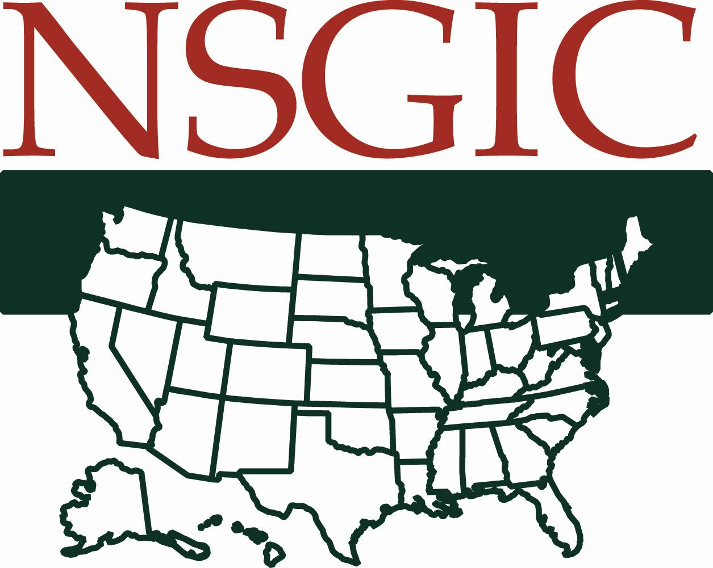
National States Geographic Information Council
167 West Main Street, Suite 600
Lexington, KY 40507

http://www.nsgic.org

NSGIC STATE SUMMARIES

2004

Prepared by the:

National
States
Geographic
Information
Council

September 2004

Acknowledgements

NSGIC would like to thank all of our corporate sponsors, who made the production of this document possible.

Thank you to the staff of AMR, especially Amanda Hermann, for assistance in coordinating the collection of the summaries from the individual states.

This document was produced in cooperation with the West Virginia Geological and Economic Survey, Morgantown, West Virginia.

© 2004 National States Geographic Information Council

National States Geographic Information Council
167 West Main Street, Suite 600
Lexington, KY 40507

http://www.nsgic.org

List of State Summary Responses

Alabama 1
Alaska 3
Arizona 5
Arkansas 7
California 9
Colorado 11
Connecticut 13
Delaware 15
Georgia 17
Hawaii 19
Idaho 21
Illinois 23
Indiana 25
Iowa 27
Kansas 29
Kentucky 31
Louisiana 33
Maine 35
Maryland 37
Massachusetts 39
Michigan 41
Minnesota 43
Mississippi 45
Missouri 47
Montana 49
Nebraska 51
Nevada 53
New Hampshire 55
New Jersey 57
New Mexico 59
New York 61
North Carolina 63
North Dakota 65
Ohio 67
Oklahoma 69
Oregon 71
Pennsylvania 73
Rhode Island 75
South Carolina 77
South Dakota 79
Tennessee 81
Texas 83
Utah 85
Vermont 87
Virginia 89
Washington 91
West Virginia 93
Wisconsin 95
Wyoming 97

ALABAMA

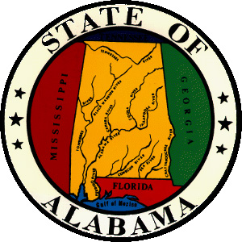
Contact Information:
Berry H. (Nick) Tew
State Geologist
Geological Survey of Alabama
P.O. Box 869999
420 Hackberry Lane
Tuscaloosa, AL 35486-6999
Phone: 205.349.2852
Fax: 205.349.2861
Email: ntew@gsa.state.al.us

State GIS Clearinghouse URL: (Metadata Clearinghouse node maintained by Geological Survey of Alabama): http://www.gsa.state.al.us
A. Describe your state’s top 3 geospatial accomplishments during the past year:
1. Initiation of development of a GIS strategic/business plan for AL (AL Dept. of Revenue, Property Tax Division).
2. Initiation of development of AL Flood Map Modernization Program with FEMA (AL Office of Water Resources—Dept. of Economic and Community Affairs, other partners)
3. Activities related to The National Map.

B. Describe your state’s top 3 geospatial goals for the coming year:
1. Continuation of strategic/business planning process.
2. Continued progress in coordination and cooperation within the state.
3. Development of funding and other resources for geospatial activities.

C. Describe the 3 most significant geospatial challenges for your state:
1. Funding and other resources for GIS development and activities.
2. Coordination and communication.
3. Education of decision makers relative to the significant benefits associated with geospatial technologies and data.

D. Describe any significant cooperative efforts with Federal, State or Local partners:
There are numerous cooperative efforts in Alabama, among partners at all levels. Generally, these are driven by specific needs or projects.
E. Describe any significant data development activities, innovative applications, cost saving measures, contracts, etc.:
N/A

F. Please provide the following Information: (enter N/A if not applicable or unknown; also enter a URL if available on the Internet)
1. GIS mission statement: N/A
2. GIS Statutory authority: N/A
3. GIS Coordinator: N/A
4. GIS Coordinating Body: N/A (no statutory body, several ad hoc coalitions and forums)
5. GIS Personnel Classifications: N/A
6. GIS Data Distribution Policy: varies among entities and levels of government
7. GIS Data Standards: N/A
8. GIS Budget (including grants, etc.): N/A
9. Other policies, publications, RFP’s, etc.: N/A

ALASKA

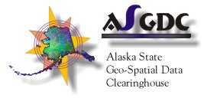
Contact Information:
Richard McMahon
Data Processing Manager

Land Records Information Section
Alaska Dept. of Natural Resources
550 W. 7th Ave Suite 706
Anchorage, AK 99501
Phone: 907-269-8836
Fax: 907-269-8920
Email: Richard_McMahon@dnr.state.ak.us

State GIS Clearinghouse URL: State-Local Node: http://www.asgdc.state.ak.us/
Federal Node: http://agdc.usgs.gov
A. Describe your state’s top 3 geospatial accomplishments during the past year:
1. Expanded Public Access with online applications
2. Implementation of Oracle / Java framework for GIS business application development
3. Strengthened interagency partnerships on cooperative projects

B. Describe your state’s top 3 geospatial goals for the coming year:
1. Linking local government parcel databases to State Recorder’s Office data; building
cadastral web-services model for local-state-federal real-time access;
creating statewide parcel maps
2. Developing shared (multi-dept) approach to Oracle-based GIS framework
3. Improved statewide digital elevation models; expand use of ortho-imagery

C. Describe the 3 most significant geospatial challenges for your state:
1. Migrating file-based GIS systems into relational databases; OGC interoperability issues
2. Developing a shared approach to Oracle-based GIS framework among multiple departments; implementing a common data-center environment
3. Coordinated Multi-agency statewide migration to NAD83.

D. Describe any significant cooperative efforts with Federal, State or Local partners:
- Alaska Land Records: http://landrecords.info
- Alaska Cadastral Project: http://cadastral.info
- Alaska Mining: http://akmining.info
- Alaska Minerals Data: http://akgeology.info
- Spill Response: http://tidelands.landrecords.info
- State Recorder’s Office http://AKrecorder.info
- NASA Grant: Interior Alaska Ortho-Imagery Project: http://www.tananachiefs.org/maps/
- Forest Health: http://www.dnr.state.ak.us/forestry/insects/surveys.htm
- Alaska Oil & Gas Geotechnical Publication (well & production info): (web site in beta)

E. Describe any significant data development activities, innovative applications, cost saving measures, contracts, etc.:
- Data Development: University of Alaska SAR Facility: Geographic Information Network of Alaska (GINA) http://www.gina.alaska.edu; DEM development
- Innovative Applications: see http://mapper.landrecords.info (e.g., user saved views)
- Cost Savings: see D above

F. Please provide the following Information: (enter N/A if not applicable or unknown; also enter a URL if available on the Internet)
1. GIS mission statement: http://agdc.usgs.gov
2. GIS Statutory authority: Alaska Statute 09.25.110-09.25.220
3. GIS Coordinator: State & Federal Co-Chair AGDC
4. GIS Coordinating Body: Alaska Geographic Data Committee (AGDC)
5. GIS Personnel Classifications: mixed (Cartographers, Analyst/Programmers, etc.)
http://www.jobs.state.ak.us/
6. GIS Data Distribution Policy: regulation: 6AAC Chapter 96 Public Information
7. GIS Data Standards: http://agdc.usgs.gov
8. GIS Budget (including grants, etc.):
9. Other policies, publications, RFP’s, etc.:

ARIZONA


Contact Information:
Gene Trobia
State Cartographer
Arizona State Cartographer’s Office
1616 West Adams Street
Phoenix, AZ 85007
Phone: 602-542-3190
Fax: 602-542-2600
Email: gtrobia@land.az.gov

State GIS Clearinghouse URL: http://www.land.state.az.us/alris/
A. Describe your state’s top 3 geospatial accomplishments during the past year:
1. Updated metadata on Arizona Land Resource Information System data.
2. Creating a state portal to allow data sharing and GIS services.
3. Establishing geodetic control to integrate state and local data.

B. Describe your state’s top 3 geospatial goals for the coming year:
1. Establishing Arizona Height Modernization.
2. Establishing an Arizona GIS Clearinghouse.
3. Establish and maintain an Arizona FIREMAP.

C. Describe the 3 most significant geospatial challenges for your state:
1. State statutes hinder data sharing.
2. Lack of updated aerial photography and spatially accurate street centerlines with address ranges.
3. Lack of resources.

D. Describe any significant cooperative efforts with Federal, State or Local partners:
- IPA with USGS to work on the NSGIC/NACo/USGS National Map Partnership Project.
- CTM grant to create an Arizona clearinghouse as part of the National Map.
- NGS State Advisor Program.
- FEMA grant to develop a statewide GIS data, contacts and services network for First Responders and Emergency Managers.
- Working with the Arizona Professional Land Surveyor’s Association to develop a new designation of Geospatial professional.

E. Describe any significant data development activities, innovative applications, cost saving measures, contracts, etc.:
- The creation of the Arizona FIREMAP to manage forest health and fuels treatment programs statewide.
- Arizona Geodata Clearinghouse will be the State’s first clearinghouse to allow data downloads.

F. Please provide the following Information: (enter N/A if not applicable or unknown; also enter a URL if available on the Internet)
1. GIS mission statement: The mission of the Arizona Geographic Information Council (AGIC) is to coordinate the development and management of geographic information in Arizona. AGIC supports the use of GIS and geospatial technologies to address problems and manage the natural, economic and infrastructure resources of the state.
2. GIS Statutory authority: The Arizona Land Resources Information System and the Arizona State Cartographer’s Office are established by Arizona Revised Statutes and Arizona Geographic Information Council was established by Executive Order.
3. GIS Coordinator: Arizona State Cartographer’s Office.
4. GIS Coordinating Body: Arizona Geographic Information Council (AGIC).
5. GIS Personnel Classifications: GIS position descriptions have been broadbanded into generic IT positions. When recruiting specific GIS characteristics may be identified.
6. GIS Data Distribution Policy: State statute currently prohibits distribution of data without considering the commercial value of the data
7. GIS Data Standards: FGDC standards are adopted by the State (unless a specific standard is deemed not in the best interests of the state).
8. GIS Budget (including grants, etc.): The budget for the Arizona Land Resources Information System, the State Cartographer’s Office and the Arizona Geographic Information Council (statewide GIS) is approximately $660,000. There is approximately $120,000 in a non-lapsing Revolving Account for data development and acquisition and to hold an annual State GIS Conference. There is also about $300,000 in current grant funding. This only includes statewide GIS budgets and does not include budgets for state agencies conducting departmental GIS.
9. Other policies, publications, RFP’s, etc.: Publishing Mapping Arizona (scheduled for August 2004).

G. Other comments: (e.g., Has participation in NSGIC benefited your state’s geospatial efforts?)
Participation in NSGIC has greatly benefited our state’s GIS Council by providing information and models of what other states are doing, knowledge of federal programs and a network of experts to discuss geospatial data and GIS development issues.

ARKANSAS

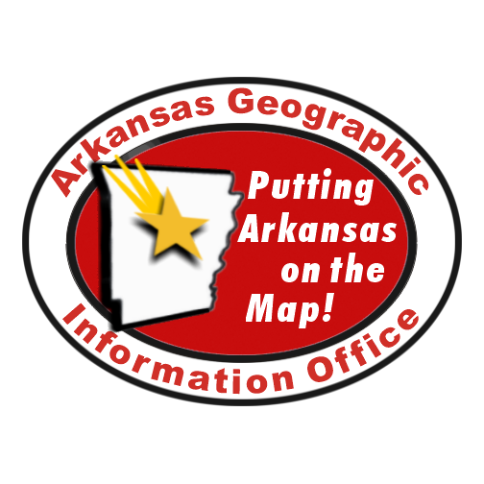
Contact Information:
Shelby D Johnson
State Geographic Information Coordinator
Arkansas Geographic Information Office
Office of Information Technology
124 West Capitol Ave, Suite 200
Little Rock, AR 72201
Phone: 501-682-2767
Fax: 501-682-2040
Email: shelby.johnson@arkansas.gov

State GIS Clearinghouse URL: http://www.gis.state.ar.us
A. Describe your state’s top 3 geospatial accomplishments during the past year:
1. The County Assessor Mapping Program (CAMP) is a statewide initiative to implement digital cadastral mapping in all 75 Assessor offices in Arkansas. In 2003, the Arkansas Assessment Coordination Department (AACD) and the Arkansas Geographic Information Office (AGIO) formed a partnership to begin this task. The program is available to any county. In just over a year 71 counties have joined the program. Through the program 58 counties have received training and are currently building their digital cadastre data. Prior to the launch of this program in 2002 less than three counties were conducting digital cadastral data development, none were standardized and none of these documented metadata. At present 95% of Arkansas counties are or will be developing digital cadastral data in a consistent and standardized manner. The program participant status is reported each month at the following web site http://www.gis.state.ar.us/Programs/Programs_current/CAMP/status.htm Building on the success of the program the state adopted a statewide digital cadastral data standard on July 2, 2004 and is now an Official State Rule and Regulation. This standard is based upon the federal cadastral core data standard.
2. The AGIO developed the Arkansas Centerline File (ACF) Program. The ACF program is designed to compile a standardized statewide road centerline GIS map data layer that can be used by all levels of government, the private sector and individuals. The ACF Program is unique in that the entire dataset is built from many different local source (city and county) datasets using a common standard. One very unique aspect of the ACF Program is that there is technology transfer that allows for the data maintenance to be done at the local level. The AGIO does not create or develop any data. The State simply integrates the various local sources into a common format in a standardized and consistent manner across jurisdictional boundaries. The ACF Standard is an Official State Rule and Regulation. During the past year more than 15 counties developing centerline data have achieved compliance with the standard and their data is published in the state GIS clearinghouse. Seven counties are in the process of being tested for compliance with the standard and 23 counties are at various stages of completion following the standard. An additional seven counties are presently in the bid process. During this past year of 75 counties 52 have achieved standard compliance or are working toward compliance, representing 69% of Arkansas counties.
3. Utilization of the GeoStor, the State’s GIS data clearinghouse, continues to grow.
The system now has over 3,300 registered users who continue to return to the clearinghouse for data. The system now records an average of over 2,500 data downloads monthly.
B. Describe your state’s top 3 geospatial goals for the coming year:
1. Statewide participation in the County Assessor Mapping Program
2. Statewide participation in the Centerline File Program
3. Continued support for agency to operate as General Revenue Agency

C. Describe the 3 most significant geospatial challenges for your state:
1. Identifying a sustainable source of revenue for local data development and maintenance.
2. Continued education of state and local policy makers about the strategic use of GIS.
3. Aligning local, state and federal data development objectives.

D. Describe any significant cooperative efforts with Federal, State or Local partners:
Arkansas has a significant partnership with the USGS jointly pursuing National Map activities. The state is working closely through the Census Regional Office in the coordination of TIGER modernization efforts. The state is presently defining the GIS coordination role in the FEMA Flood Map Modernization program as well. On the state level many state agencies are working to build state and local level data for a variety of applications. These activities are frequently highlighted under the News section located at http://www.gis.state.ar.us
E. Describe any significant data development activities, innovative applications, cost saving measures, contracts, etc.:
Cadastral data by counties, road centerline data by cities, counties, planning and development districts, the One-Call (Call Before Dig) Center, the state Transportation Department and the Census Bureau.
F. Please provide the following Information: (enter N/A if not applicable or unknown; also enter a URL if available on the Internet)
1. GIS mission statement: The Arkansas State Land Information Board coordinates geographic information programs and delivers data products and education, improving resource management, health, safety, and decision making for economic development across Arkansas.
2. GIS Statutory Authority: Arkansas Code 15-21501, http://www.gis.state.ar.us/ASLIB_index.htm
3. GIS Coordinator: Arkansas Code 15-21-503
4. GIS Coordinating Body: Arkansas Code 15-21-503
5. GIS Personnel Classifications: N/A
6. GIS Data Distribution Policy: The AGIO has recommended to the State Land Information Board to adopt the FGDC Guidelines for Providing Appropriate Access to Geospatial Data in Response to Security Concerns as a state guideline for distributing data.
7. GIS Data Standards: http://www.gis.state.ar.us/Documents/Standards_index.htm
8. GIS Budget (including grants, etc.): $700,380
9. Other policies, publications, RFP’s, etc.:

G. Other comments: (e.g., Has participation in NSGIC benefited your state’s geospatial efforts?)
Yes. The state has received tremendous benefit from participating in NSGIC.

CALIFORNIA


Contact Information:
John Ellison
Agency Information Technology Officer
California Resources Agency
1416 9th St., Suite 1311
Sacramento, CA 95814
Phone: (916) 653-2238
Fax: (916) 653-1802
Email: john.ellison@resources.ca.gov

State GIS Clearinghouse URL: http://www.ceres.ca.gov
A. Describe your state’s top 3 geospatial accomplishments during the past year:
1. Completed the California Spatial Information Library (www.gis.ca.gov)
2. Established the California GIS Council (http://gis.ca.gov/council/)
3. The California Department of Forestry and Fire Protection completed state needs assessment for digital lands information system

B. Describe your state’s top 3 geospatial goals for the coming year:
1. Identify and promote solution for statewide digital lands information system
2. Cultivate high-level state government sponsorship for GIS coordination and the California GIS Council
3. Obtain funding for GIS coordination activities

C. Describe the 3 most significant geospatial challenges for your state:
1. Need to establish Office and function of the Geographic Information Officer
2. Gain Governor’s cabinet level sponsorship of GIS coordination (e.g., California GIS Council)
3. Obtain Governor’s office endorsement of initiative to obtain Federal appropriation to fund high-resolution satellite image of entire state to promote collaborative acquisition and sharing in support of government services at all levels (e.g., federal, state and local)

D. Describe any significant cooperative efforts with Federal, State or Local partners:
California Resources Agency and USGS have formed partnership in pursuit of the National Map. Resources Agency also works closely with the California Geographic Information Association to facilitate formation and function of regional GIS councils.
E. Describe any significant data development activities, innovative applications, cost saving measures, contracts, etc.:
The California Resources Agency has recently completed the first ever assembly of a statewide county plan data set. This data set is available at no cost on-line at http://gis.ca.gov/catalog/ under the California Legacy Project Data Collection. The California GIS Council has passed a resolution seeking a Federal appropriation to fund the procurement of high resolution (e.g., sub meter) for California (see http://gis.ca.gov/council/docs/Imagery_Resolution-FINAL.rtf). The objective is to promote a collaborative approach to imagery acquisition and sharing.

F. Please provide the following Information: (enter N/A if not applicable or unknown; also enter a URL if available on the Internet)
1. GIS mission statement: From the Charter for the California GIS Council…” The California Geographic Information System Council, hereinafter “The Council,” will enable governments to work together to develop, maintain and share accurate, consistent place-based information that is accessible to all Californians and the agencies and organizations that serve them.”
2. GIS Statutory authority: None directly related to GIS per se. Some references to coordinating mapping can be found in statute.
3. GIS Coordinator: California does not have a GIS Coordinator
4. GIS Coordinating Body: California GIS Council (http://gis.ca.gov/council/)
5. GIS Personnel Classifications:
Research Analyst I (GIS)
Research Analyst II (GIS)
Research Manager I (GIS)
Research Manager II (GIS)
Research Manager III (GIS)
Research Program Specialist I (GIS)
Research Program Specialist II (GIS)
Research Program Specialist III (GIS)
6. GIS Data Distribution Policy: No formal California State GIS data distribution policy exists. There may be a few distribution policies among individual state government agencies.
7. GIS Data Standards: De facto metadata standard represented by CERES (http://www.ceres.ca.gov). Otherwise there are no formal GIS data standards in place. California GIS data are strongly influenced by Federal standards.
8. GIS Budget (including grants, etc.): Impossible to say. There is no California State Government GIS Budget. GIS efforts scattered throughout many individual state agencies.
9. Other policies, publications, RFP’s, etc.: N/A
G. Other comments: (e.g., Has participation in NSGIC benefited your state’s geospatial efforts?)
NSGIC activities have been of value to GIS coordination in California in general. Our partnership with USGS will allow us to have representation at the upcoming NSGIC conference in Austin, TX.
California continues to lag behind much of the rest of the Nation in coordinating its geospatial activities at a state level. However, individual state agencies heavily invested in GIS continue to coordinate with each other and partners in the federal, local government, academic and private sectors to share data and realize efficiencies. The current fiscal crisis and change in state administration have distracted many state government agencies with more basic issues of funding and restructuring. It is very difficult to get high level attention to technical issues like GIS at this time.
Local governments and professional associations are very active in coordinating geospatial efforts throughout the state. We have also benefited greatly from the efforts of the Open GIS Consortium (http://www.opengis.org/) and the Open Data Consortium (http://www.opendataconsortium.org/). The model Data Distribution Policy created by the latter holds great potential for promoting the development of organization specific data sharing policies throughout the state.

COLORADO


Contact Information:
Heather Hicks
GIS Coordinator
Department of Natural Resources
1313 Sherman Street
Room 423
Denver, CO 80203
Phone: 303-866-2170
Fax: 303-866-3415
Email: heather.hicks@state.co.us

State GIS Clearinghouse URL: http://www.aclin.org

A. Describe your state’s top 3 geospatial accomplishments during the past year:
1. Received grant for inclusion in The National Map
2. Received grant for Homeland Security to assess, exercise and train for emergency response preparedness
3. Received grant to fund temporary fulltime State GIS Coordinator

B. Describe your state’s top 3 geospatial goals for the coming year:
1. Build geospatial data repository
2. Secure funding for State GIS Coordinator
3. Implementation plan for GIS Crisis and Response Center
4. Assessment, exercise and training for state’s emergency response capabilities and capacities

C. Describe the 3 most significant geospatial challenges for your state:
1. Lack of support and funding for a fulltime, permanent State level GIS Coordinator
2. Lack of agency participation and cooperation
3. Lack of support from highest levels of government for creation of GIS program/office

D. Describe any significant cooperative efforts with Federal, State or Local partners:
Colorado has partnered with several agencies to build at central geospatial data repository for the state. The USGS is supporting the state in developing the infrastructure to become part of The National Map. Additionally, Colorado is working with the Department of Homeland Security to improve access to and dissemination of data for emergency response. Other federal partners are interested in collaborating on data sharing and partnerships are being developed to support common goals and share imagery.
E. Describe any significant data development activities, innovative applications, cost saving measures, contracts, etc.:
- The Colorado DOT is working with several local agencies to develop an integrated, statewide roads GIS layer that includes data produced by local governments and CDOT. Local agencies are serving as data producers and custodians, with CDOT serving as an area integrator for those jurisdictions. CDOT is fulfilling the producer and custodian role for areas that do not have local cooperators. Eleven jurisdictions have completed the integration process, and another 10-20 are expected to do so in the next year. Another 58 jurisdictions have provided GIS datasets on a one-time basis for inclusion, but are not yet participating in the integrated, shared GIS layer portion of the project. Discussions are also ongoing with the US Forest Service and the Bureau of Land Management regarding their participation in the shared layer.
- The Division of Wildlife has map-enabled its existing and popular Web site with context-sensitive map delivery by leveraging technology provided by The Natural Diversity Information Source (NDIS) MapIt! Application. Supporting maps for any area, species, or project mentioned on the site can now be made available to the Division's diverse clientele via MapIt's interactive mapping interface. Development focused on support for the approximately 300,000 licensed hunters, 900,000 licensed anglers and the countless number of outdoor enthusiasts who like to hike, camp, or watch wildlife in any of DOW's 230 recreation areas. Currently MapIt! provides over 800 map links off the Division's site.

F. Please provide the following Information: (enter N/A if not applicable or unknown; also enter a URL if available on the Internet)
1. GIS mission statement: N/A
2. GIS Statutory authority: Governor’s Office of Innovation and Technology
3. GIS Coordinator: No fulltime equivalent at this time
4. GIS Coordinating Body: SAGIS: State Agency GIS http://www.covl.org/sagis/
5. GIS Personnel Classifications: N/A
6. GIS Data Distribution Policy: http://www.covl.org/sagis/dataexchange.htm
7. GIS Data Standards: http://www.covl.org/sagis/standards.htm
8. GIS Budget (including grants, etc.): (no central budget) $120,000 in GIS grants in 2004
9. Other policies, publications, RFP’s, etc.: N/A
G. Other comments: (e.g., Has participation in NSGIC benefited your state’s geospatial efforts?)
Colorado has been trying to implement at statewide GIS program. Having the foundation and models from other states is helping Colorado’s GIS and IT communities demonstrate to policy makers the importance of GIS and support that other states are willing to give to GIS. This year Colorado is attempting to build a central spatial data repository, and we look forward to learning of other similar projects and experiences from other member states. We hope to participate more fully in NSGIC activities in the future.

CONNECTICUT

Contact Information:

Steven O. Fish
Director
CT Department of Environmental Protection
79 Elm Street
Hartford, CT 06106
Phone: 860-424-3642
Fax: 860-424-4058
Email: steve.fish@po.state.ct.us

State GIS Clearinghouse URL:

A. Describe your state’s top 3 geospatial accomplishments during the past year:
1. Completion of 2004 Statewide Flight to capture the digital orthophoto quads
2. Interagency effort toward establishing a geospatial web portal and geospatial data
warehouse in cooperation with Department of Information Technology.
3. Workgroup progress toward development portal requirements.

B. Describe your state’s top 3 geospatial goals for the coming year:
1. Making the 2004 orthophotos available for viewing and download through the state portal.
2. Passage of legislation and/or the establishment of an executive order to formally recognize the CT Geospatial Council.
3. Access to geospatial data to support emergency responders through a statewide incident/crisis management system and preparation for TOPOFF 3 exercise in April, ‘05

C. Describe the 3 most significant geospatial challenges for your state:
- Development of a business plan by the Council for cooperative development and maintenance of framework data and geospatial data.
- Creation of a mechanism to cooperatively fund the development and maintenance of framework data through a formally established Council.
3. Dedicated long-term funding for data update and maintenance.

D. Describe any significant cooperative efforts with Federal, State or Local partners:
- Statemap – Scanning of geologic maps and development of geology coverages to add to the GIS.
- NHD – Working with USGS through a joint funding agreement that will result in statewide coverage of the National Hydrography Dataset (NHD) at 1:24K scale resolution as a part of the National Map.
- NDDB – Utilize Biotics, a customized database and GIS application for tracking endangered species distributions developed by NatureServ and Linnet. It applies Natural Heritage methodology used in environmental permitting review
- National Map – besides the NHD work, the DEP continues to work with selected datatsets to add to the National Map.
E. Describe any significant data development activities, innovative applications, cost saving measures, contracts, etc.:
- GDT data – statewide license through the E911 OSET.
- 2004 Statewide Flight – cooperatively funded for the first time through a multi-agency agreement.
- HS critical infrastructure – working with several state agencies to identify the source and location of critical infrastructure data for use in a statewide incident/crisis management system.

F. Please provide the following Information: (enter N/A if not applicable or unknown; also enter a URL if available on the Internet)
1. GIS mission statement: The mission of the CT Geospatial Council is to develop and administer policies and processes regarding statewide geospatial Information: to provide common data access for all authorized users to the geospatial data; and to specify the geospatial technical architecture for the State of Connecticut.
2. GIS Statutory authority: N/A
3. GIS Coordinator: Interim Coordinator/Chair: Steven Fish, EGIC, DEP
4. GIS Coordinating Body: CT Geospatial Council
5. GIS Personnel Classifications: N/A
6. GIS Data Distribution Policy: distribution via web and CD
7. GIS Data Standards:
8. GIS Budget (including grants, etc.): Varies; combination of available funds from different agencies made up of federal funds and state funds.
9. Other policies, publications, RFP’s, etc.: FIS RFP released in Spring 2004
G. Other comments: (e.g., Has participation in NSGIC benefited your state’s geospatial efforts?)
New membership for me – information and contacts through my membership with NSGIC this past year has been most helpful in the work that is currently underway here in CT.

DELAWARE

Contact Information:
Michael B. Mahaffie
Principal Planner
Delaware Office of State Planning Coordination
540 S. DuPont Hwy
3rd Floor Suite 7
Dover, DE 19901
Phone: (302) 739-3090
Fax: (302) 739-6958
Email: mike.mahaffie@state.de.us

State GIS Clearinghouse URL: http://datamil.udel.edu/metadata/
A. Describe your state’s top 3 geospatial accomplishments during the past year:
1. Secured funding and legislative authority to migrate Delaware DataMIL from Development site at University of Delaware, to Production environment within Department of technology and Information.
2. Developed and approved Acceptable Use Policy, Agreements, and process for distribution of ¼-meter pixel resolution orthophotography, deemed a potential security risk by homeland security officials.
3. Completed effort to fund completion of NHD for final portion of the state. All CU’s that include Delaware are expected to be updated by end of calendar year 2004.

B. Describe your state’s top 3 geospatial goals for the coming year:
1. Legislation creating an official Delaware GIS Coordination office, with line-item funding and an appointed Geospatial Council.
2. Completion of DataMIL migration.
3. Completion of integrated County/State process for maintenance of Transportation portion of the Framework.

C. Describe the 3 most significant geospatial challenges for your state:
1. Lack of direct, legislative, coordination authority and spatial data funding.
2. Retaining skilled, trained GIS staff within County government.
3. Cementing data steward responsibilities for key framework layers.

D. Describe any significant cooperative efforts with Federal, State or Local partners:
Delaware is negotiating with USGS EROS Data Center for archiving and distribution of State orthophotography. We are also working with USGS, USDA and FEMA on projects to gather and make full use of high-resolution elevation data. USGS has helped align part of Delaware’s road centerline data with new orthophotography.
E. Describe any significant data development activities, innovative applications, cost saving measures, contracts, etc.:
Delaware has begun a project to create a statewide address-point data set for use in 911 and emergency response applications. This will be integrated with the local/state transportation data effort. The Delaware DataMIL has spawned several state and local IMS web sites that will eventually be cross linked with the DataMIL to create a distributed on-line spatial data Framework.

F. Please provide the following Information: (enter N/A if not applicable or unknown; also enter a URL if available on the Internet)
1. GIS mission statement: A “Problem Statement” approved by the Delaware Spatial Data Framework Implementation Team:
http://www.state.de.us/planning/coord/dgdc/i-t_problem.htm
2. GIS Statutory authority: 29 Delaware Code §9101(g)(4) (4) Delaware Geographic Data Committee and Comprehensive State Planning Database System. (http://www.delcode.state.de.us/title29/c091/sc01/index.htm#P15_157 )
3. GIS Coordinator: Michael B. Mahaffie
4. GIS Coordinating Body: Delaware Spatial Data Implementation Team and the Delaware Geographic Data Committee
5. GIS Personnel Classifications: N/A
6. GIS Data Distribution Policy: No defined policy, other than legislative mandate, in citation noted above, “to insure the implementation of a coordinated program to catalog and distribute geographic data.”
7. GIS Data Standards: In development.
8. GIS Budget (including grants, etc.): None.
9. Other policies, publications, RFP’s, etc.: http://www.state.de.us/planning/coord/dgdc/index.htm

G. Other comments: (e.g., Has participation in NSGIC benefited your state’s geospatial efforts?)
NSGIC has been a vital resource in our effort to improve the coordination of GIS and spatial data efforts in Delaware.

GEORGIA

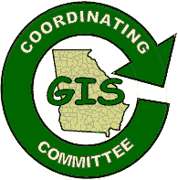
Contact Information:
Lisa Westin
Senior GIS Specialist
Georgia Department of Community Affairs
60 Executive Park South, NE
Suite 250
Atlanta, GA 30329
Phone: 404-679-3135
Fax: 404-679-0572
Email: mailto:lwestin@dca.state.ga.us

State GIS Clearinghouse URL: http://www.gis.state.ga.us
A. Describe your state’s top 3 geospatial accomplishments during the past year:
1. Working with EPA under grant funding for development of the National Wetlands Inventory (NWI), Georgia has completed the update of the NWI data set for Georgia.
2. The state has implemented an online annexation reporting tool. These annexations will be passed on to the US Census Bureau to assist with BAS.
3. Revisions have been completed to provide more options for data delivery via Georgia's GIS Clearinghouse, http://gis.state.ga.us. The clearinghouse application has been updated to allow for the sale of local government data in compliance with state laws that allow local governments to recover GIS development cost through the sale of data. Changes were also implemented to allow the Georgia GIS Clearinghouse to respond to queries through the Geospatial One-stop search engine. The Georgia GIS clearinghouse is offering searchable metadata for themes that include administrative boundaries, labor statistics, census population and housing, labor statistics, population projections, economic development data, natural resources data and more.

B. Describe your state’s top 3 geospatial goals for the coming year:
1. Georgia will continue efforts to complete the update of GSDI Framework layers in the upcoming year with updates for transportation and imagery. We also need to develop a maintenance strategy for these framework layers.
2. Georgia hopes to increase the cost efficiencies of the State's procurement of GIS software and data through the greater use of enterprise contracts. During the upcoming year, Georgia hopes to establish contracts for commonly used imagery and desktop GIS software.
3. Georgia hopes to complete the data collection for the TIGER modernization project.

C. Describe the 3 most significant geospatial challenges for your state:
1. Funding remains a general challenge for all State activities as tax revenue continues to decline and Georgia, like many other states, is faced with budget cuts and fiscal constraints.
2. Intergovernmental coordination. A continuing challenge for the State is coordinating the successes of the local government GIS programs with those of State agencies and our federal partners.

D. Describe any significant cooperative efforts with Federal, State or Local partners:
- Coordination with the U.S. Bureau of the Census on the Boundary & Annexation Survey, and the TIGER Modernization project.
- NHRGIS: Georgia is working on its first effort to cooperatively develop cultural resources information for use by multiple agencies. Under this project, which will be completed in the upcoming year, Georgia's Archeological and historical cultural resources databases are being redesigned and integrated with web based tools to ensure greater accuracy and provide better access to data used to support a variety of state applications from historic preservation to comprehensive planning. Guidance for this effort, funded by the FHWA, is being given by the States GIS Coordinating Committee which has set up a technical advisory board of agency stakeholder for that purpose.
E. Describe any significant data development activities, innovative applications, cost saving measures, contracts, etc.:
- Trip Planning Georgia received a grant from the Federal Transit Administration for the development of a web based rip planning tools.
- The GISCC is working with Georgia Technology Authority procurement staff to establish enterprise contract for procurement of off the shelf imagery products and for GIS software. It is anticipated that this effort will greatly reduce overall expenditures for GIS related purchases.
F. Please provide the following information; (enter N/A if not applicable or unknown; also enter a URL if available on the Internet)
1. GIS mission statement: The GIS Data Clearinghouse will make the application of spatial information technologies within the State of Georgia more efficient by eliminating the duplication of spatial data production and distribution through effective cooperation, standardization, communication, and coordination.
http://gis.state.ga.us/Clearinghouse/Resources/Mission/mission.html
2. GIS Statutory authority:
3. GIS Coordinator: Lisa Westin
4. GIS Coordinating Body: GISCC
5. GIS Personnel Classifications: N/A
6. GIS Data Distribution Policy: http://gis.state.ga.us/Coordination/Documents/documents.html
7. GIS Data Standards: http://gis.state.ga.us/Coordination/Documents/documents.html
8. GIS Budget (including grants, etc.): N/A
9. Other policies, publications, RFP’s, etc.:

G. Other comments: (e.g., Has participation in NSGIC benefited your state’s geospatial efforts?)
NSGIC remains an important point of contact for the state as Georgia continues to look to the best practices of other states in its efforts to develop GIS in the most efficient manner.

HAWAII

Contact Information:

Craig Tasaka
GIS Program Manager
Dept. of Business, Economic Development
and Tourism / Office of Planning
P.O. Box 2359
Honolulu, HI 96804
Phone: (808) 587-2894
Fax: (808) 587-2899
Email: ctasaka@dbedt.hawaii.gov

State GIS Clearinghouse URL: http://clearinghouse.esri.com/ESRIgateway.htm
A. Describe your state’s top 3 geospatial accomplishments during the past year:
1. Began to fill in DOQQ gaps—there is no existing DOQQ statewide coverage
2. Began to acquire LIDAR data for Oahu and portions of Maui
3. Received a Federal Homeland Security grant to build GIS capacity within the State Civil Defense Division

B. Describe your state’s top 3 geospatial goals for the coming year:
1. Fill in remaining DOQQ gaps
2. Update our Statewide GIS Strategic Plan
3. Improve address range data

C. Describe the 3 most significant geospatial challenges for your state:
1. Finding funding sources to acquire new or update existing data sets
2. Gaining support at the upper levels of State government
3. Acquisition of cloud-free remotely sensed data

D. Describe any significant cooperative efforts with Federal, State or Local partners:
Our Hawaii Geographic Information Coordinating Council, a body of Federal, State, local, private and non-profit partners, planned, coordinated and sponsored a successful Statewide GIS conference.
E. Describe any significant data development activities, innovative applications, cost saving measures, contracts, etc.:
DOQQ and LIDAR acquisitions mentioned in A

F. Please provide the following Information: (enter N/A if not applicable or unknown; also enter a URL if available on the Internet)
1. GIS mission statement: The Office of Planning GIS Program leads a multi-agency effort to establish, promote, and coordinate the use of geographic information systems (GIS) technology among Hawaii State Government agencies. The State Office of Planning is responsible for the planning and coordination of activities that are critical to the State’s enterprise GIS. The primary goal of the Statewide GIS Program is to improve overall efficiency and effectiveness in government decision-making.
2. GIS Statutory authority: Chapter 225M, Hawaii Revised Statutes
3. GIS Coordinator: Craig Tasaka
4. GIS Coordinating Body: Hawaii Geographic Information Coordinating Council
5. GIS Personnel Classifications: N/A at the State level; 3 of the 4 counties have classifications in place
6. GIS Data Distribution Policy: Anything considered public information is free
7. GIS Data Standards: Loosely follow National Map Accuracy standards
8. GIS Budget (including grants, etc.): minimal
9. Other policies, publications, RFP’s, etc.:

IDAHO

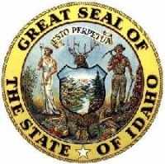
Contact Information:
Nathan Bentley
State GIS Coordinator
Department of Administration – ITRMC Staff
650 West State Street Room 100
PO Box 0042
Boise, ID 83720-0042
Phone: 208-332-1879
Fax: 208-332-1884
Email: nbentley@adm.Idaho.gov

State GIS Clearinghouse URL: http://www.insideidaho.org

A. Describe your state’s top 3 geospatial accomplishments during the past year:
1. Entered into a multiple agency (State, Federal, Local) Purchase agreement with FSA for statewide 1meter color Digital Orhothophoto Quads - Idaho has never had full state coverage of DOQs this purchase will make that happen help fulfill the I-Plan goal for ortho-Imagery.
2. Largest turn out to the Idaho Geospatial Users Meeting 2003 held Fall 2003
3. Working the I-Plan to establishing a priority for data creation and maintenance

B. Describe your state’s top 3 geospatial goals for the coming year:
1. Build a statewide CORS data Clearinghouse
2. Identify long term funding solutions for State Clearinghouse
3. Identify Funding for completion of Core Data layers

C. Describe the 3 most significant geospatial challenges for your state:
- Data Sharing between Local, State and Federal Governments.
2. Funding of core data development and Geospatial Clearinghouse.
3. Establishing lines of communication from the communities through all levels of government.

D. Describe any significant cooperative efforts with Federal, State or Local partners:
Idaho Geospatial users have partnered with the Farm Service Agency (FSA) to acquire statewide 1 meter Digital Orthophoto Quads, As part of FSA’s Agriculture inventory program Idaho geospatial users were invited to participate in with the funding of this data collection.
County, Tribal, University, State, Federal governments and private companies partnered to contribute funding for Idaho’s Collection.
E. Describe any significant data development activities, innovative applications, cost saving measures, contracts, etc.:
As part of the state clearinghouse activities and part of the National Map efforts, INSIDE Idaho is hosting county GIS data as their conduit for Web-based mapping applications:
http://www.insideidaho.org/geodata/countywide/index.htm

F. Please provide the following Information: (enter N/A if not applicable or unknown; also enter a URL if available on the Internet)
1. GIS mission statement: The mission of the Idaho Geospatial Committee is to provide a forum for the GIS community to facilitate the use, development, sharing and management of geospatial data; and to communicate the value of geospatial information to citizens and decision-makers
2. GIS Statutory authority: Ground Water Protection Act of 1989 states that IDWR “has the responsibility to maintain the natural resource GIS for the state” (Idaho Code 39-120)
3. GIS Coordinator: Nathan Bentley – http://www.itrmc.idaho.gov
4. GIS Coordinating Body: Idaho Geospatial Committee formed by Executive Order 2001-07. http://www2.state.id.us/gov/mediacenter/execorders/eo01/eo_2001_07.htm
and http://www2.state.id.us/itrmc/committees.htm#IGC
5. GIS Personnel Classifications: http://www.dhr.state.id.us/jobdescriptions.asp?letter=G
6. GIS Data Distribution Policy:
7. GIS Data Standards:
8. GIS Budget (including grants, etc.):
9. Other policies, publications, RFP’s, etc.:

ILLINOIS

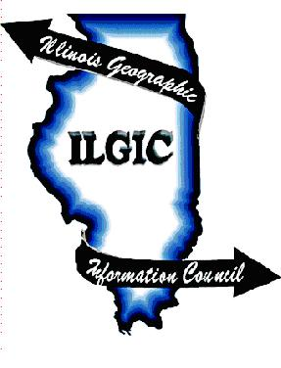
Contact Information:
Sheryl Oliver
GIS Coordinator
llinois Department of Natural Resources
One Natural Resources Way
Springfield, Illinois 62702
Phone: 217-785-8586
Fax: 217-524-44177
Email: soliver@dnrmail.satate.il.us
State GIS Clearinghouse URL:
http://www.isgs.uiuc.edu/nsdihome/ISGSindex.html
A. Describe your state’s top 3 geospatial accomplishments during the past year:
1. Acquisition portion for an Illinois 2005 leaf-off, black and white film collection using NAPP specifications. The six county Chicago metropolitan area will be collected with natural color film using the National Geospatial Intelligence Agency Urban Areas specifications. Additional imagery includes the 2004 NAIP using color-infrared instead of standard natural color film.
2. Ongoing maintenance of the Illinois clearinghouse including the addition of a substantial number of historical aerial photographs from the late 1930’s/early 1940’s. Twenty-five of the 102 counties of Illinois are available and an additional 20 will be on-line and available for download by September 2004.
3. State agencies in Illinois are providing more on-line access to data via innovative Internet map server applications. Several state agencies are using the ArcIMS technology to provide on-line access to agency database holdings. Organizations include the Illinois Technology Office (RouteMap application), Illinois Department of Transportation (road construction information), Illinois Department of Natural Resources (DNR Information System and Resource Management Mapping Service), Illinois Environmental Protection Agency (water quality information and remediation sites), Illinois State Water Survey (IL Rivers Decision Support System, IL Streamflow Assessment Model), and Illinois State Geological Survey (wells and borings data, historical aerial photography and DOQs). During the year, many of these map server applications were either launched on-line or were significantly improved. Together, these applications are providing easy and continuous access to a substantial array of digital map data. In addition, a Health and Human Services Agencies facilities mapping Project for the Governor’s Office is underway.

B. Describe your state’s top 3 geospatial goals for the coming year:
1. Efforts are underway to secure FY05 cost-share funds for the processing of the orthoimagery products which include 0.5-meter ground resolution orthimagery for urban areas natural color aerial photography.
2. To secure one of our options to develop I-ROADS, a multifunctional statewide road database.
3. Implement Illinois’ new Governance Model Architecture framework for IT/GIS.

C. Describe the 3 most significant geospatial challenges for your state:
1. Implementing Illinois’ new Governance Model and Architecture Framework for IT/GIS which consists of reducing IT spending by 100M FY05, FY06, improve service levels, migrate from current state to managed state (enterprise-wide governance, standards, repeatable processes, continued improvement
2. Establishing a stable funding mechanism for GIT Coordination issues including Clearinghouse activities as they relate to implementing the new Governance Model (#1).

D. Describe any significant cooperative efforts with Federal, State or Local partners:
- The USDA-FSA is acquiring first-time statewide National Agricultural Imagery Program (NAIP) digital orthoimagery for Illinois during July-August, 2004. As a result of cooperative funding from the DNR, the 2004 NAIP is being acquired using color-infrared film instead of standard natural color. As a result of several regular and special meetings of the Illinois mapping Advisory Committee, the USGS Eastern regional Geography Program has brought together sufficient FY04 cost-share funding from multiple federal agencies to assure the acquisition portion for an Illinois 2005 leaf-off black and white film collection using NAPP specifications. The six county Chicago metropolitan area will be collected with natural color film using the National Geospatial Intelligence Agency Urban Areas specifications. Additional imagery includes the 2004 NAIP using color-infrared instead of standard natural color film.
- In response to the 2004 NSDI Cooperative Agreements Program (CAP) call for proposals, the Illinois State Geological Survey (ISGS) submitted a proposal to the Federal Geographic Data Committee (FGDC). The primary objectives of the proposal are to establish formal agency interaction for The National Map between the USGS and the State of Illinois; to enhance the Illinois Clearinghouse web mapping service that provides access to all DOQs for Illinois; and to provide on-line access for file viewing and download of both the existing DOQs and the images from the planned 2005 DOQ update. The proposal was endorsed by the Illinois Mapping Advisory Committee and the Illinois Geographic Information Council.
- A multiyear grant from US Fish and Wildlife has been awarded to DNR to build a state wildlife plan. The GIS portion includes the creation and maintenance of several databases. These are comprehensive owned, managed and leased lands, conservation practices, and heritage. It is required by the US CDC that the National Electronic Disease Surveillance System include a geo-coding tool and GIS interface.
E. Describe any significant data development activities, innovative applications, cost saving measures, contracts, etc.:
See Above. Consolidation efforts have been underway during 2003-2004. The process includes a total restructuring of IT in the State. This restructuring will assure alignment of services, rigorous asset management, lowest material cost, and professional program management.
F. Please provide the following Information: (enter N/A if not applicable or unknown; also enter a URL if available on the Internet)
1. GIS mission statement: http://www100.state.il.us/ilgic/
2. GIS Statutory authority: http://www100.state.il.us/ilgic/
3. GIS Coordinator: Sheryl Oliver
4. GIS Coordinating Body: Illinois Geographic Information Council
5. GIS Personnel Classifications: http://www.ilgisa.org
6. GIS Data Distribution Policy:
7. GIS Data Standards:
8. GIS Budget (including grants, etc.):
9. Other policies, publications, RFP’s, etc.:

INDIANA


Contact Information:
Jill Saligoe-Simmel
Executive Director
Indiana Geographic Information Council, Inc.
107 Kenwood Circle
Indianapolis, IN 46260
Phone: 317-233-6009
Fax: 317-233-9000
Email: jsaligoe@iupui.edu

State GIS Clearinghouse URL: http://www.in.gov/ingisi
A. Describe your state’s top 3 geospatial accomplishments during the past year:
1. Ongoing development of statewide framework and non-framework GIS data through the Atlas of Indiana (hosted by the Indiana Geological Survey)
2. Secured funding for IndianaMap, Statewide 2005 Orthophotography Project, and Homeland Security GIS development
3. Memorandum of Cooperation with USGS on the IndianaMap and the National Map

B. Describe your state’s top 3 geospatial goals for the coming year:
1. IndianaMap framework data, data delivery, and web mapping portal development
2. Successful acquisition and delivery of statewide orthophotography
3. Development and execution of statewide data sharing agreements for Homeland Security/Emergency Management and IndianaMap.

C. Describe the 3 most significant geospatial challenges for your state:
1. Lack of sustainable funding
2. Lack of authorization of statewide coordinating body and institution of a implementation office
3. Lack of policies that promote inter-governmental sharing of geospatial framework and non-framework data.

D. Describe any significant cooperative efforts with Federal, State or Local partners:
- The Indiana Department of Transportation has negotiated a license agreement that will provide statewide GDT data to all local government entities and selected state agencies at no additional charge to those agencies;
- IGIC has worked with the Indiana Higher Education Telecommunications Network to quickly distribute the statewide 2003 1-meter NAIP orthophotography to Indiana universities that have subsequently posted image catalogs (this reduced the time to distribute this data from 18 months (experienced in 1998) to less than 1 week.
- All IGIC committees have long enjoyed strong local government participation but that has increased in the last year with the Orthophotography I-Team Workgroup and the establishment of a Local Government Subcommittee.

E. Describe any significant data development activities, innovative applications, cost saving measures, contracts, etc.:
The following statewide data sets were completed and/or funded within the last year:
- Statewide hypsography 1:24,000 5’ and 10’ contours
- Statewide Public Land Survey System (state, county, township, section boundaries)
- Digitization of FIMA Flood Insurance Rate Maps
- NAIP 2003 Statewide 1-meter Orthophotography
- Statewide 1:12,000 System 1, 2, 3 Department of Transportation Roads
- 170 Statewide GIS Layers of framework and non-framework data
- Funding for 2005 Statewide multi-resolution color orthophotography

F. Please provide the following Information: (enter N/A if not applicable or unknown; also enter a URL if available on the Internet)
1. GIS mission statement:
- Mission: The Indiana GIS Council will lead the effective application of GIS in Indiana for an improved quality of life.
- Vision: All Indiana communities will be safer, healthier, wealthier and wiser because they are part of a robust statewide GIS infrastructure.
- Goals: Coordination of Indiana GIS through dissemination of data and data products, education and outreach, adoption of standards, and building partnerships.
2. GIS Statutory authority: none (2001 Governor Proclamation)
3. GIS Coordinator: Roger Koelpin, State Agency GIS Coordinator; Jill Saligoe-Simmel, IGIC Statewide Coordination
4. GIS Coordinating Body: statewide – Indiana Geographic Information Council, Inc.
5. GIS Personnel Classifications: N/A
6. GIS Data Distribution Policy: under development
7. GIS Data Standards: http://www.in.gov/ingisi
8. GIS Budget (including grants, etc.): grant funding 2004 $4.8million
9. Other policies, publications, RFP’s, etc.:
G. Other comments: (e.g., Has participation in NSGIC benefited your state’s geospatial efforts?)
NSGIC continues to be an extremely valuable resource for Indiana’s geospatial coordination efforts. NSGIC has been an unequalled external resource for our efforts providing the benefit of networking among state peers and keeping abreast of national and federal initiatives.

IOWA

Contact Information:
Alan D. Jensen
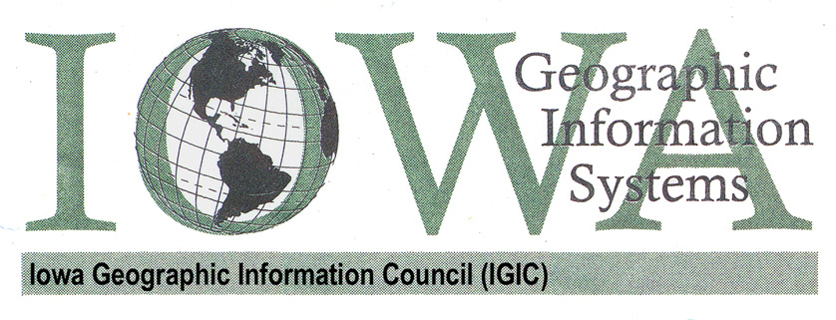
IGIC State GIS Coordinator
Iowa Geographic Information Council
105 W. Adams St.
Suite A
Creston, IA 50801
Phone: (641) 782-8426
Fax: (641) 782-7213
Email: adjensen@iastate.edu

State GIS Clearinghouse URL: http://igic.gis.iastate.edu/ ; http://www.gis.iastate.edu/
A. Describe your state’s top 3 geospatial accomplishments during the past year:
- Completed the design of the Iowa DOT Linear Referencing System with ongoing implementation continues.
- Customized field GPS/GIS training and data collection, with support teams from state offices. (Specifically focused for Homeland Security and natural resources.)
- Creation and internal support of several road databases and datasets important to Emergency Management and Iowa Homeland Security, including the implementation of an internal satellite and aerial photography image distribution system for the Iowa DOT. Creation of our ArcIMS web-mapping site for emergency management coordinator’s and state personnel.

B. Describe your state’s top 3 geospatial goals for the coming year:
- Increased information sharing and assistance with the county and local level in Iowa.
- Complete the Linear Referencing System (LRS) implementation
- Formalize partnerships with local governments and other agencies for maintenance of the road centerlines for the entire state of Iowa.

C. Describe the 3 most significant geospatial challenges for your state:
- Coordination of the many counties and other governing groups to minimize redundancy.
- Gaining support for GIS at the state legislative level.
- Lack of quality, trained resources available for high-end geospatial work.

D. Describe any significant cooperative efforts with Federal, State or Local partners:
- Multiple cooperative efforts exists among our partners such as with Iowa State University Extension to Communities, Iowa State University GIS Support and Research Facility, Iowa DOT, Iowa DNR, and other federal agencies on various data development and application projects.
- The IGIC Remote Sensing Committee is now initiating activities for a state-wide aerial imagery acquisition effort. Our last very successful effort in 2002 involved 40 some agencies as funding partners.
- Iowa DOT is working closely with Federal, State, and Local partners to create a single road centerline database for all 110,000 miles of public roads in Iowa. The new maintenance systems are being built to consider external support for the database maintenance. While not all jurisdictions will be able to participate in formal partnerships due to resource issues, all roads will be included. An effort to coordinate with the US Census Bureau is being fostered, and the new LRS and road database designs have been completed with the Geospatial One Stop model as a consideration.

E. Describe any significant data development activities, innovative applications, cost saving measures, contracts, etc.:
- The development of the Linear Referencing System (LRS) is a very innovative system. Many DOTs have built “LRSs”, but Iowa DOT used research from the National Cooperative Highway Research Program to develop their system. The research recommendations were developed from many state DOT’s, industry experts, geospatial system and data vendors, Federal agencies and others. The broad range of input and the comprehensive amount of consideration given to enterprise system support developed in the recommendations make this effort special in the United States. One of the significant outstanding points of the system is its ability to handle the temporality of the road network. The system has the ability to track the state of the road centerline database from day-to-day, thus allowing the DOT to know what the road network looks like today, at any day in the past, and even future dates (assuming data is entered). This allows Iowa DOT to accurately represent the road events (traffic volumes, crashes, pavement conditions, etc) on the temporally correct road centerlines. Not only are the temporal dates tracked, but also the metadata for what changes were made, why the changes were made, the accuracy of the changes, and who made the changes. All of the metadata are an integral part of the LRS. In addition, a complete navigable link/node network of the Iowa roads is part of the LRS, thus providing data support for routing and navigation applications.
- All public roads in Iowa are being recaptured at 1:12,000 or better (most are better) for the LRS. This undertaking will provide a very good spatial representation of the Iowa roads for integration with GPS and other spatial products.
- Also see aerial imagery project in ‘D’ above.

F. Please provide the following Information: (enter N/A if not applicable or unknown; also enter a URL if available on the Internet)
- GIS mission statement: “Promote efficient geographic information activities in Iowa advocating coordination, education, data development, and stewardship.”
- GIS Statutory authority: Executive Order #65, July 1998, now a not-for-profit organization
- GIS Coordinator: Alan D. Jensen
- GIS Coordinating Body: Iowa Geographic Information Council
- GIS Personnel Classifications: NA
- GIS Data Distribution Policy: NA
- GIS Data Standards: NA
- GIS Budget (including grants, etc.): NA
- Other policies, publications, RFP’s, etc.: http://igic.gis.iastate.edu/about/
G. Other comments: (e.g., Has participation in NSGIC benefited your state’s geospatial efforts?)
We are very pleased to see that URISA helped kickoff the GIS Professional Certification Program. NSGIC should help promote and foster this type of effort as much as possible.

KANSAS

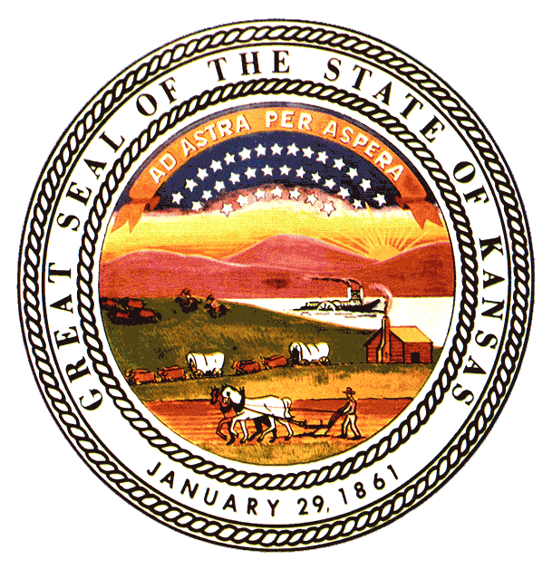
Contact Information:
Ivan L. Weichert
GIS Director
Kansas Information Technology Office
900 SW Jackson ST
Room 751
Topeka KS 66612-1275
Phone: (785) 296.0257
Fax: (785) 296.1168
Email: Ivan.Weichert@da.state.ks.us

State GIS Clearinghouse URL: http://gisdasc.kgs.ku.edu
A. Describe your state’s top 3 geospatial accomplishments during the past year:
1. Completed statewide aerial photography acquisition and 1 M DOQQ Production.
2. Established Kansas Mapping Partnership Office (MPO) w/ USGS.
3. Successful pilot project for National Map w/ Arkansas & Missouri.

B. Describe your state’s top 3 geospatial goals for the coming year:
1. Complete 24K NHD Development/Enhancement for statewide coverage.
2. Continue DEM development for Kansas.
3. Improve cross-agency and local government collaboration

C. Describe the 3 most significant geospatial challenges for your state:
1. Securing stable funding source for GIS application and data development.
2. Statewide implementation of existing GIS data standards.
3. Implementation of GIS in rural communities and small local governments.

D. Describe any significant cooperative efforts with Federal, State or Local partners:
Mapping Partnership Office established in Kansas with USGS. Significant involvement with Mid America GIS Consortium on regional level collaboration. Kansas Geospatial Community Commons initiative is dedicated to building vertical and horizontal partnerships across Kansas for data warehousing, sharing and application development.
E. Describe any significant data development activities, innovative applications, cost saving measures, contracts, etc.:
Currently we are working in concert with the Governor’s Budget Efficiency & Savings Team to develop web mapping applications to track the location of and manage state owned assets such as land, buildings, leased space, vehicles and citizen services. This effort continues to identify new partners and opportunities for data and resource sharing across all levels of state government.

F. Please provide the following Information: (enter N/A if not applicable or unknown; also enter a URL if available on the Internet)
1. GIS mission statement: ftp://clone.kgs.ku.edu/gishelp/docs/pbexecorder.pdf
2. GIS Statutory authority: Kansas Governor Bill Graves issued Executive Order No. 2000-07 in 2000, confirming the importance of GIS in the state and establishing expanded control of GIS initiatives under the Kansas GIS Policy Board. (http://da.state.ks.us/gis)
3. GIS Coordinator: Kansas has a full-time GIS Director/Coordinator in the Kansas Information Technology Office, fully integrated into the state’s Division of Information Systems and Communications, operating directly under the Governor.
4. GIS Coordinating Body: The Kansas Geographic Information Systems Policy Board is made up of 27 members appointed by the Governor; from state government agencies (12), local government (5), academia (4), utilities and private sector (3), federal agencies (2), and other statewide entities (1).
5. GIS Personnel Classifications: Kansas has no personnel classifications specific to GIS.
6. GIS Data Distribution Policy: Kansas maintains an FGDC sponsored Data Clearinghouse at our Data Access and Support Center, where all data assets are available to the Public Domain.
7. GIS Data Standards: Kansas GIS policies and data standards are referenced in the GIS Strategic Management Plan, as well as the state’s Information Technology Architecture; available from the DASC at http://gisdasc.kgs.ku.edu/kgcc/docs/index.cfm
8. GIS Budget (including grants, etc.): approximately $500,000/year not including salaries.
9. Other policies, publications, RFP’s, etc.: http://gisdasc.kgs.ku.edu/docs

G. Other comments: (e.g., Has participation in NSGIC benefited your state’s geospatial efforts?)
Participation in NSGIC has enabled Kansas to stay informed and involved in all levels of GIS initiatives, and has resulted in raising the bar in Kansas to continually improve ourselves and our collaborative efforts with others within and outside of Kansas.

KENTUCKY

Contact Information:
Gary R. Harp
Director
Finance and Administration Cabinet /
Commonwealth Office of Technology /
Office of Enterprise IT Policy and Planning /
Division of Geographic Information
21 Millcreek Park
Frankfort, KY 40601
Phone: (502) 573-1450
Fax: (502) 573-1711
Email: garyr.harp@ky.gov

State GIS Clearinghouse URL: http://ogi.ky.gov
A. Describe your state’s top 3 geospatial accomplishments during the past year:
1. Initiation of The Commonwealth Map project
2. Kentucky BaseMap Viewer and KyGeoNet
3. Mine Mapping Project; Address Range Project, Kentucky Landscape Projects, partnership with FSA for 1 meter, leaf-on color imagery (statewide coverage),

B. Describe your state’s top 3 geospatial goals for the coming year:
1. The Commonwealth Map project, Mine Mapping Project Address Range Project, Kentucky Landscape Projects, partnership with FSA for 1 meter, leaf-on color imagery (statewide coverage), Kentucky Watershed Modeling Information Portal, and Height and Flood Plain Mapping projects
2. Setting standards for the collection of address locations and improving the quality of address data collected in IT systems, enhancing the capability of address data to be mapped and analyzed using GIS technology
3. Expanding the use of GIS within governmental agencies for the collection of data and for analytical and decision making purposes

C. Describe the 3 most significant geospatial challenges for your state:
1. Funding
2. Reducing Redundancy and sharing knowledge of what type GIS data is available among the governmental agencies
3. Expanding the use of GIS within governmental agencies for the collection of data and for analytical and decision making purposes

D. Describe any significant cooperative efforts with Federal, State or Local partners:
- The Commonwealth Map /The National Map
- Mine Mapping Project
- Address Range Project
- Kentucky Landscape Projects
- Kentucky Watershed Modeling
- Height Modernization
- Flood Plain Mapping Project
E. Describe any significant data development activities, innovative applications, cost saving measures, contracts, etc.:
Cost Saving Measures:
- Partnership with FSA for 1 meter, leaf-on color imagery (statewide coverage)
- ESRI/Council on Postsecondary Education site license
- Development and Innovative Applications
- The Commonwealth Map
- Mine Mapping Application
- Address Range Application
- Kentucky Landscape Snapshot/Census Projects (NASA grants)

F. Please provide the following Information: (enter N/A if not applicable or unknown; also enter a URL if available on the Internet)
1. GIS mission statement: Facilitate electronic statewide geographic data sharing and its use for better decision making, greater efficiency, and economic vitality.
2. GIS Statutory authority:
- Office (Division) of Geographic Information - KRS 42.630 & KRS 42.650
- Geographic Information Advisory Council - KRS 11.515 & KRS 11.517
3. GIS Coordinator: Gary R. Harp -- Division of Geographic Information
4. GIS Coordinating Body: Division of Geographic Information, Geographic Information Advisory Council
5. GIS Personnel Classifications: Geoprocessing Specialist I, Geoprocessing Specialist II. Geoprocessing Specialist III, Systems Engineer IT, Systems Consultant IT, Systems Technician Specialist IT Data Base Analyst, Systems Analyst Information Services Manager, Director
6. GIS Data Distribution Policy: GIS data can be downloaded for free. If requesting CDs from the Division of Geographic Information, CDs are free to governmental agencies, otherwise there is a charge, typically ranging from $50 - $200 per CD.
7. GIS Data Standards: http://giac.ky.gov/standards.htm
8. GIS Budget (including grants, etc.): The Division of Geographic Information’s budget is approximately $500,000
9. Other policies, publications, RFP’s, etc.:

LOUISIANA

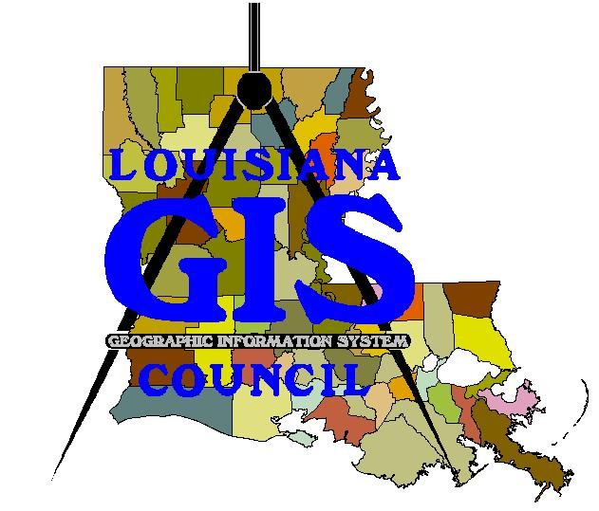
Contact Information:

Joe Holmes

IT Geographic Manager
LA Dept. of Environmental Quality

OMF/IT/GIS Center

602 North 5th Street

Baton Rouge, LA 70802

Phone: 225-219-3348
Fax: 225-219-3374
Email: Joe.Holmes@LA.gov

Alternate:
Craig Johnson
Director
Louisiana Geographic Information Center (LAGIC)
E-313 Howe Russell Bldg.
Louisiana State University
Baton Rouge, LA. 70803
Phone: (225) 578-3479
Fax: (225) 578-7289
Email: cjohnson@lsu.edu

State GIS Clearinghouse URL: Node on the NSDI: http://lagic.lsu.edu/datacatalog
A. Describe your state’s top 3 geospatial accomplishments during the past year:
1. Update of the 1998 DOQQ statewide layer in progress with new orthophotos from 2004 and 2005.
2. Implementation of LouisianaMap a new geospatial portal for Louisiana.
3. Sharing of large geospatial datasets among several state agencies via ArcIMS Internet Servers to ArcMap clients

B. Describe your state’s top 3 geospatial goals for the coming year:
1. Add to the High Resolution NHD coverage for Louisiana.
2. Educate new legislators and executive staff on the importance of geospatial data.
3. Increase the functionality of LouisianaMAP geospatial portal

C. Describe the 3 most significant geospatial challenges for your state:
1. Metadata development by all state Agencies having geospatial data sets.
2. Coordinate imagery acquisitions among federal, state and local governments
3. Find long term funding sources for Louisiana Geographic Information Center (LAGIC)

D. Describe any significant cooperative efforts with Federal, State or Local partners:
- FGDC CAP grants have funded cooperative metadata training programs between LAGIC and the Louisiana Planning Councils, the Louisiana Cooperative Extension and the Baton Rouge City/Parish Planning Committee.
- LAGIC has surveyed GIS Capability among local government, with the cooperation of the Louisiana Assessors Association, the Louisiana Municipal Association and the Louisiana Police Jury Association.
- Louisiana has a history of federal/state cooperation for the acquisition of imagery including the DOQQ program and LIDAR data collection.
E. Describe any significant data development activities, innovative applications, cost saving measures, contracts, etc.:
- The Louisiana Department of Social Services (DSS) used GIS to uncover food stamp fraud, resulting in a large cost savings to both state and federal government.
- The Louisiana State Land Office has saved state government thousands of dollars using GIS to determine the boundaries of state and private lands for acquisition and solving disputed land claims.3) The Louisiana Office of Culture Recreation and Tourism is using GIS in new park site selection and design.

F. Please provide the following Information: (enter N/A if not applicable or unknown; also enter a URL if available on the Internet)
1. GIS mission statement: "Eliminate duplication of effort and unnecessary redundancy in data collections and systems and to provide for integration of geographically-related data bases to facilitate the policy and planning purposes of the state of Louisiana."
(La R.S. 49:1051-1057; Acts 1995, No.922 amended by Act 772 of 2001)
2. GIS Statutory authority: Act 922 of 1995 and amended by Act 772 of 2001.
http://www.doa.state.la.us/lgisc/index.htm
3. GIS Coordinator: LAGIC assists in geospatial data coordination
http://lagic.lsu.edu/
4. GIS Coordinating Body: Louisiana GIS Council http://www.doa.state.la.us/lgisc/index.htm
5. GIS Personnel Classifications: http://www.dscs.state.la.us (Job Specifications: IT Geographic)
6. GIS Data Distribution Policy: Varies by Agency
7. GIS Data Standards: FGDC Data Standards and metadata Standard (CSGDM).
8. GIS Budget (including grants, etc.): varies by Agency
9. Other policies, publications, RFP’s, etc.:
G. Other comments: (e.g., Has participation in NSGIC benefited your state’s geospatial efforts?)
NSGIC participation has benefited the state by providing examples of geospatial “best practices” and alternative methods for creating, updating, funding and maintaining geospatial data.

MAINE

Contact Information:


Dan Walters

GIS Administrator
Maine Office of GIS

145 State House Station

Augusta, Maine 04333-0145

Phone: 207-624-9435
Fax: 207-287-3842
Email: dan.walters@maine.gov

State GIS Clearinghouse URL: http://megis.maine.gov

A. Describe your state’s top 3 geospatial accomplishments during the past year:
1. Established a grant program for towns to digitize parcel maps - $350,000 of grant money from state bond funds will distributed to towns. The data resulting data will be contributed to the GeoLibrary
2. Continued $3 million statewide high resolution color orthoimagery project – 3 year project resulting in color 1 and 2 foot GSD imagery with expected completion in 2006
3. Strengthened enterprise GIS including central pool of GIS licenses – enterprise geospatial library with integrated internet mapping capabilities and clearinghouse functions; agencies continue to contribute agency GIS licenses to central pool.

B. Describe your state’s top 3 geospatial goals for the coming year:
1. Coordinate activities of state agencies with TIGER modernization – emphasis will be put on working with Maine DOT and E911 to coordinate road centerline development with the Census Bureau as well as make new high resolution orthos available for improving accuracy.
2. Full involvement with FEMA Map Modernization
3. Finalize core internet map services and registration with USGS

C. Describe the 3 most significant geospatial challenges for your state:
1. Developing funding model to pay for enterprise GIS including data storage and the geospatial clearinghouse – setting fees for use of enterprise infrastructure that also supports public and private sector activities continues to be a problem. The cost of storing imagery in a robust environment capable of serving many sectors is a particular problem that needs to be resolved.
2. Coordinating multiple data development projects involving municipalities – digitizing parcel maps, production of DFIRMS and orthoimagery

D. Describe any significant cooperative efforts with Federal, State or Local partners:
- Joint funding agreements with USGS to develop DEMs, aerial photography and high resolution orthoimagery
- Joined the DHS FEMA Cooperative Technical Partner program and received grant to begin the preparation of DFIRMS
- Coordinating statewide land cover project with NOAA and USGS

E. Describe any significant data development activities, innovative applications, cost saving measures, contracts, etc.:
- Data development – orthoimagery, DEMs, DFIRMS, land cover (see above)
- Applications – base map and orthoimagery IMS viewers

F. Please provide the following Information: (enter N/A if not applicable or unknown; also enter a URL if available on the Internet)
1. GIS mission statement::
GIS Executive Council Strategic Plan
http://megis.maine.gov/executive/ecstratplanfin2.doc
Maine Library of Geographic Information legislation http://janus.state.me.us/legis/ros/lom/lom120th/4pub601%2D650/pub601%2D650%2D48.htm)
2. GIS Statutory authority: search on GIs to view all relevant legislation
http://janus.state.me.us/legis/ros/meconlaw.htm
3. GIS Coordinator: Dan Walters
4. GIS Coordinating Body: GIS Executive Council http://megis.maine.gov/executive/;
Maine Library of Geographic Information Board http://www.maine.gov/geolib/
5. GIS Personnel Classifications:
http://www.informe.org/cgi-bin/bhrsalary/description.pl
6. GIS Data Distribution Policy: http://megis.maine.gov/catalog/
7. GIS Data Standards: http://megis.maine.gov/standards/
8. GIS Budget (including grants, etc.): $500,000
9. Other policies, publications, RFP’s, etc.:

MARYLAND

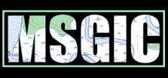
Contact Information:
William S. Burgess
President
BurGIS, LLC
396 Stanford Court
Arnold, MD 21012
Phone: 410-544-2005
Fax: 410-544-4064
Email: William.burgess@comcast.net

State GIS Clearinghouse URL: http://www.marylandgis.net
A. Describe your state’s top 3 geospatial accomplishments during the past year:
1. Development by Towson University of the Emergency Management Mapping Application (EMMA) for use by first responders, emergency managers and other appropriate officials, and their development of the Online Mapping Resource Guide under an FGDC CAP grant as a tool to support EMMA.
2. Development and implementation of a “unified” road centerline project that is being jointly developed, maintained, and shared by the State Highway Administration and local jurisdictions.
3. Use of a common tile scheme and standards for orthophotography and digital elevation models and partnering on joint projects when feasible.

B. Describe your state’s top 3 geospatial goals for the coming year:
1. To identify stable funding sources for joint data development projects which are relevant to state and local agencies (e.g. orthophotography, road centerlines, elevation, cadastre).
2. Provide appropriate educational opportunities for all MSGIC members to support full implementation of OGC’s standards and to achieve a truly interoperable enterprise between all levels of government.
3. Achieve more effective GIS coordination activities by implementing additional features of the NSGIC Model State Coordination Criteria.

C. Describe the 3 most significant geospatial challenges for your state:
1. Maintaining an “all volunteer” GIS coordination structure that is effective and relevant to the needs of all stakeholder groups.
2. Working without stable funding sources and facing continual budget and personnel cuts.
3. Working outside of the existing information technology infrastructure in the state, because GIS is still not viewed as a part of the State’s IT program.

D. Describe any significant cooperative efforts with Federal, State or Local partners:
Towson University led an effort to pull together state and local data resources into a common OGC-compliant Internet mapping system that is accessible only by the first responder and emergency management communities. They named this system EMMA (Emergency Management and Mapping Application) and have incorporated a standards-based approach to making it interoperable with incident management systems which helps provide effective communication and incident management between all levels of government during an emergency event. Future applications development and system features are being driven by a user needs process that involves the affected communities.

E. Describe any significant data development activities, innovative applications, cost saving measures, contracts, etc.:
- The State Highway Administration, Department of Natural Resources and Maryland Department of Planning eliminated access restrictions to most (or all) of their publicly accessible GIS data and created online systems to make their data readily available.
- The State Highway Administration has formed effective partnerships with many local jurisdictions to create and maintain a single road centerline file built on a common standard that includes features such as linear referencing, dynamic segmentation and addressing. This partnership will be extended to all local jurisdictions in Maryland.
- The Department of Natural Resources with assistance from the NOAA Coastal Services Center is partnering with many local jurisdictions on the production of LIDAR digital elevation models to meet FEMA’s Appendix A requirements. By using a prime contractor and working with subcontractors for each phase of the project, DNR has been able to keep the costs below $400 per mile² in the coastal plain, which is well below the national average. NOAA is posting Maryland’s data to the Internet using their LIDAR Data Retrieval Tool (LDART). This eliminates the burden on the State of developing and managing a similar capability.
- The State GIS Committee adopted a tile schema and production standards that are being increasingly used by state and local agencies for the production of LIDAR DEM’s and orthophotography.

F. Please provide the following Information: (enter N/A if not applicable or unknown; also enter a URL if available on the Internet)
1. GIS mission statement: MSGIC’s mission is to promote the coordinated development and efficient use of human and financial resources between and among all entities involved in the collection and/or use of spatial data and GIS.
2. GIS Statutory authority: Not Applicable
3. GIS Coordinator: Not Applicable
4. GIS Coordinating Body: Maryland State Geographic Information Committee
5. GIS Personnel Classifications: Not Applicable
6. GIS Data Distribution Policy: Various by agency and county.
7. GIS Data Standards: http://www.msgic.state.md.us
8. GIS Budget (including grants, etc.): Not Applicable
9. Other policies, publications, RFP’s, etc.: http://www.msgic.state.md.us

G. Other comments: (e.g., Has participation in NSGIC benefited your state’s geospatial efforts?)
Yes - By being actively involved in NSGIC, Maryland stays informed about important national issues and programs. NSGIC also provides a forum for making critical contacts with the leaders in the geospatial industry to keep abreast of general issues and work openly with our peers.

MASSACHUSETTS

Contact Information:
Christian Jacqz
Director
MassGIS, Exec. Office of Environmental Affairs
251 Causeway St.
Boston, MA 02114
Phone: 617 626 1056
Fax: 617 626 1249
Email: Christian.Jacqz@state.ma.us

State GIS Clearinghouse URL: http://www.mass.gov.mgis
A. Describe your state’s top 3 geospatial accomplishments during the past year:
1. Software: Rolled out general purpose map viewer (OLIVER) built on Open GIS Consortium web services architecture.
2. Coordination: Instituted statewide MOU for cooperation between Regional Planning Agencies and state GIS program.
3. Data: Collected .025 and 0.5 meter digital sensor ortho imagery with IR band for a small area as prototype for next year statewide flight, cooperative project between Exec. Offices of Environmental Affairs and Transportation. Other data development described below.

B. Describe your state’s top 3 geospatial goals for the coming year:
1. Software: Standardize GIS data review and data entry via the web, again based on OGC web mapping standards.
2. Coordination: Execute agreement between DOT, MassGIS and Statewide Emergency Telecom Board to maintain and improve geocoding database for all addresses in the Commonwealth.
3. Data: Fly statewide color ortho based on this year’s pilot.

C. Describe the 3 most significant geospatial challenges for your state:
1. Lack of funding for coordination, centralized data acquisition and data repository functions – without which there will be even more redundant and wasteful data compilation and many missed opportunities for use of GIS.
2. Dealing with a variety of scales.
3. Lack of awareness of GIS resources (geospatially challenged management!)

D. Describe any significant cooperative efforts with Federal, State or Local partners:
MassGIS is receiving grants from the USGS/GD through Cooperative Topographic Mapping Program for National Map and from NASA through the IAGT for use of remotely sensed data with 3D software tools on the web. We are doing cooperative work with and funding many localities for data development, particularly for tax maps, also funding GIS work by the Regional Planning Agencies on infrastructure and zoning. We have ongoing projects with USGS/WRD on surficial geology and with NRCS on soils. We are looking forward to continued funding from Federal Highway through our DOT for development of statewide roads inventory. We are encouraging cooperative efforts at state level between Department of Public Safety/Emergency Management and Dept. of Public Health on homeland security projects.
E. Describe any significant data development activities, innovative applications, cost saving measures, contracts, etc.:
- Data development: completed first phase of surficial geology/water resources mapping; funded last phase of statewide soils mapping; completed first phase of digital parcel mapping, completed town boundary mapping to 1”=100’ scale; completed conflation of DOT attributes with 1”= 400’ roads mapping;
- Developed ROI analysis for proposed GIS base mapping projects which might be of interest to other states.
- Continued development of web mapping based on Open GIS Consortium API including point update for state facility locations and support for Comprehensive Emergency Management data collection.
F. Please provide the following Information: (enter N/A if not applicable or unknown; also enter a URL if available on the Internet)
All available at http://www.mass.gov/mgis
1. GIS mission statement:
2. GIS Statutory authority:
3. GIS Coordinator:
4. GIS Coordinating Body:
5. GIS Personnel Classifications:
6. GIS Data Distribution Policy:
7. GIS Data Standards:
8. GIS Budget (including grants, etc.):
9. Other policies, publications, RFP’s, etc.:
G. Other comments: (e.g., Has participation in NSGIC benefited your state’s geospatial efforts?)
Haven’t participated much in NSGIC, but we plan to!

MICHIGAN

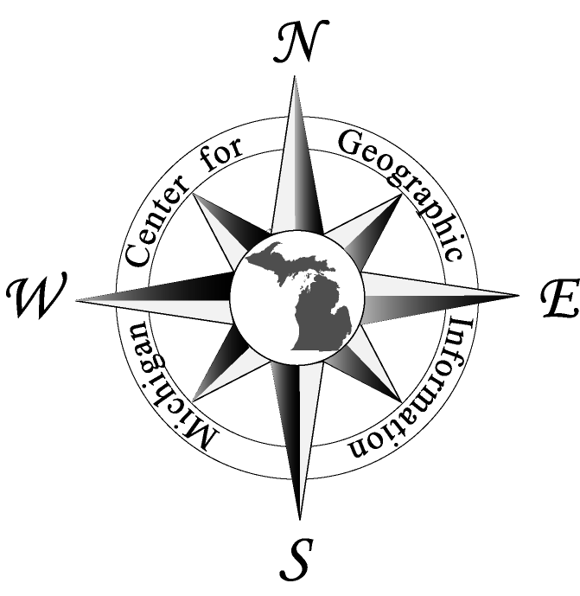
Contact Information:
Eric Swanson
Director, Center for Geographic Information
Michigan Department of Information Technology
111 S. Capitol Avenue
10th Floor Romney Building
Lansing, MI 48933
Phone: 517-373-7910
Fax: 517-373-2939
Email: swansone@michigan.gov

State GIS Clearinghouse URL: http://www.michigan.gov/cgi
A. Describe your state’s top 3 geospatial accomplishments during the past year:
1. Michigan Geographic Framework Version 4 completed and delivered
2. Establishment of the Michigan Homeland Security GIS Advisory Committee
3. Appointed as the “Central Data Agency” for Transportation Asset Management Council

B. Describe your state’s top 3 geospatial goals for the coming year:
1. Complete and Deliver Michigan Geographic Framework Version 5
2. Synchronize EOC efforts with GIS efforts statewide
3. Solidify enterprise “web mapping” technology

C. Describe the 3 most significant geospatial challenges for your state:
1. Staff development/recruitment to rapidly evolving needs
2. Tight budgets
3. Increasing Demands

D. Describe any significant cooperative efforts with Federal, State or Local partners:
Michigan Homeland Security Advisory Committee—composed- 5 state agencies, 4 counties, 2 cities, 1 township, 1 region.
E. Describe any significant data development activities, innovative applications, cost saving measures, contracts, etc.:
Southeast Michigan Regional Ortho acquisition – composition - State, 7 counties, 1 region. Joint funding use—i.e. state share $150K for $1 Million product—everyone wins.

F. Please provide the following Information: (enter N/A if not applicable or unknown; also enter a URL if available on the Internet):
Most can be found at whttp://www.mighigan.gov/cgi
1.GIS mission statement:
2. GIS Statutory authority:
3. GIS Coordinator:
4. GIS Coordinating Body:
5. GIS Personnel Classifications:
6. GIS Data Distribution Policy:
7. GIS Data Standards:
8. GIS Budget (including grants, etc.):
9. Other policies, publications, RFP’s, etc.:
G. Other comments: (e.g., Has participation in NSGIC benefited your state’s geospatial efforts?)
Although Michigan has not been an active NSGIC participant in the past couple of years we look forward to becoming more involved.

MINNESOTA

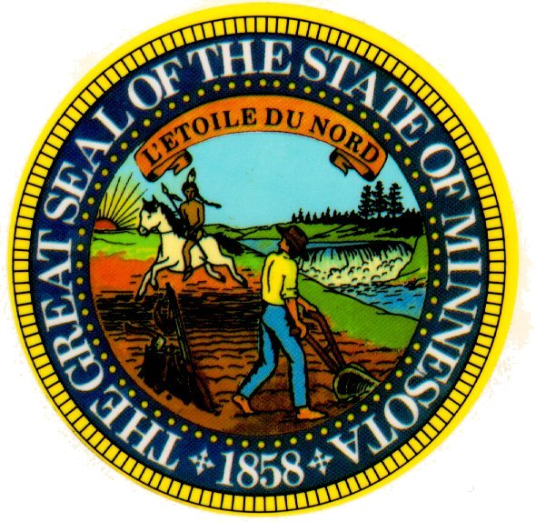
Contact Information:
David Arbeit
Director
Land Management Information Center
Room 300
658 Cedar Street
Saint Paul, MN 55155
Phone: (651) 296-1209
Fax: (651) 296-1212
Email: david.arbeit@state.mn.us

State GIS Clearinghouse URL: http://www.lmic.state.mn.us/chouse/index.html
A. Describe your state’s top 3 geospatial accomplishments during the past year:
- Developed strategic plan for Minnesota GIS, A Foundation for Coordinated GIS: Minnesota’s Spatial Data Infrastructure, as a basis for future organizational and funding initiatives
2. Acquired 2003 orthoimagery for entire state, cooperatively funded by the state and the National Aerial Imagery Program of the Farm Services Agency, and made data available at no cost to users
3. Implemented GIS skills requirement as element of state K-12 education standard for social studies

B. Describe your state’s top 3 geospatial goals for the coming year:
- Gain executive and legislative branch support for recommendations in “A Foundation for Coordinated GIS: Minnesota’s Spatial Data Infrastructure”
2. Complete I-Plans for Minnesota framework data elements
3. Complete development of an integrated web service for data distribution

C. Describe the 3 most significant geospatial challenges for your state:
1. Improving integration among state GIS programs, increasing efficiency and effectiveness
2. Developing and implementing a solution for responsive GIS support for emergencies
3. Sustaining institutional and financial support for statewide coordination

D. Describe any significant cooperative efforts with Federal, State or Local partners:
- Minnesota has been a cooperating partner with the USGS National Mapping Division and other federal agencies for many years through agreements executed by the Land Management Information Center on behalf of the state. Cooperative efforts have focused on data development (orthoimagery, hydrography, soils) and web mapping projects, such as The National Map. The most recent relationship was between Minnesota and the Farm Services Agency; state agencies contributed to a joint project with the FSA to produce color orthoimagery for the entire state. The state has coordinated delivery of the data to users within the state through web services and media distribution.
- The state also participates in regional cooperative programs, notably MetroGIS within the Minneapolis-St. Paul region, and encourages cooperative efforts of local units of government.

E. Describe any significant data development activities, innovative applications, cost saving measures, contracts, etc.:
Although no permanent ongoing source of funding for data development exists within Minnesota. Instead, most data development is undertaken by line agencies to support ongoing business activities. Where special needs have been defined, funding often is sought from operating agencies to meet those needs. A Foundation for Coordinated GIS: Minnesota’s Spatial Data Infrastructure was recently endorsed by the MN Governor’s Council on Geographic Information. It includes recommendations for meeting Minnesota’s GIS needs through organizational changes as well as funding strategies.
F. Please provide the following Information: (enter N/A if not applicable or unknown; also enter a URL if available on the Internet)
1. GIS mission statement: “to promote efficient and effective use of resources by providing leadership and direction in the development, management and use of geographic information in Minnesota.” (http://www.gis.state.mn.us/about.htm#mission)
2. GIS Statutory authority: Executive Order
3. GIS Coordinator: David Arbeit, Director, Land Management Information Center
4. GIS Coordinating Body: Minnesota Governor’s Council on Geographic Information (http://www.gis.state.mn.us/)

5. GIS Personnel Classifications: N/A
6. GIS Data Distribution Policy: Almost all government data is considered public data under the provisions of the Minnesota Data Practices Act. Most government developed geospatial data is available at little or no cost to the public and available through web services. The Minnesota Geographic Data Clearinghouse offers a web portal for search and retrieval of most government geospatial data. See http://www.lmic.state.mn.us/chouse/index.html.
7. GIS Data Standards: Minnesota supports the use of established geospatial technology standards, participates in standards development, and promotes training in standards use. See (http://www.gis.state.mn.us/committe/stand/).
8. GIS Budget (including grants, etc.): No statewide compilation of GIS budgets is maintained. State funding for GIS is budgeted through individual agencies. The budget for the Minnesota Governor’s Council on Geographic Information is about $35,000/year.
9. Other policies, publications, RFP’s, etc.: No formal state GIS policies have been adopted. Many of Minnesota’s GIS products, services and publications are listed at http://server.admin.state.mn.us/Resources.html?Subject=Geographic%20Information%20Systems.
G. Other comments: (e.g., Has participation in NSGIC benefited your state’s geospatial efforts?)
NSGIC is an important venue for state GIS programs and continues to be valuable to Minnesota despite growing difficulty in sustaining active participation resulting from budget limitations and travel restrictions. Despite the diminished capacity to attend scheduled meetings, the information provided through NSGIC is essential. No comparable forum for GIS coordinators exists anywhere.

MISSISSIPPI


Contact Information:
Jim Steil
Director
MARIS (Mississippi Automated Resource Information System)

3825 Ridgewood Road
Jackson, MS 39211-6453
Phone: (601) 432-6354
Fax: (601) 432-6893
Email: Jsteil@ihl.state.ms.us

State GIS Clearinghouse URL: http://www.maris.state.ms.us

A. Describe your state’s top 3 geospatial accomplishments during the past year:
1. Establishment and regular meeting of the new GIS Council
2. Survival of the Executive Council through a gubernatorial election
3. Establishment and regular meeting of the GIS Policy Advisory Committee (PAC) and Technical Users Group (TUG)

B. Describe your state’s top 3 geospatial goals for the coming year:
1. Begin work on a new clearinghouse
2. Data collection (especially high resolution ortho)
3. Standards adoption

C. Describe the 3 most significant geospatial challenges for your state:
1. Funding (lack of)
2. Intra-state partnerships (State & Local)
3. Integration with Homeland Security activities

D. Describe any significant cooperative efforts with Federal, State or Local partners:
The new GIS Council has established executive level state and local cooperation
E. Describe any significant data development activities, innovative applications, cost saving measures, contracts, etc.:
- Statewide hardware & software contracting mechanism
- DFIRM Map-Mod has begun
- Statewide 1:24K contours and 10m DEMs
- 2003 LULC

F. Please provide the following Information: (enter N/A if not applicable or unknown; also enter a URL if available on the Internet)
1. GIS mission statement: N/A
2. GIS Statutory authority: HB861 http://www.ms.gov/frameset.jsp?URL=http%3A%2F%2Fwww.ls.state.ms.us
3. GIS Coordinator: N/A
4. GIS Coordinating Body: Mississippi Coordinating Council for Remote Sensing and Geographic Information Systems http://www.giscouncil.ms.gov/gis/gis.nsf
5. GIS Personnel Classifications: N/A
6. GIS Data Distribution Policy: Currently being developed
7. GIS Data Standards: Currently being developed
8. GIS Budget (including grants, etc.): In kind only
9. Other policies, publications, RFP’s, etc.: Legislative report http://www.giscouncil.ms.gov/gis/gis.nsf/webpage/1_plan/$FILE/Strategic_Plan.pdf?OpenElement
G. Other comments: (e.g., Has participation in NSGIC benefited your state’s geospatial efforts?)
Yes!

MISSOURI


Contact Information:
Tony Spicci
Chair, Missouri GIS Advisory Committee
Missouri Department of Conservation
1110 South College Avenue
Columbia, MO 65201
Phone: 573.882.9909 x3295
Fax: 573.882.4517
Email: Tony.Spicci@mdc.mo.gov

State GIS Clearinghouse URL: http://msdisweb.missouri.edu/ - spatial data clearinghouse
http://www.mgisac.org – Missouri GIS Advisory Committee
A. Describe your state’s top 3 geospatial accomplishments during the past year:
1. Completion of 2nd generation DOQs through NAIP and on-line posting at the state’s spatial data clearinghouse (MSDIS).
2. Incorporation of GIT Standards within the State Architecture framework providing more visibility and policy stature to these standards at the state level.
3. Completion of the Missouri 1:24k National Hydrology Dataset (NHD).

B. Describe your state’s top 3 geospatial goals for the coming year:
1. Development of a statewide street centerline database.
2. Development of a GIT ‘certification’ or educational / training program for Missouri.
3. Building stronger relationships within the local government community and within the broader state/local/federal geospatial community. One area in which we will focus efforts on is in accessing and capitalizing on Homeland Security funding opportunities.

C. Describe the 3 most significant geospatial challenges for your state:
1. Lack of GIS Coordinator Position with contracting and funding authority.
2. Lack of effective coordination between local government and state agencies.
3. Lack of funding for large-scale data development projects such as street centerlines and elevation data.

D. Describe any significant cooperative efforts with Federal, State or Local partners:
GIS pilot projects with county assessors, creation of a Local Government GIS committee and participation from multiple local governments, the local government GIS survey, continued development of USGS National Map Partnerships, development of the Missouri Adaptive Enterprise Architecture – GIT component, participation in MAGIC. Missouri participation in the MO-KS-AR National Map Project, Pursuit of State Mapping Partnership Office with USGS, participation in the Missouri Digital Summit for State and Local Government, Attendance and promotion of statewide user groups, participation in various association meetings within the state.
E. Describe any significant data development activities, innovative applications, cost saving measures, contracts, etc.:
- Missouri Emergency Response GIS (MERGIS) - was developed at the Missouri Department of Health and Senior Services to aid and enhance emergency response through the use of GIS. The initial program, funded by the Center for Disease Control (CDC), includes a training program for local health officials in GIS, field teams of GIS professionals, and a web mapping application. Because the program has grown from a public health application into a statewide GIS Homeland Security solution, the coordination of MERGIS is being transferred to the Missouri Army National Guard and will be funded through grants from the federal Department of Homeland Security. Currently over 100 spatial data layers are available for use in emergency response, and more will be added as other state agencies become involved in the program.. Additionally, Missouri completed a statewide NAIP procurement, the MoRAP River Reach dataset, the CARES elevation data sets, an addressing, centerline, DOQQ and metadata standard.
- The Missouri GIS Advisory Committee was appointed to an ex-officio membership on the State’s Information Technology Advisory Board (ITAB) this year. Finally, the GIT discipline within the Missouri Adaptive Enterprise Architecture (MAEA) was kicked this past year. Development of the GIT discipline will lead to the incorporation of GIT Standards within the State Architecture framework providing more visibility and policy stature to these standards at the state level.

F. Please provide the following Information: (enter N/A if not applicable or unknown; also enter a URL if available on the Internet)
1. GIS mission statement: http://www.mgisac.org/bylaws.htm
2. GIS Statutory authority: N/A
3. GIS Coordinator: no formal position. Tony Spicci currently chairs the Missouri GIS
Advisory Committee
4. GIS Coordinating Body: Missouri GIS Advisory Committee http://www.mgisac.org/
5. GIS Personnel Classifications:
http://www.oa.mo.gov/pers/ClassSpecs/List_G-O.htm#G
6. GIS Data Distribution Policy: data access policy under development, clearinghouse
Distribution policy: http://msdisweb.missouri.edu/services/index.htm
7. GIS Data Standards: http://www.mgisac.org/standards.htm
8. GIS Budget (including grants, etc.): N/A
9. Other policies, publications, RFP’s, etc.:
GIT Architecture - http://oit.mo.gov/architecture/Domains/Information/index.htm
Policies, pubs, etc http://msdisweb.missouri.edu/index.htm or http://www.mgisac.org/

G. Other comments: (e.g., has participation in NSGIC benefited your state’s geospatial efforts?)
Missouri does feel that participation in NSGIC has benefited our state; however it is sometimes difficult to tell to what degree. Certainly the ability to keep pulse of the activities of other states has been beneficial as has been the information exchange. There is a great benefit in participating in NSGIC and we look forward to the future.

MONTANA

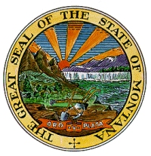
Contact Information:
Stewart Kirkpatrick
GIS Bureau Chief / State GIS Coordinator
MT Dept. of Administration
Information Technology Services Division
P.O. Box 200113
125 N. Roberts
Helena, MT 59620-0113
Phone: 406-444-9013
Fax: 406-444-1255
Email: skirkpatrick@state.mt.us

State GIS Clearinghouse URL: http://nris.state.mt.us/
A. Describe your state’s top 3 geospatial accomplishments during the past year:
1. Drafting and marketing of the Montana Land Information Act – an act to provide stable funding primarily for maintenance of the Montana Spatial Data Infrastructure by increasing the present document recordation fees by $1 per page.
2. Merging several existing GIS technical groups into the Montana Association of Geographic Information Professionals (MAGIP), an association dedicated to education, outreach and the sharing of geospatial technical expertise.
3. Applying for, and actually receiving ODP Homeland Security funding for the building of critical infrastructure databases.

B. Describe your state’s top 3 geospatial goals for the coming year:
1. Passage of the Montana Land Information Act in the 2005 legislature.
2. Receiving additional federal funding to build the MSDI.
3. Building and strengthening the Montana Association of Geographic Information Professionals

C. Describe the 3 most significant geospatial challenges for your state:
1. Obtaining stable state funding for MSDI maintenance
2. Obtaining additional federal funding for MSDI development
3. Getting ALL (not just some) federal agencies to work with state and local partners in non-duplicative efforts to build MSDI

D. Describe any significant cooperative efforts with Federal, State or Local partners:
- The National Map (USGS, Montana State Library, MT DOA/ITSD)
- USGS Grant for Development of a geodatabase model for structures (USGS, Texas, MT DOA/ITSD
- Transportation (road centerlines and addresses) Framework Development (State, Federal, Tribal, Private and Local Government partners
- Critical Infrastructure database development (State, Federal and Local partners)
E. Describe any significant data development activities, innovative applications, cost saving measures, contracts, etc.:
- The Montana Transportation Framework project is aggregating multi-jurisdictional road centerline geometry into a standardized UniTrans geodatabase model. The geometry will be delivered to the U.S. Census Bureau as a state-wide standardized model by September 2005 for inclusion in the Tiger Modernization project. Phase 2 of the project will include attribution including standardized statewide addresses.
- The Homeland Security GIS Taskforce, using ODP funding, is presently collecting several statewide critical infrastructure databases including schools, airports, pipelines, police and fire stations and other emergency facilities. They also funded the collection of high-resolution orthoimagery over 17 Montana cities and towns, using a Montana company, Positive Systems.
F. Please provide the following Information: (enter N/A if not applicable or unknown; also enter a URL if available on the Internet)
1. GIS mission statement: NA
2. GIS Statutory authority: There are several pertinent standards giving IT authority to DOA/ITSD and data distribution authority to the Montana State Library
3. GIS Coordinator: Stewart Kirkpatrick
4. GIS Coordinating Body: Montana Geographic Information Council. http://state.mt.us/itsd/policy/councils/mgic/mgic.asp
5. GIS Personnel Classifications: NA
6. GIS Data Distribution Policy: GIS data falls under the all applicable Montana FOI statutes
7. GIS Data Standards: Montana attempts to use federal standards whenever possible
8. GIS Budget (including grants, etc.): There is no “single” budget for all Montana geospatial endeavors and an attempt to total all relevant budgets has not been attempted.
9. Other policies, publications, RFP’s, etc.: NA
G. Other comments: (e.g., Has participation in NSGIC benefited your state’s geospatial efforts?)
Attempting to coordinate the diverse and expanding geospatial community in Montana, or any state, is almost an impossible job. The assistance and idea sharing I get from other state coordinators, through NSGIC, is invaluable. NSGIC is the single most valuable organization I belong to.

NEBRASKA

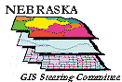
Contact Information:
Larry K. Zink
Coordinator
Nebraska GIS Steering Committee
IMSevices Divison - DAS
P.O. Box 95045
Lincoln, NE 68509
Phone: 402-471-3206
Fax: 402-471-4864
Email: lzink@notes.state.ne.us

State GIS Clearinghouse URL: http://www.dnr.state.ne.us/databank/geospatial.html
A. Describe your state’s top 3 geospatial accomplishments during the past year:
1. Laid organizational and policy framework and began implementation of enterprise geospatial data center for Nebraska
2. Developed “best available” street centerline-address statewide public database for Nebraska combining local, state and federal data
3. Interagency collaborative effort to purchase FSA NAIP Imagery for Nebraska

B. Describe your state’s top 3 geospatial goals for the coming year:
1. Pass legislation establishing a state/local partnership to develop and maintain cadastres as part of a Nebraska Land Information System Program
2. Broaden the Nebraska geospatial data available through the National Map and other interactive map servers
3. Lay policy foundation and complete a pilot project for on-going maintenance of “best available” statewide street centerline-address database

C. Describe the 3 most significant geospatial challenges for your state:
1. Lack of significant general fund budget appropriation or spending authority for GIS Steering Committee
2. Need for increased level of coordination/collaboration between GIS Steering Committee and the folks coordinating enhanced E911 implementation in the state
3. Development of institutional arrangements to support enterprise-wide GIS projects at the state level

D. Describe any significant cooperative efforts with Federal, State or Local partners:
Collaboration between NRCS-USDA, USGS, Nebr. Dept. of Natural Resources, Univ. of Nebraska, Nebraska Dept. of Environmental Quality and others in the development of standardized Watershed Boundary Datasets for Nebraska. Interagency effort involving state, local and federal agencies to purchase statewide copies of the FSA-USDA NAIP 1-meter, color imagery for Nebraska and serve to the broader user community. Collaborative state, local, and university effort to develop “best available” street centerline-address database by incorporating local data into state and federal data.

E. Describe any significant data development activities, innovative applications, cost saving measures, contracts, etc.:
Collaborative interagency effort underway to develop high-resolution NHD for Nebraska and Watershed Boundary Datasets for Nebraska. As noted above a “best available” street centerline-address statewide dataset was developing by combining state, federal and local data. The Nebraska Public Service Commission will be investing significant fund over the next year to develop street centerline-address database for at least half of Nebraska’s counties as part of its enhanced E911 development efforts.

F. Please provide the following Information: (enter N/A if not applicable or unknown; also enter a URL if available on the Internet)
1. GIS mission statement: The mission of the Nebraska Geographic Information System Steering Committee is to encourage the appropriate utilization of GIS technology and to assist organizations to make public investments in GIS technology and geospatial data in an effective, efficient, and coordinated manner.
2. GIS Statutory authority: http://www.calmit.unl.edu/gis/legislation.html
3. GIS Coordinator: Larry K. Zink
4. GIS Coordinating Body: Nebraska Geographic Information System Steering Committee
5. GIS Personnel Classifications: N/A
6. GIS Data Distribution Policy: N/A
7. GIS Data Standards: N/A
8. GIS Budget (including grants, etc.): $160,000
9. Other policies, publications, RFP’s, etc.: Annual Report and Strategic Plan: http://www.calmit.unl.edu/gis/AnnlRpt2003.pdf

G. Other comments: (e.g., Has participation in NSGIC benefited your state’s geospatial efforts?)
NSGIC, and the associated network of state coordinators, has been an on-going significant source for information, guidance, leading, and inspiration as we seek to do our statewide coordinator work here in Nebraska. NSGIC is an irreplaceable resource for people doing the type of work we do.

NEVADA


Contact Information:

Ronald H. Hess
Executive Secretary
State Mapping Advisory Committee/
Information Systems Specialist
Nevada Bureau of Mines and Geology
University of Nevada, Reno
M.S. 178
Reno, Nevada 89557-0088
Phone: 775-784-6691 Ext. 121
Fax: 775-784-1709
Email: rhess@unr.edu

State GIS Clearinghouse URL: http://www.nbmg.unr.edu/geoinfo/geoinfo.htm
A. Describe your state’s top 3 geospatial accomplishments during the past year:
1. First time Digital Orthophoto Quad (DOQ) coverage of all non-military lands in Nevada should be complete by end of year. Nevada will have complete 10-meter Digital Elevation Model (DEM) coverage by end of year.
2. Nevada Department of Transportation is continuing a program to GPS roads and transportation related facilities throughout the State.
3. Creation of an Imagery and Data Compression Subcommittee, under the State Mapping Advisory Committee, to address agency concerns about data and image compression software, distribution of compressed files, policy, and associated costs.

B. Describe your state’s top 3 geospatial goals for the coming year:
1. Work toward completion of large scale hydrography layer for Nevada.
2. Work toward completion of large scale transportation layer for Nevada.
3. The Nevada Bureau of Mines and Geology, Nevada Department of Transportation, Nevada Division of State Lands, the University of Nevada, Reno, and other State and Local agencies will continue to populate the W. M. Keck Earth Sciences and Mining Research Information Center Web Site, housed by the University of Nevada, Reno, with regional and local data sets. Digital maps on this site are available for public download and include DOQs, DEMs, Landsat and ASTER Imagery, DRGs, geologic maps, digital indexes, and various other geoscience, historic, and regional planning related data sets.

C. Describe the 3 most significant geospatial challenges for your state:
1. Ensuring the continued funding of Department of Interior High Priority Mapping Program.
2. Making the next State-wide aerial photography/imagery mission happen.
3. Completion of large scale transportation and hydrography coverages for Nevada.

D. Describe any significant cooperative efforts with Federal, State or Local partners:
Ongoing coordination activities with various DOI agencies to improve overall digital map coverage of the State and to increase the awareness of Federal agencies to identified priorities of local agencies.

E. Describe any significant data development activities, innovative applications, cost saving measures, contracts, etc.:
Continue to work with the University of Nevada, Reno, to develop, maintain and support the W. M. Keck Earth Sciences and Mining Research Information Center Web Site. This site serves as a depository for digital maps which are available for public download and include DOQs, DEMs, Landsat and ASTER Imagery, DRGs, geologic maps, digital indexes, and various other geoscience, historic, and regional planning related data sets.
F. Please provide the following Information: (enter N/A if not applicable or unknown; also enter a URL if available on the Internet)
1. GIS mission statement: To serve as a forum for discussion and coordination of state, local, and federal agency and private sector priorities for mapping within Nevada: http://www.nbmg.unr.edu/smac/smac.htm
2. GIS Statutory authority: N/A
3. GIS Coordinator: N/A
4. GIS Coordinating Body: State Mapping Advisory Committee: http://www.nbmg.unr.edu/smac/smac.htm
5. GIS Personnel Classifications: N/A
6. GIS Data Distribution Policy: N/A
7. GIS Data Standards: N/A
8. GIS Budget (including grants, etc.): N/A
9. Other policies, publications, RFP’s, etc.: For meeting documents see the State Mapping Advisory Committee Web page at http://www.nbmg.unr.edu/smac/smac.htm and for digital map data see the Data depository Web page at http://keck.library.unr.edu/

G. Other comments: (e.g., Has participation in NSGIC benefited your state’s geospatial
efforts?)
Yes, by increasing awareness of various federal mapping programs, funding sources, and cost/work share opportunities. The annual meeting also serves to introduce new and developing technologies such as GeoSpatial One Stop and the National Map as well as address problems such as the lack of a follow-on mission to Landsat. It also allows the States to express their needs and priorities directly to multiple Federal agencies at the same time.

NEW HAMPSHIRE
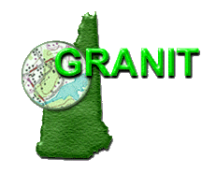
Contact Information: New Hampshire
Ken Gallager
Principal Planner
Office of Energy and Planning
57 Regional Dr.
Concord, NH 03301
Phone: (603) 271-2155
Fax: (603) 271-2615
Email: ken.gallager@nh.gov

State GIS Clearinghouse URL: http://www.granit.sr.unh.edu
A. Describe your state’s top 3 geospatial accomplishments during the past year:
1. Establishing the state GIS portal (GRANIT, at the University of New Hampshire) as a node on Geospatial One-Stop.
2. Encouraging State agencies to adopt metadata standards.
3. Improving coordination with the newly reorganized NH Office of Information Technology Management.

B. Describe your state’s top 3 geospatial goals for the coming year:
1. Establishing blanket GIS software contract for all State agencies.
2. Obtaining new, large-scale orthophotography for all/part of the state.
3. Completing the National Hydrography Dataset state-wide.

C. Describe the 3 most significant geospatial challenges for your state:
1. Establishing secure, stable funding source for State GIS activities, to be aided by an increased awareness at all political levels of the importance of geospatial technology.
2. Continuing efforts to coordinate with the reorganized Office of Information Technology Management, currently hampered by lack of official State GIS coordinator.
3. Maintaining skill levels of the existing GIS personnel scattered among numerous State agencies.

D. Describe any significant cooperative efforts with Federal, State or Local partners
- Growth of NHGCC: New Hampshire GIS Conservation Collaborative (NHGCC), a consortium of State, Federal, regional, municipal, and non-profit GIS professionals, interfacing with private funding organizations.
- Participation of NH GRANIT in multi-jurisdictional cooperative efforts, including:
- FEMA Cooperating Technical Partner;
- Space Grant Partner to support geospatial training;
- Partner in Institute of Applied Geospatial Technologies, to advance use of remote sensing and related technologies at the state and local level..

E. Describe any significant data development activities, innovative applications, cost saving measures, contracts, etc.:
- Innovative applications: the University of New Hampshire Complex Systems Research Center, home of NH GRANIT, has conducted a project to map impervious land surfaces in the coastal New Hampshire region, using subpixel processing techniques applied to Landsat Thematic Mapper (TM) imagery.
- Significant data development activities:
  - raster data archive for land use planning purposes, requiring orthorectification of multi-temporal aerial photography covering 40 years for 2 of the most populous counties;
  - multi-agency imagery acquisition and processing for large timberland transfer to State in the north.

F. Please provide the following Information: (enter N/A if not applicable or unknown; also enter a URL if available on the Internet)
1. GIS mission statement: “The mission of New Hampshire GIS is to promote the efficient use of New Hampshire’s diverse resources by utilizing geographically related information in an effective way and by providing geographic information and corresponding tools to citizens and organizations.” (http://www.nh.gov/oep/resourcelibrary/referencelibrary/g/geographicinformationcenter/documents/gisplan.doc)
2. GIS Statutory authority: NH RSA 4-C:3
3. GIS Coordinator: No official coordinator. Ken Gallager (ken.gallager@nh.gov) hosts GIS Advisory Committee; Fay Rubin (fay.rubin@unh.edu) (UNH-Complex Systems Research Center) coordinates data activities.
4. GIS Coordinating Body: NH GIS Advisory Committee
5. GIS Personnel Classifications: none in effect
6. GIS Data Distribution Policy:
http://www.granit.sr.unh.edu/cgi-bin/load_file?PATH=/data/userguide.html - Section III
7. GIS Data Standards:
http://www.granit.sr.unh.edu/cgi-bin/load_file?PATH=/data/userguide.html - Section II
8. GIS Budget (including grants, etc.):
FY04 budget: $450,000 ($100,000 in core funding, balance in grants/contracts)
9. Other policies, publications, RFP’s, etc.: N.A.
G. Other comments: (e.g., Has participation in NSGIC benefited your state’s geospatial efforts?)
Our lack of an official GIS coordinator has prevented our active participation in NSGIC affairs.

NEW JERSEY

Contact Information:
Bruce Harrison
GIO
NJ Office of GIS
200 Riverview Plaza
P.O. Box 212
Trenton, NJ 08625
Phone: 609.633.0276
Fax: 609.633.0200
Email: bruce.Harrison@oit.state.nj.us

State GIS Clearinghouse URL: http://njgin.nj.gov
A. Describe your state’s top 3 geospatial accomplishments during the past year:
1. Establishment of new GIT governance structure & GIO position
2. Augmentation of the NJ Geographic Information Network (NJGIN) through the establishment of 8 additional local government data nodes. Twelve out of the State’s 21 counties and 2 major cities currently participate on the network.
3. Acquiring Phase 1 funding ($2.5M) in support of a statewide geospatial information architecture and solutions environment.

B. Describe your state’s top 3 geospatial goals for the coming year:
1. Acquiring funding to support a statewide elevation dataset derived from LIDAR and the next round of orthophotography (approx. $5.5M).
2. Augmenting the NJGIN architecture with a minimum of 8 additional data nodes and a municipal government portal environment.3. Beginning the process of re-engineering the State’s tax map process

C. Describe the 3 most significant geospatial challenges for your state:
1. Funding
2. Intergovernmental GIT coordination
3. Balancing information sharing with information security

D. Describe any significant cooperative efforts with Federal, State or Local partners:
- Emergency Preparedness Information Network (EPINet) - OGIS is working cooperatively with the NJ Domestic Security Preparedness Task Force and Office of Attorney General on the development of a comprehensive geospatial information architecture and solutions environment.
- NJ Mapping Assistance Partnership Program (NJMapp) - OGIS is continuing build out the NJ Geographic Information Network (NJGIN) through the state’s incentive based initiative, NJMApp. Originally designed to support the sharing and integration of geospatial information between state and county governments, the NJMapp initiative has now been expanded to support municipal governments.
- FEMA Flood Map Modernization for NJ – FEMA in cooperation with the NJ Department of Environmental Protection and OGIS has developed a business plan for the purpose of supporting a multi-hazard flood map modernization. Through this effort, NJ is working with FEMA on a 35/65% cost share for the development of a statewide elevation dataset derived from LIDAR.
E. Describe any significant data development activities, innovative applications, cost saving measures, contracts, etc.:
- Transportation (State Road Inventory) – NJ Dept. of Transportation is currently completing a statewide GPS roadway inventory. Part of the project also included the development of a transportation data model.
- Hydrography/ Landuse/Landcover – NJ Dept. Of Environmental Protection is currently updating NJ’s hydrography and landuse/landcover using the state’s 2002 hi-res orthophotography.
- NJ Image Warehouse – This web application allows users to find, view and freely download orthoimagery for the entire state. Users can choose either 2002 orthophoto tiles or 1995 USGS quarter quads by selecting the appropriate tab at the top of the page. Visit http://njgin.nj.gov/OIT_IW/index.jsp
- NJ Municipal Government Portal (NJMGP) – This NJMGP effort takes the State NJMapp initiative to the next level by developing partnerships at the municipal government level. NJMGP provides access to municipal government data through a consistent dashboard of web services within a customizable portal environment.
- Transportation (Enterprise License Agreement – Commercial Street Dataset) – In an effort to support the mapping and analysis needs of government in NJ, OGIS in conjunction with the Dept. of Law and Public Safety have procured an enterprise license of a commercial street dataset.
- State GIS Services/Software Contract: http://www.state.nj.us/treasury/purchase/noa/contracts/t1841.shtml
http://www.state.nj.us/treasury/purchase/noa/contracts/t1842.shtml
F. Please provide the following Information: (enter N/A if not applicable or unknown; also enter a URL if available on the Internet)
1. GIS mission statement: http://nj.gov/ogis/gis_office.html2 .
2. GIS Statutory authority: http://www.state.nj.us/infobank/circular/eow122.htm
3. GIS Coordinator: Bruce Harrison
4. GIS Coordinating Body: NJ Office of GIS - http://nj.gov/ogis/
5. GIS Personnel Classifications: Geographic Information Systems Specialist I, II & III - http://www.state.nj.us/personnel/specs/03177.htm
6. GIS Data Distribution Policy: N/A
7. GIS Data Standards: Currently working on metadata, security, data hosting, accuracy and maintenance policies.
8. GIS Budget (including grants, etc.): $4.5M
9. Other policies, publications, RFP’s, etc.: N/A

G. Other comments: (e.g., Has participation in NSGIC benefited your state’s geospatial efforts?)
As NJ’s GIO, I have only been involved with NSGIC for two years. After attending a number of conferences and keeping abreast of events and other member experiences through the listserve, I firmly believe that coordinating GIS at a state level would not be the same without participation in NSGIC. “The power of NSGIC is in the people that participate in it!”

NEW MEXICO

Contact Information:
Amelia M. Budge
Manager, Clearinghouse Services
EDAC, University of New Mexico
MSC01 1110
1 University of New Mexico
Albuquerque, NM 87131-0001
Phone: 505-277-3622, ext. 231
Fax: 505-277-3614
Email: abudge@edac.unm.edu

State GIS Clearinghouse URL: http://rgis.unm.edu
A. Describe your state’s top 3 geospatial accomplishments during the past year:
1. An Executive Order was issued by Governor Bill Richardson to establish the Geographic Data Acquisition Coordinating Committee (GDACC). GDACC’s mission is to assess and coordinate acquisition of aerial and mapping data for New Mexico. Responsibilities include: 1) represent the State’s mapping priorities and requirements; 2) assess, prioritize, and request aerial and mapping data; 3) coordinate aerial and mapping needs with New Mexico’s congressional delegation; and 4) identify funding sources.
2. OSE Enterprise GIS.
3. The New Mexico Geographic Information Council (NMGIC) celebrated its 20th anniversary in 2004, commemorating two decades of GIS cooperation, coordination, and data sharing between all sectors.

B. Describe your state’s top 3 geospatial goals for the coming year:
1. Acquire digital aerials & orthophotos for entire State
2. Upgrade RGIS Clearinghouse capabilities (v.2 under development)
3. Establish a state Mapping Center at RGIS to Improve coordination of geospatial activities between agencies.

C. Describe the 3 most significant geospatial challenges for your state:
1. Coordinating parcel mapping statewide
2. Establish an enterprise GIS effort among three NM state agencies: Office of State Engineer, Environment Department, and Department of Game and Fish.
3. IT Consolidation and Budgetary constraints

D. Describe any significant cooperative efforts with Federal, State or Local partners:
- Federal Geographic Data Committee – cooperative agreement focused on “Metadata Outreach.” This project is: 1) assisting state and local agencies in creating FGDC-compliant metadata; 2) providing metadata training to these agencies, if needed; 3) providing online metadata tools for us by these agencies; 4) serving agency metadata on the RGIS Clearinghouse; and 5) promoting and encouraging development of metadata at state and local meetings.
- Office of State Engineer and Department of Environment joint effort on GIS for water wells
E. Describe any significant data development activities, innovative applications, cost saving measures, contracts, etc.:
- Upgrades to the RGIS Clearinghouse - The team at EDAC has been developing and maintaining web-based data discovery, delivery, and visualization applications using a variety of commercial and open source platforms and applications. The development team built OGC WMS services, and clients based upon those services, using both ArcIMS and Minnesota Map Server, and developed and presented WMS implementation workshops. A planned data registration and registration update system will facilitate data maintenance activity while also allowing for remote data registration by state data provider partners.
- Governor’s IT Consolidation Executive Order that seeks to coalesce IT-related purchasing, personnel, planning, and which will include at least some aspects of GIS in the near-term.

F. Please provide the following Information: (enter N/A if not applicable or unknown; also enter a URL if available on the Internet)
1. GIS mission statement: See GISAC Strategic Plan: http://www.state.nm.us/gisac/docs/GISAC-Plan.pdf.
2. GIS Statutory authority:
- 1987 Executive Order 87-17 establishing NMGIC as coordinating body
- 1999 Information Systems Management Act established ITC and GISAC
- 1999 enacted HB 795 (amended NMSA 7-38-9) for a uniform system of real property description and directed the state Taxation and Revenue Department to promulgate same.
- 2003 Executive Order 2003-018 establishing GDACC.
3. GIS Coordinator: N/A
4. GIS Coordinating Body: Geographic Information Systems Advisory Committee (GISAC)
5. GIS Personnel Classifications: None officially at present, although State Personnel Office study supposedly underway
6. GIS Data Distribution Policy: no formal requirements, distribute through RGIS Clearinghouse
7. GIS Data Standards: Small scale standards; FGDC Content Standards for Metadata
8. GIS Budget (including grants, etc.): No figures at present; IT Consolidation results will provide some indication
9. Other policies, publications, RFP’s, etc.: N/A

NEW YORK

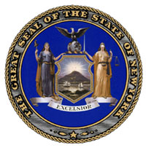
Contact Information:
R. Bruce Oswald
Assistant Director & CIO
NYS Office of Cyber Security
& Critical Infrastructure Coordination
30 S. Pearl St
Floor P2
Albany, NY 12207-3425
Phone: (518) 474-0865
Fax: (518) 402-3799
Email: bruce.oswald@cscic.state.ny.us

State GIS Clearinghouse URL: http://www.nysgis.state.ny.us
A. Describe your state’s top 3 geospatial accomplishments during the past year:
1. Completion of 1st cycle of statewide high-resolution digital orthoimagery for New York.
2. Completion of New York’s first statewide roads and address dataset.
3. Re-Organization of New York State’s GIS Coordinating Body to reflect a wider diversity by including additional representation from local government, the private sector (commercial and not-for-profit) and the federal government.

B. Describe your state’s top 3 geospatial goals for the coming year:
1. Development of a unique spatial data infrastructure to support New York’s Homeland Security efforts.
2. Establishment of a data maintenance program for roads and addressing data.
3. Establishment of a Cadastral Work Group to address cadastral data issues.

C. Describe the 3 most significant geospatial challenges for your state:
1. Obtaining funding for the continuation of the State’s digital orthoimagery program.
2. Building a successful data maintenance program for State and local government.
3. Completion of New York’s GIS Homeland Security application on time and within budget.

D. Describe any significant cooperative efforts with Federal, State or Local partners:
New York State is providing a federated approach to accessibility for its latest GIS Homeland Security application. Using a simple, web based application with no required plug-ins, partners in the State Emergency Management Office, State agencies, New York City and federal agencies have access to the latest, most accurate information. Working with the State Emergency Management Office, New York has undertaken a significant training initiative and rollout to county governments across the State.

E. Describe any significant data development activities, innovative applications, cost saving measures, contracts, etc.:
New York is developing a new spatial data warehouse infrastructure to improve its data management and query capabilities for its GIS homeland security application. Unique in this project is the use of data catalog concept to improve query capabilities for non-normalized data housed in the warehouse. New York is also developing a statewide data improvement training program. This program is being undertaken subsequent to the release of New York’s first statewide roads and address dataset to assist local governments and state agencies in developing more accurate geospatial data for statewide usage. Lastly, New York has initiated a pilot project for local government GIS web hosting. The goal of this project is to demonstrate the benefits of offering GIS web hosting services via state contract to allow local governments to gain access to Internet-based GIS technology at a low cost to make GIS data available to their citizens.
F. Please provide the following Information: (enter N/A if not applicable or unknown; also enter a URL if available on the Internet)
1. GIS mission statement: The NYS GIS Coordinating Body, operating under the auspices of the NYS Office of Cyber Security and Critical Infrastructure Coordination, coordinates, promotes and facilitates the development, effective use, and sharing of geographic information. It also removes barriers to implementing geographic information technology to improve the delivery of public services, protect the public and the environment, and enhance the business climate for the benefit of the State, its municipalities, businesses and citizens. (http://www.nysgis.state.ny.us/gis_nys.htm#mission)
2. GIS Statutory authority: No statutory authority. Please refer to Technology Policy 96-18 (http://www.oft.state.ny.us/policy/tp_9618.htm)
3. GIS Coordinator: Bruce Oswald
4. GIS Coordinating Body: Please refer to: (http://www.nysgis.state.ny.us/reports/cbody/coordbdy_struct.htm)
5. GIS Personnel Classifications: Variety of Civil Service titles used; including Mapping Technician and Mapping Technologist series, Program Technology Analyst series, Computer Programmer/Analyst series, DataBase Programmer series, and other titles.
6. GIS Data Distribution Policy: N/A
7. GIS Data Standards: Datum and Coordinate Std (http://www.nysgis.state.ny.us/datum.htm) and Metadata Std. (http://www.fgdc.gov/metadata/contstan.html)
8. GIS Budget (including grants, etc.): ~ $5-6 million annually
9. Other policies, publications, RFP’s, etc.: New York issued an RFP to provide a data load and update module as well as a new inquiry module to work in conjunction with its new spatial data warehouse infrastructure for its GIS homeland security application.

G. Other comments: (e.g., Has participation in NSGIC benefited your state’s geospatial efforts?)
Participation in NSGIC is an extremely effective method to keep abreast of issues facing GIS Coordinators and practitioners. Contacts that are made in other States through NSGIC serve as great points of reference in addressing State issues as well. Finally, the NSGIC list serve provides a rapid response mechanism to obtain feedback on state coordination problems and solutions being undertaken.

NORTH CAROLINA

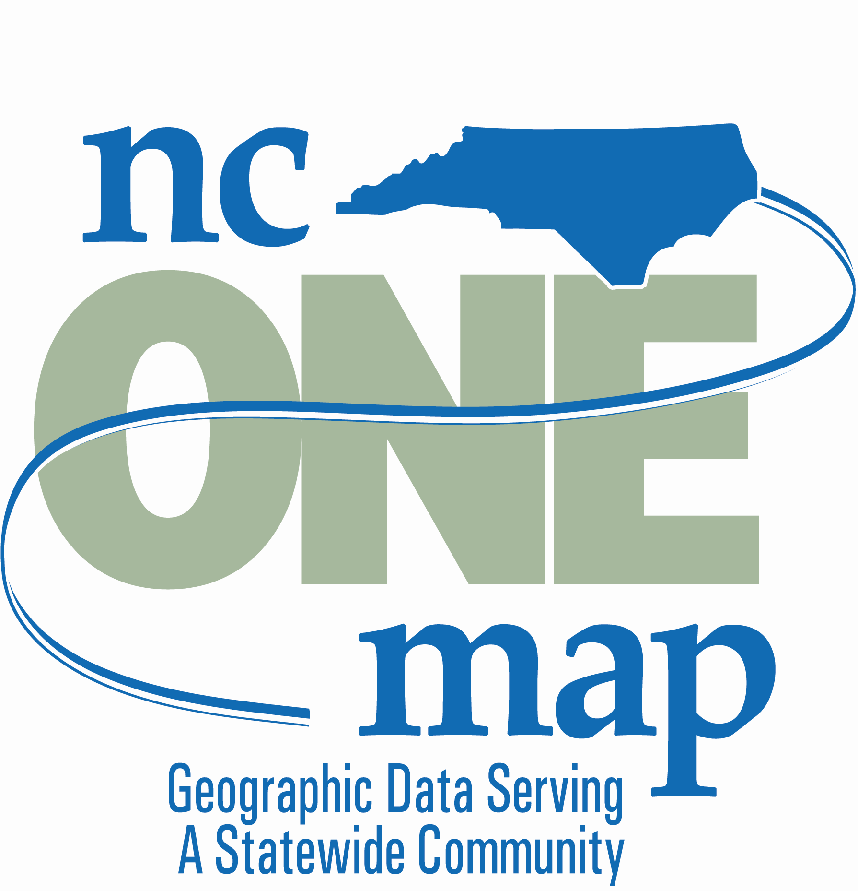
Contact Information:
Zsolt Nagy
Coordination Program Manager
Center for Geographic Information & Analysis
20322 Mail Service Center
Raleigh, NC 27699-0322
Phone: 919-733-2090
Fax: 919-715-0725
Email: zsolt.nagy@ncmail.net

State GIS Clearinghouse URL: http://www.cgia.state.nc.us

A. Describe your state’s top 3 geospatial accomplishments during the past year:
1. The Geographic Information Coordinating Council achieved the initial release of NC OneMap, a geospatial data resource that will connect approximately 50 local government databases by fall 2004. Work has been accomplished in cooperation with the USGS and its National Map initiative. The resulting Internet viewer and data access point is at http://www.nconemap.com
2. A local government data inventory was conducted using an Internet-based survey of all
100 counties and 141 cities. A response rate of over 90% was achieved, leading to valuable insights into the investments made by local governments in geospatial data. The results also show opportunities for data sharing and the potential for making better use of geospatial data for decision making.
3. One project that was particularly successful was the E-NC effort where an Internet map service was integrated with a database on telecommunications service providers. This tool can be found at http://www.e-nc.org

B. Describe your state’s top 3 geospatial goals for the coming year:
1. Increase participation in NC OneMap by more local, state, and federal government agencies through outreach and other means.
2. Complete and implement data content standards for all framework data layers.
3. Acquire sustainable funding for NC OneMap to ensure the ongoing availability of the statewide data resource.

C. Describe the 3 most significant geospatial challenges for your state:
1. Sustained funding for NC OneMap.
2. Identifying partners to support ongoing funding for several key statewide data layers
3. Achieving statewide data coverage by filling gaps in the “quilt” and enabling local government “have nots.”

D. Describe any significant cooperative efforts with Federal, State or Local partners:
There are two current significant efforts in North Carolina that involve Federal, State and local government partners. The first is a major ongoing initiative to update digital flood insurance rate maps (DFIRMs). This effort involves funding and technical support from the Federal Emergency Management Agency (FEMA), the State’s Floodplain Mapping Program Office and several other cooperating State agencies, and local governments who are providing base data deemed “best available” for producing the highest quality background information for the DFIRMs.
The second and most recent effort is the cooperative work between the USGS, the Center for Geographic Information & Analysis, and a number of counties and cities in the implementation of the first release of NC OneMap. This activity is being conducted in a testbed environment to jointly advance the technical work behind both the National Map and NC OneMap initiatives.

E. Describe any significant data development activities, innovative applications, cost saving measures, contracts, etc.:
- Concerning data development, North Carolina continues to move forward with acquisition of LIDAR to support the development of DFIRMs. Approximately 80% of the State has been flown and processed. Federal, state, and local government agencies are benefiting from the availability of this data resource.
- The Geographic Information Coordinating Council is evaluating alternatives for funding statewide aerial imagery to ensure statewide coverage on a consistent basis. All potential combinations of funding sources are under consideration.
- Throughout a grant from NASA, the State is looking at remote sensing techniques for delineation of impervious surfaces. This will meet the needs of a variety of state and local government users.
- Counties in North Carolina are using the LIDAR data generated through the Floodplain Mapping Program to lower their costs by an average of $40,000 in collection/processing of local, high-resolution aerial imagery.

F. Please provide the following Information: (enter N/A if not applicable or unknown; also enter a URL if available on the Internet)
1. GIS mission statement: N/A
2. GIS Statutory authority: NC General Statute §143-725 through §143-727
3. GIS Coordinator: Center for Geographic Information & Analysis
4. GIS Coordinating Body: Geographic Information Coordinating Council
5. GIS Personnel Classifications: GIS Technician, Computing Consultant series
6. GIS Data Distribution Policy: moving toward freely available data over Internet
7. GIS Data Standards: on Internet at http://www.cgia.state.nc.us/gicc/standards
8. GIS Budget (including grants, etc.): $1.5 million for CGIA, but much larger statewide
9. Other policies, publications, RFP’s, etc.: NC OneMap Implementation Plan, 2003 GICC Report to Governor and General Assembly, 2004 GICC Report to Governor and General Assembly
G. Other comments: (e.g., Has participation in NSGIC benefited your state’s geospatial efforts?)
NSGIC helps focus the dialog on issues that are of interest to North Carolina and in
relation to national priorities.

NORTH DAKOTA

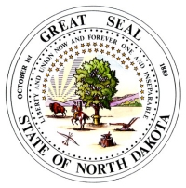
Contact Information:
Bob Nutsch
GIS Coordinator
Information Technology Department, State of North Dakota
600 East Boulevard Ave.
Dept. 112
Bismarck, ND 58505
Phone: 701-328-3212
Fax: 701-328-3000
Email: bnutsch@state.nd.us

State GIS Clearinghouse URL: http://www.discovernd.com/gis
A. Describe your state’s top 3 geospatial accomplishments during the past year:
1. Multiple applications have been and continue to be developed for the GIS Hub. For example: Sales Tax Rates, Road Conditions, Road Load Limits, Road Construction.
2. Improved vector downloading.
3. Increased awareness by state agencies of the GIS Hub infrastructure and its utility.

B. Describe your state’s top 3 geospatial goals for the coming year:
1. Begin a state-wide road centerline project.
2. Increased GIS budget.
3. Update state-wide 10-meter DEMs.

C. Describe the 3 most significant geospatial challenges for your state:
1. Obtaining funding for data development.
2. Continued development of partnerships with local government.
3. Completion of the state-wide road centerline project that will soon begin.

D. Describe any significant cooperative efforts with Federal, State or Local partners:
We have received a grant from the USGS to deploy OGC-standard Web Map Services. The state has been meeting with city and county governments to discuss data sharing and other opportunities.
E. Describe any significant data development activities, innovative applications, cost saving measures, contracts, etc.:
A vendor will soon be selected for collection of highly accurate state-wide road centerlines to be used for emergency response and other uses.
F. Please provide the following Information: (enter N/A if not applicable or unknown; also enter a URL if available on the Internet)
1. GIS mission statement: "The State of North Dakota's GIS Hub will provide the essential infrastructure to share core geographic datasets through an accessible data warehouse among Stakeholders with browsing ability to the general public. The Hub will leverage the State's existing data, infrastructure and expertise to implement the core elements of this enterprise solution." and see http://www.discovernd.com/gis
2. GIS Statutory authority: http://www.state.nd.us/gis/about/enabling/
3. GIS Coordinator: Bob Nutsch, Information Technology Department. Please visit http://www.state.nd.us/itd/about/ then click on the ‘ITD Personnel Flow Chart link to see how GIS fits in.
4. GIS Coordinating Body: http://www.state.nd.us/gis/about/gistech/index.html
5. GIS Personnel Classifications: Visit http://www.state.nd.us/hrms/comp/index/classes.asp and in the title search field, type in ‘geographic’ without the quotes.
6. GIS Data Distribution Policy: We are an open records state
7. GIS Data Standards: Under development, please visit http://www.state.nd.us/gis/resources/standards/
8. GIS Budget (including grants, etc.): We are general funded; we have been operating on less than $750,000 per biennium but we hope to increase that for the 2005-2007 biennium.
9. Other policies, publications, RFP’s, etc.

G. Other comments: (e.g., Has participation in NSGIC benefited your state’s geospatial efforts?)
Being a member of NSGIC has been very beneficial to our state.

OHIO

Contact Information:

Stu Davis
Administrator
Enterprise Shared Services
Service Delivery Division
Ohio Office of Information Technology
77 South High Street, Room 1990
Columbus, Ohio 43215
Phone: 614-466-4747
Fax: 614-728-5297 fax
Email: stu.davis@ohio.gov

State GIS Clearinghouse URL: http://metadataexplorer.gis.state.oh.us/metadataexplorer/explorer.jsp

A. Describe your state’s top 3 geospatial accomplishments during the past year:
1. Launch of the Location Based Response System (LBRS) - The Location Based Response System is a statewide program that establishes partnerships between state and local government for the creation and maintenance of locally generated high-resolution spatial data. The initial emphasis is to create a high-resolution street centerline layer with address ranges and site-specific address points for the entire state. To date we have initiated 6 pilot projects across the state, these pilots will help determine the requirements for data sharing and the partnership agreements in the form of a Memorandum of Agreement.
2. GIServOhio - Established a spatial data server for data discovery and distribution incorporating web-based mapping services for imagery, vector, and FGDC compliant metadata. This includes the Ohio County GIS profiles with future integration with the RAMONA project. Services supported through the GIServOhio are enterprise geocoding, the Streamline Tax Initiative, and Prevention Services.
3. Streamline Sales Tax Project (SSTP) – Working with the Department of Taxation to develop a solution for sales, school district, property and municipal tax determination across the web.

B. Describe your state’s top 3 geospatial goals for the coming year:
- Cultural Boundary Development – Cultural boundaries (School and Tax Districts, Municipal boundaries, Fire Districts, etc.) are the next step in the process of parcel development, using local government data to create boundaries that depict a more accurate and maintained representation of reality than existing data that was created from federal sources.
- Continuation of the Location Based Response System (LBRS) – Continued roll out of this partnership program with local government.
- Strategy for statewide parcel development – Various state initiatives have elevated the need for parcel-based information to support taxation, education, agriculture, and homeland security. Ohio will be working with state and county officials to develop a statewide parcel fabric that includes parcel boundaries and characteristics.
- Continued population of the GIServOhio – Continue to add datasets to increase the speed of discovery, determination and access to relevant data to support federal, state and local government, the private sector as well as the citizens of Ohio.

C. Describe the 3 most significant geospatial challenges for your state:
- Funding – Identifying, locating obtaining and sustaining funding as well as aligning funding for multi-agency and multi-governmental initiatives.
- Institutional issues – Continue to tip-toe around “turf” issues.
- Moving quickly – Moving quickly at all levels of government is a relative term. Our ability to strike on issues while they are hot is difficult within government constructs.

D. Describe any significant cooperative efforts with Federal, State or Local partners:
The Location Based Response System (LBRS) is a partnership with local government and the state for the development of a consistent, high-resolution centerline with site address and address ranges to support emergency response, public safety and economic development. This has a significant impact on numerous statewide projects, such as the Multi-Agency Radio Communications System (MARCS), Department of Transportation’s Road Inventory program, Ohio Disease Reporting System to name a few.
E. Describe any significant data development activities, innovative applications, cost saving measures, contracts, etc.:
Several data development activities are associated with the LBRS and Streamline Sales Tax initiatives. These include centerlines, cultural boundaries and the creation of an imagery server and application to locate images by address to support the Ohio Emergency Management Agency.

F. Please provide the following Information: (enter N/A if not applicable or unknown; also enter a URL if available on the Internet)
The majority of requested information can be found on the OGRIP website. http://www.das.ohio.gov/itsd/ess/ogrip
G. Other comments: (e.g., Has participation in NSGIC benefited your state’s geospatial efforts?)
Being involved with NSGIC has been extremely beneficial to Ohio. It has provided significant weight to Ohio’s voice on issues ranging from the DOQQ program to coordination. We have had an impact on federal/national initiatives and policies that are more supportive of state government and spatial coordination. Ohio has benefited from interacting with other state coordinators and their program directives and activities. We consider NSGIC as the sounding board for a variety of our statewide initiatives. Membership in NSGIC is well worth the expense and Ohio would strongly urge all states to participate as a member.

OKLAHOMA


Contact Information:
Mike Sharp
Director Information Technology
Oklahoma Conservation Commission
2800 N. Lincoln Blvd., Suite 160
Oklahoma City, OK 73105
Phone: 405-521-4813
Fax: 405-521-6686
Email: mikes@okcc.state.ok.us

State GIS Clearinghouse URL: http://www.geo.ou.edu/ (Maintained by Geo Information Systems at the University of Oklahoma in support of the State GIS Council activities.)
A. Describe your state’s top 3 geospatial accomplishments during the past year:
1. Developed & passed legislation to establish an Office of Geographic Information and a position of State Geographic Information Coordinator.
2. Brought legislative definition to the authority and scope of the State GIS Council, increasing membership to include local (city and county) representation.
3. Became a partner in the USGS National Map initiative.

B. Describe your state’s top 3 geospatial goals for the coming year:
1. Establish a funding source for the Geographic Information Office and Coordinator position.
2. Conduct a search and fill the position of State Geographic Information Coordinator.
3. Initiate a standardized centerline program for the State.

C. Describe the 3 most significant geospatial challenges for your state:
1. Funding.
2. The long-term consequences of not having a State Coordinator (highly independent programs within local, county, and state agencies).
3. Professional outreach/networking among GIS professionals within the State and outside of the State in the Region and Nation.

D. Describe any significant cooperative efforts with Federal, State or Local partners:
- FGDC grant supported the enhancement of interactive mapping (e.g., the development of WMS capabilities) for the State Clearinghouse web site.
- Became a partner in the USGS National Map program.

E. Describe any significant data development activities, innovative applications, cost saving measures, contracts, etc.:
A synergy has been developed between the address location processing that was developed for the State voter registration system, and the database development required for the State’s participation in the Streamlined Sales Tax (SST) program. By building on the Election system’s existing infrastructure, the Tax Commission has achieved a 95% accuracy rate at a fraction of the cost that other states are incurring for the SST program.

F. Please provide the following Information: (enter N/A if not applicable or unknown; also enter a URL if available on the Internet)
1. GIS mission statement: The current mission statement (which can be found at http://okmaps.onenet.net/mission.htm) is now obsolete given the new legislation. A new one must be developed in the coming year.
2. GIS Statutory authority: HB 2457 from the 2004 Oklahoma Legislature contains the new authorities that are effective November 1, 2004.
3. GIS Coordinator: Pending funding and filling new position. Mike Sharp is the chair of the GIS Council and currently serves in a coordinating capacity.
4. GIS Coordinating Body: Oklahoma State GIS Council (http://okmaps.onenet.net/index.html)
5. GIS Personnel Classifications: None
6. GIS Data Distribution Policy: None
7. GIS Data Standards: None
8. GIS Budget (including grants, etc.): None
9. Other policies, publications, RFP’s, etc.: None

G. Other comments: (e.g., Has participation in NSGIC benefited your state’s geospatial efforts?)
The Oklahoma GIS Community has made significant progress in establishing the processes for effective GIS coordination, and hopefully will be able to continue with that progress in the near future. While Oklahoma’s participation in NSGIC has been minimal, it has proven to be very valuable! The preliminary and final drafts of the NSGIC Model State guidelines provided very important input for the Oklahoma plans as they were being developed, and provided support for the justifications that were presented to key stakeholders in the process. Hopefully one outcome of this progress will be increased NSGIC participation by Oklahoma in future years.

OREGON

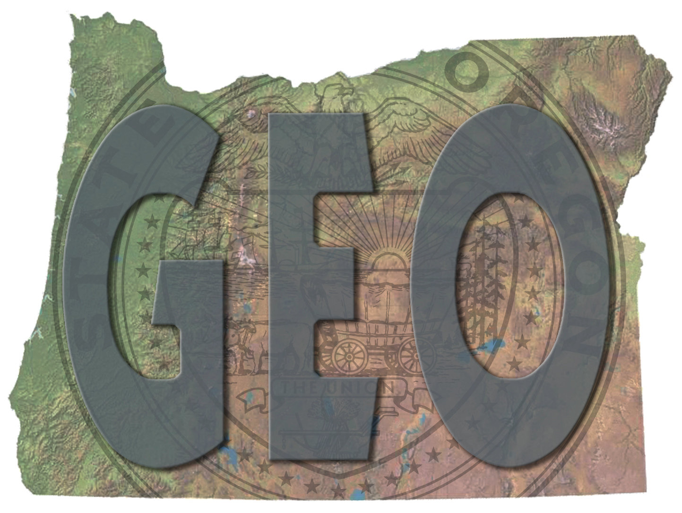
Contact Information:
Cy Smith
Statewide GIS Coordinator
Department of Administrative Services
1225 Ferry St. SE, 2nd Floor
Salem, OR 97301
Phone: 503-378-6066
Fax: 503-373-1424
Email: cy.smith@state.or.us

State GIS Clearinghouse URL: http://www.gis.state.or.us
A. Describe your state’s top 3 geospatial accomplishments during the past year:
1. Data migration: Migrated entire spatial data library to Oracle/SDE and made available via web browser to public and via feature streaming to state agencies using ArcIMS.
- Standards: GIS Community approved, and Council endorsed, three new data content standards for Transportation, Climate, and Elevation; 7 endorsed, 11 more to go.
- Certification: Council approved GIS professional certification plan that endorses the URISA professional certification and recommends that all organizations that share data ensure the quality of that data by certifying at least one person in responsible charge of that data sharing. http://www.gis.state.or.us/coord/ogic/DraftCertificationPlan2.pdf

B. Describe your state’s top 3 geospatial goals for the coming year:
1. Justify significantly larger investment in program ($30M over 6 years) to accelerate Framework data development and implement technology to improve distributed data sharing and processing, and begin implementation of that GIS Utility.
- Complete acceptance and adoption process for several more standards, including Cadastral, Addressing, GeoScience, and Geodetic Control.
- Adopt and implement a data sharing agreement with all governmental entities in Oregon.

C. Describe the 3 most significant geospatial challenges for your state:
1. Data access issues are significantly impeding our ability to share data.
2. Convincing state agencies and the Governor to significantly increase investment in GIS.
3. Coordinating the large volume of data development and web services activity

D. Describe any significant cooperative efforts with Federal, State or Local partners:
Working on MOU with Census to agree to use the same local government data for statewide street centerline and to coordinate with Harris on data development. Asking Council to sign TNM MOU with USGS at September meeting. Developing statewide data sharing agreement with all partners based on national model developed by Open Data Consortium. Council working on requirements analysis for statewide GIS utility. Working with the Interorganizational Resource Information Coordinating Council (http://www.reo.gov/iricc/) to modify their charter to reflect a broader constituency and to become a federal/state regional coordinating body for all geospatial issues in the Pacific Northwest.
E. Describe any significant data development activities, innovative applications, cost saving measures, contracts, etc.:
- Hydrography Clearinghouse, operated by BLM, is operational and provides a mechanism for authorized data providers to check out and edit data for their watershed, and check it back in. BLM, as the state data steward for the Hydro theme, performs quality control on the data before making it available through the Clearinghouse to all users. http://hydro.reo.gov/
- The ORMAP program to develop a statewide cadastral theme is continuing. A $1 fee per real estate transaction is administered by the Dept. of Revenue and provides grants to counties and regional cooperatives to develop data. http://www.ormap.com/
- The Transportation Framework Committee is on pace to complete a statewide street centerline, following an agreed upon data model, by December 2005, based on local, state, regional, tribal, and federal data. ODOT will operate a clearinghouse, following the hydro model, and be the data steward.
- Completed DOQ coverages for 1995 and 2000 vintages and working with FSA and numerous partners to fund 1m color DOQ statewide coverage for 2005.

F. Please provide the following Information: (enter N/A if not applicable or unknown; also enter a URL if available on the Internet)
1. GIS mission statement: http://www.gis.state.or.us/
2. GIS Statutory authority: Executive Order only http://www.gis.state.or.us/coord/ogic/eo00_02.pdf
3. GIS Coordinator: Cy Smith
4. GIS Coordinating Body: Oregon Geographic Information Council http://www.gis.state.or.us/coord/OGIC.html
5. GIS Personnel Classifications: N/A
6. GIS Data Distribution Policy: N/A
7. GIS Data Standards: http://www.gis.state.or.us/coord/standards.html
8. GIS Budget (including grants, etc.): ~$1.6M/biennium
9. Other policies, publications, RFP’s, etc.: http://www.gis.state.or.us/
G. Other comments: (e.g., Has participation in NSGIC benefited your state’s geospatial efforts?)
Absolutely! Sharing ideas, documents, concepts, etc., with other states through NSGIC is a tremendous benefit. An even greater benefit is the leadership and coordination NSGIC provides on all our behalf on national geospatial issues, including standards, federal initiatives coordination, and NSDI/Framework.

PENNSYLVANIA

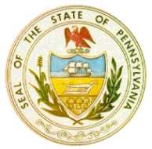
Contact Information:
Jim Knudson
Director
Bureau of Geospatial Technologies
Office of Administration
Office for Information Technologies
210 Finance Building
Harrisburg, PA 17120
Phone: 717-346-1538
Fax: 717-787-4523
Email: jknudson@state.pa.us

State GIS Clearinghouse URL: http://www.pasda.psu.edu
A. Describe your state’s top 3 geospatial accomplishments during the past year:
1. Hired full-time State GIS coordinator, created Bureau of Geospatial Technologies in CIO’s office
2. New Governance Model for Geospatial Technologies – Executive, Steering, Users
3. Received Homeland Security Grant for Real-Time Weather GIS

B. Describe your state’s top 3 geospatial goals for the coming year:
1. Enterprise GT Data Architecture for agency data sharing and implementation of OGC web mapping services
2. PAMAP Imagery for 1/3 of state counties
3. PA Geospatial Data Sharing Standards (PGDSS) and state/local collaboration

C. Describe the 3 most significant geospatial challenges for your state:
1. Sustainable funding
2. Federal partners not coordinating efforts, not sharing data
3. Thin complement for GT staffing levels in agencies

D. Describe any significant cooperative efforts with Federal, State or Local partners:
- USGS liaison established
- Hope to work with DHS on Geospatial Enterprise Architecture
- Commonwealth Enterprise GT initiatives are targeting state and local governments and first responders
- PAMAP imagery program with counties
- PGDSS
E. Describe any significant data development activities, innovative applications, cost saving measures, contracts, etc.:
- PAMAP Imagery
- Enterprise GDT license possible
- Enterprise GT Data Architecture project – fault-tolerant, distributed servers at Enterprise Server Farm, all data stored once, published regularly by agency data stewards, consumed by all users/applications from official data location, served out also by OGC compliant web mapping services
- Enterprise Geocoder
- Enterprise Routing Server
- Enterprise Weather Project

F. Please provide the following Information: (enter N/A if not applicable or unknown; also enter a URL if available on the Internet)
1. GIS mission statement: The Bureau of Geospatial Technologies will provide leadership and coordination to agencies and other Commonwealth extended enterprise partners to:
break down the barriers that exist in geospatial information sharing, create data standards, improve operational efficiencies, reduce duplication of efforts, build enterprise assets, and reduce overall cost of operations.
2. GIS Statutory authority: Governor’s Executive Order
3. GIS Coordinator: Jim Knudson
4. GIS Coordinating Body: GT Advisory Committee (GTAC - executives), GT Steering Committee (GTSC – IT/GIS Coordinators, external ad hoc members), GT Council (GTC users)
5. GIS Personnel Classifications: No, not likely. Probably a compromise to include GIS/GT skills as part of most common current IT and business classifications
6. GIS Data Distribution Policy: Public access from PASDA clearinghouse
7. GIS Data Standards: Working on Version 1.0
8. GIS Budget (including grants, etc.): $2,500,000 for 2004, not sustainable?
9. Other policies, publications, RFP’s, etc.: Will be working on data policy, security in 2004
G. Other comments: (e.g., Has participation in NSGIC benefited your state’s geospatial
efforts?)
Yes it has. NSGIC is a helpful and beneficial organization, and could be more so if it:
- Facilitated more regional and inter-state exchanges
- Started raising holy hell with federal partners for not cooperating and coordinating with state coordinators and NOT SHARING DATA
- Facilitated a national geospatial data model and standards

RHODE ISLAND

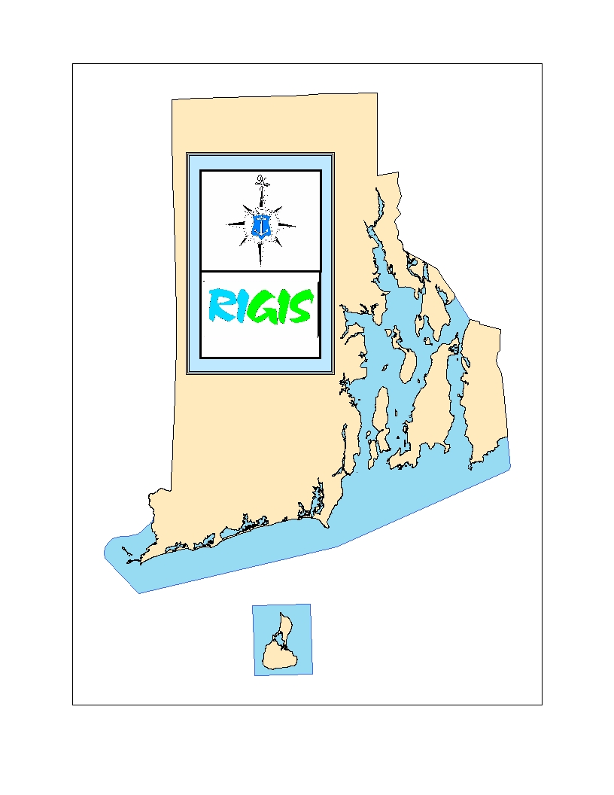
Contact Information:
John Stachelhaus
RIGIS Coordinator
RI Dept. of Administration
Statewide Planning Program-RIGIS
One Capitol Hill
Providence, RI 02908-5872
Phone: (401) 222-6483
Fax: (401) 222-6482
Email: rigis@admin.ri.gov

State GIS Clearinghouse URL: http://www.edc.uri.edu/rigis
A. Describe your state’s top 3 geospatial accomplishments during the past year:
1. Maintained RIGIS Database with inclusion of new and updated data
2. Hosted regional GIS Users Conference for New England, NY and NJ
3. Completed and instituted RIGIS standards for developing municipal digital parcel data.

B. Describe your state’s top 3 geospatial goals for the coming year:
1. Formulate and complete RIGIS Strategic Plan for 2005-2010
2. Implement multi agency hardware/software system for state agency GIS
3. If funding becomes available will initiate actions for developing NSDI/GOS clearinghouse
and web portal.

C. Describe the 3 most significant geospatial challenges for your state:
1. Obtain funding to support overall RIGIS effort
2. Continue to keep higher level managers informed about RIGIS
3. Develop and provide simple public interface for public access to geospatial information

D. Describe any significant cooperative efforts with Federal, State or Local partners:
- Applied for FGDC NSDI CAP award and USDA grant for outreach assistance in 2004
- Awarded IAGT grant for remote sensing application.
E. Describe any significant data development activities, innovative applications, cost saving measures, contracts, etc.:
- Will complete and offer for distribution new statewide color 2’ pixel orthos in 2004-2005
- If funding available will be developing public safety/homeland security critical data in 2004-2005
F. Please provide the following Information: (enter N/A if not applicable or unknown; also enter a URL if available on the Internet)
1. GIS mission statement: The RIGIS mission is to monitor, coordinate, and provide guidance for activities related to the use of geographic information system technology in Rhode Island, to support initiatives to implement or use this technology, and to manage and provide access to a comprehensive database of geographically referenced information. http://www.planning.ri.gov/gis/gishome or http://www.edc.uri.edu/rigis
2. GIS Statutory authority: The RIGIS was legislatively established in 1990 under the General Laws of Rhode Island 44-11 and 16-32. The RIGIS is administered from within Rhode Island Department of Administration and is staffed by the RIGIS Coordinator working from within that state agency. Oversight policy and guidance of the collective efforts of RIGIS participants is formulated by an Executive Committee of representatives from the many organizations using GIS technology in Rhode Island.
3. GIS Coordinator: RIGIS Coordinator, RI Dept. of Administration, Statewide Planning Program, Serves as Executive Secretary of the RIGIS Executive Committee
4. GIS Coordinating Body: RIGIS Executive Committee
5. GIS Personnel Classifications: Within RI Personnel system
6. GIS Data Distribution Policy: All RIGIS Data is distributed under licensing policies from the RIGIS database maintained at the Environmental Data Center at the University of Rhode Island by agreement of RIGIS participants.
7. GIS Data Standards: Digital Data Entry Standards 1990, Adopted FGDC Metadata Content Standards 2000.
8. GIS Budget (including grants, etc.): No central budget. All GIS efforts for agency and local needs are supported only from within individual operating budgets
9. Other policies, publications, RFP’s, etc.: http://www.planning.ri.gov/GIS/GISHomewww.edc.uri.edu/rigis
G. Other comments: (e.g., Has participation in NSGIC benefited your state’s geospatial efforts?)
Some benefits from NSGIC web site and contact list – No recent active participation in NSGIC (no staff, no money, no time).

SOUTH CAROLINA

Contact Information:
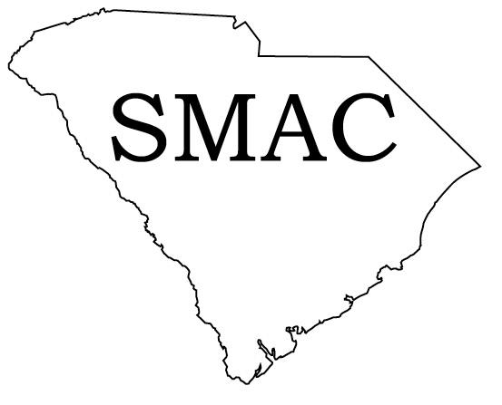
Wm Lynn Shirley
GIS Manager
University of South Carolina
Geography Dept.
Callcott Bldg.
Columbia, SC 29208
Phone: 803-777-4590
Fax: 803-777-4972
Email: lynn@sc.edu

Jim Scurry
Technology Development Section Leader
Dept. of Natural Resources
1000 Assembly Street, Rm. 123
Columbia, SC 29201
Phone: 803-734-9494
Fax: 803-734-8377
Email: scurryj@dnr.statesc.gov

State GIS Clearinghouse URL: There is no central clearinghouse but data are available on multiple servers including:
- Dept. of Natural Resources (http://www.dnr.state.sc.us/water/nrima/gisdata/)
- Dept. of Health & Environmental Control (http://www.scdhec.net/eqc/gis/)
- University of South Carolina (http://www.cla.sc.edu/gis/dataindex.html)
- SC Geodetic Survey (http://www.scgs.state.sc.us/)
- Additional data may be found at numerous county, municipal and local government web sites. Link to individual counties at: http://www.state.sc.us/counties
A. Describe your state’s top 3 geospatial accomplishments during the past year:
1. Renewed initiatives to establish a statewide coordination office.
2. State Mapping Advisory Committee assumed interim role as point of contact for federal geospatial data coordination
3. Transition from NAD83/86 to NAD83/2001 coordinate system by Geodetic Survey provided advanced uses of GPS technology and more accuracy with State Plane coordinates

B. Describe your state’s top 3 geospatial goals for the coming year:
1. Create champions for GIS coordination at all levels of government and industry
2. Establish a single on-line inventory of geospatial data holdings (portal) within the state
3. Implement a virtual reference system for GPS collection

C. Describe the 3 most significant geospatial challenges for your state:
- Overcoming the lack of mandated coordination and the resulting inefficiencies in providing and using spatial information
- Establishing permanent funding sources for foundation geospatial data collection and projects (e.g. ortho acquisition, landcover classification)
- Creating geospatial data sharing mechanisms which work for private and public entities

D. Describe any significant cooperative efforts with Federal, State or Local partners:
Since there is no mandated GIS coordination in South Carolina, there are no state level cooperative efforts that have evolved at this level. Many public agency and private entities have specific cooperative agreements with various agencies at all levels of government and industry to meet their specific geospatial needs. There is also interest in SMAC reaching out to newly formed groups like Carolina URISA and existing groups that have not participated fully in coordination activities in the past ( e.g. City managers, planning officials, assessing officials). SMAC has started to participate in meetings with other organizations to share GIS coordination thoughts to a wider audience. In that role SMAC has presented to a business-focused development group (Carolina Crescent Coalition – Midlands region) on the status of coordination efforts and has planned future presentations to regional and topical users groups through South Carolina.

E. Describe any significant data development activities, innovative applications, cost saving measures, contracts, etc.:
The Office of the CIO is establishing a statewide contract for the purchase of ESRI products for state agencies, regional and local governments as well as K-12 and higher education institutions. In addition, negotiations are continuing on a statewide license agreement for higher education and K-12 participants.

F. Please provide the following Information: (enter N/A if not applicable or unknown; also enter a URL if available on the Internet)
1. GIS mission statement: none
2. GIS Statutory authority: none
3. GIS Coordinator: none in official capacity – Wm. Lynn Shirley (incoming SMAC Chair) servers as contact point for SMAC
4. GIS Coordinating Body: (Interim) SMAC (http://scmapping.net)
5. GIS Personnel Classifications: N/A
6. GIS Data Distribution Policy: N/A – varies by agency
7. GIS Data Standards: various adopted and accepted, including ortho mapping (FGDC std) and street addressing issues.
8. GIS Budget (including grants, etc.): N/A
9. Other policies, publications, RFP’s, etc.:
- GIS Coordination Plan for South Carolina, Volume 1
http://www.scgs.state.sc.us/smac/1134.SP5%20FINAL%20Vol%20I.htm
- GIS Coordination Plan for South Carolina, Volume 2
http://www.scgs.state.sc.us/smac/1134.SP5%20FINAL%20Vol%20II.htm

SOUTH DAKOTA

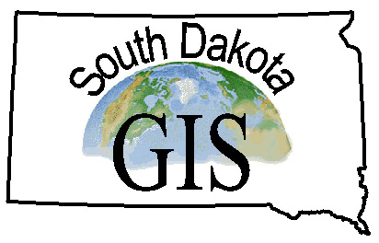
Contact Information:
Erik Nelson
GIS Programmer / Analyst
Bureau of Information and Telecommunication
523 E. Capitol Ave
Pierre, SD 57501
Phone: (605) 773-6701
Fax:
Email: erik.nelson@state.sd.us

State GIS Clearinghouse URL:
A. Describe your state’s top 3 geospatial accomplishments during the past year:
1. State Geological Map completed
2. Lake Oahe imagery available
3. DOT utilizes GIS to publish needs book

B. Describe your state’s top 3 geospatial goals for the coming year:
1. Move from file based to server based GIS data files.
2. GIS data clearinghouse on the web
3. Statewide color aerial photography

C. Describe the 3 most significant geospatial challenges for your state:
1. Interoperability between agencies and various software packages
2. Complete metadata for all GIS data layers
3. Storage space and funding for increased GIS data needs

D. Describe any significant cooperative efforts with Federal, State or Local partners:
- Lake Oahe imagery project: Lake Oahe is a large Reservoir located in North Central South Dakota. Record low water levels have brought to the forefront issues with endangered species, public water access, recreation, archeological sites, and water supply access. A partnership between three state agencies and the Corps of Engineers allowed for the development of high resolution aerial photography and the creation of digital elevation models. These products are being used by the participating entities in analyzing a multitude of physical characteristics.
- K-12 GIS Education Initiative: DECA, BIT, South Dakota State University, South Dakota schools and ESRI, Inc. partnered to provide applied geography data collection and analysis skills to all K-12 schools in the state. DECA purchased a state site license for ArcView GIS software (the state’s GIS standard) that allows the state to provide the software to any school district who completes training and requests the software. BIT also provides a set of base data specifically designed for each school district. Students are instructed in how to acquire field data using global positioning system (GPS) technology. The ultimate goal of the project will be an environment in which state government works with schools to provide "tools and tasks" that can be used in meeting state education standards while state agencies receive accurate location information for needed state data sets.

E. Describe any significant data development activities, innovative applications, cost saving measures, contracts, etc.:
A project initiated by the South Dakota Department of Transportation in cooperation with ESRI was recently completed which converted the South Dakota Highway Needs and Project Analysis Report from Intergraph MGE format to ArcGIS 9.0 format. The Highway Needs document contains information relating to the identification, geometrics, condition of the highway segment including information on asphalt and concrete index values, structures and structural descriptions, traffic, accidents, and programmed improvements among others. The new application is fully operational and was used to create the 700 page document published Spring 2004.

F. Please provide the following Information: (enter N/A if not applicable or unknown; also enter a URL if available on the Internet)
1. GIS mission statement: N/A
2. GIS Statutory authority: N/A
3. GIS Coordinator: Erik Nelson – Acting Coordinator
4. GIS Coordinating Body: Cabinet Level Steering Committee
5. GIS Personnel Classifications: GIS Manager, GIS Programmer/Analyst, Automated Mapping Specialist, GIS Data Clerk
6. GIS Data Distribution Policy: Public Domain
7. GIS Data Standards: Yes
8. GIS Budget (including grants, etc.): N/A
9. Other policies, publications, RFP’s, etc.: http://www.state.sd.us/gis/

TENNESSEE

Contact Information:



Mark A. Tuttle
Director, GIS Services
Finance & Administration, Office for Information Resources
16th Floor, Snodgrass TN Tower
312 8th Avenue North
Nashville, TN 37243-0288
Phone: (615) 741-9356
Fax: (615) 532-0471
Email: mark.tuttle@state.tn.us

State GIS Clearinghouse URL: http://gis.state.tn.us/
A. Describe your state’s top 3 geospatial accomplishments during the past year:
1. Successfully increased funding for the Tennessee Base Mapping Program (TNBMP) from $2.275M to $7.775M for the FY04/05.
2. Working with the TN Department of Personnel, developed 2 GIS Career Service tracks encompassing a total of 11 GIS career classifications.
3. Completed production efforts for the TNBMP for 8 additional counties; successfully developing local partnerships in 6 of 8 counties.

B. Describe your state’s top 3 geospatial goals for the coming year:
1. With the increased funding, commence TNBMP production of 25 of 49 remaining counties.
2. Design, develop, and implement an internet and intranet extensible location service featuring static and on-demand geocoding, as well as agency application plug-in functionality.
3. Begin transition from cover/file-based database design to geodatabase design.

C. Describe the 3 most significant geospatial challenges for your state:
1. Funding

D. Describe any significant cooperative efforts with Federal, State or Local partners:
The fiscal foundation of the TNBMP is a cost share between the State and local governments across the State. The State continues to have significant success in developing local partnerships for the production of the TNBMP data products. The goal of Federal fiscal participation remains unfulfilled.
E. Describe any significant data development activities, innovative applications, cost saving measures, contracts, etc.:
Data Development: The TNBMP, originally scheduled for a five-year completion remains the most dominant data development activity in Tennessee. While the original goal of a 2004 completion is unachievable, the administration’s renewed commitment to the program with a $5.5M funding increase narrows the previous estimated completion to 2007. The TN Department of Economic and Community Development, Office of Local Planning Assistance, has completed the development of Tennessee Flood Map Modernization Business Case calling for all FEMA map modernization efforts in TN to be build on the foundation of the TNBMP produced base map.

F. Please provide the following Information: (enter N/A if not applicable or unknown;
also enter a URL if available on the Internet)
1. GIS mission statement: The mission of the GIS Services Division is to provide the highest possible quality geospatial services to users within the State of Tennessee in a timely fashion as economically as possible. The Division will facilitate the efficient and effective management of the human, cultural, and financial, and natural resources of the State of Tennessee, and its local communities. Geospatial services are defined as technical, management, and administrative consulting, data provision, application development and implementation services of spatial information. (http://gis.state.tn.us/)
2. GIS Statutory authority: N/A
3. GIS Coordinator: Mark Tuttle
4. GIS Coordinating Body: State of TN, Information System Council; Tennessee Geographic Information Council
5. GIS Personnel Classifications: in-development
6. GIS Data Distribution Policy: TCA 10-7-506
7. GIS Data Standards: See TNBMP Technical Specifications at http://gis.state.tn.us/ for Ortho Imagery, base map, and parcel standards.
8. GIS Budget (including grants, etc.): Average $3.7M per year since inception.
9. Other policies, publications, RFP’s, etc.: see http://gis.state.tn.us
G. Other comments: (e.g., Has participation in NSGIC benefited your state’s geospatial efforts?)

TNBMP Status:

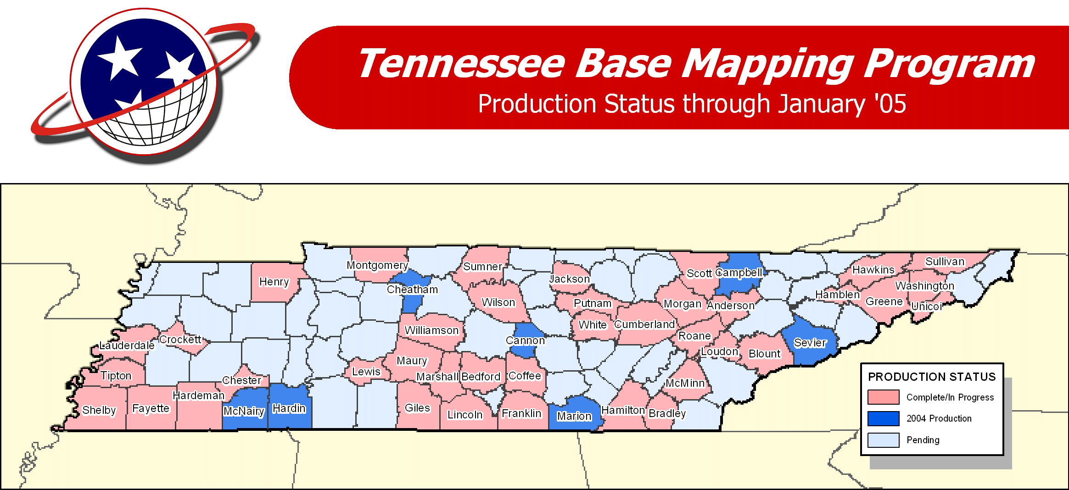

TEXAS

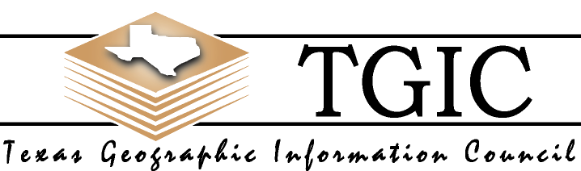
Contact Information:
Michael Ouimet
State GIS Coordinator
Texas Department of Information Resources
P.O. Box 13564
300 West 15th Street, Suite 1300
Austin, Texas, 78711-3564
Phone: 512.305.9076
Fax: 512.475.4759
Email: michael.ouimet@dir.state.tx.us

State GIS Clearinghouse URL: http://www.tnris.state.tx.us

A. Describe your state’s top 3 geospatial accomplishments during the past year:
1. The usefulness of GIS technology for statewide emergency response was clearly demonstrated to state leadership from the response to the Space Shuttle Columbia tragedy in 2003. The shuttle recovery was the largest search effort in the nation’s history and relied extensively on GIS and global positioning system (GPS) technology to locate and map the location of the Space Shuttle materials. In Texas alone, debris was spread over an area exceeding 2,000 square miles. Without the use of GIS and GPS technology the recovery effort could have potentially required many more months and cost millions of dollars more to conduct search operations.
2. The Texas Geographic Information Council (TGIC) completed and submitted its State GIS legislative report/plan – 2004 Biennial Report on Geographic Information Systems Technology to the Texas State Legislature.
3. The Texas Department of Public Safety significantly upgraded the State Operations Center for Emergency Response that included several improvements to its GIS technical capabilities.

B. Describe your state’s top 3 geospatial goals for the coming year:
1. Establish a sustainable funding mechanism to support statewide base mapping needs.
2. Develop better coordination mechanisms between public safety and homeland security officials and the state geospatial community.
3. Coordination of agency resources to implement an enterprise GIS for State government that is aligned with goals established by the Texas Geographic Information Council (TGIC) and the State CIO at the Texas Department of Information Resources.

C. Describe the 3 most significant geospatial challenges for your state:
- Sustainable funding for framework and other base map dataset development.
- Maintaining sufficient staffing levels within state government to manage contract projects and implement technical applications.
- Develop an agreed approach and methodology for statewide street address and 911-address mapping.
D. Describe any significant cooperative efforts with Federal, State or Local partners:
- An effort led by regional councils of government is underway to develop a new geodatabase model suitable for application to E-911 addressing and transportation datasets collected by local, regional, and state agencies.
- The Commission on State Emergency Communications produced a “Best Practices” Document for 911 Street Addressing for the State 911 Districts.
- The Texas Water Development Board (TWDB) has entered into a partnership agreement with the Farm Service Agency for the acquisition of statewide one-meter CIR imagery for Texas for the National Agricultural Imagery Program (NAIP). The Natural Resources Conservation Service and U.S Geological Survey were also funding partners.
- Texas is nearing completion of its 1:24,000-scale high resolution National Hydrography Dataset. TWDB has worked in partnership with U.S. Geological Survey, U.S. Forest Service, U.S. Army Corps of Engineers, and the North Central Texas Council of Governments. Several watersheds that cross Texas borders remain to be done.

E. Describe any significant data development activities, innovative applications, cost saving measures, contracts, etc:
- As a part of its GIS Architecture and Infrastructure project, the Texas Department of Transportation (TxDOT) is developing a web-based data portal that will provide access to all of the agency’s data through either spatial intersect or automated SQL queries.
- In September, TxDOT will implement a GIS-based online Highway Conditions Reporting System that will include hurricane evacuation routes as well as weather conditions and road closures.
- The Texas GIS Clearinghouse (TNRIS) is now providing emergency management and disaster preparedness Internet map services for outside organizations.
- A Crash Records Information System is being developed in collaboration between the Texas Dept. of Public Safety and Texas Dept. of Transportation and will use GIS data and technology to locate and analyze traffic accident data.
- TNRIS is working to scan and rectify historical aerial photography so that it can be used with more recent raster and vector data for historical and planning applications.

F. Please provide the following Information: (enter N/A if not applicable or unknown; also enter a URL if available on the Internet)
- GIS mission statement: http://www.tgic.state.tx.us
- GIS Statutory authority: http://www.tgic.state.tx.us
- GIS Coordinator: http://www.tgic.state.tx.us
- GIS Coordinating Body: http://www.tgic.state.tx.us
5. GIS Personnel Classifications:
6. GIS Data Distribution Policy:
- GIS Data Standards: http://www.tgic.state.tx.us
8. GIS Budget (including grants, etc.):
- Other policies, publications, RFP’s, etc.: http://www.tgic.state.tx.us

UTAH

Contact Information:

Dennis Goreham
Manager
Automated Geographic Reference Center
5130 State Office Building
Salt Lake City, UT 84114
Phone: 801-538-3163
Fax: 801-538-3317
Email: dgoreham@utah.gov

State GIS Clearinghouse URL: http://agrc.utah.gov

A. Describe your state’s top 3 geospatial accomplishments during the past year:
1. Web mapping and data access enhancements: AGRC manages the State Geographic Information Database that contains many layers of geographic data including streets with addresses, political boundaries, homeland security infrastructure, etc. A listing of statewide geographic datasets can be viewed at: http://agrc.utah.gov/sgid/statewide/index.htm.
AGRC developed and manages http://mapit.utah.gov that allows agencies and the public to create their own map pages to embed on web sites or in email to show locations of offices, services, etc. The website contains a gallery of maps created by a variety of public agencies in a statewide index available online, listing map titles, descriptions, and links to traditional and interactive map sites pertaining to the State.
A new ArcIMS interactive map allows the user to view and query the Utah Geographic Names Information System (GNIS) database of over 40000 geographic features in Utah. This application is available at http://www.atlas.utah.gov/gazetteer/.
2. Data acquisitions including NHD and imagery: The state partnered with USGS, Forest Service, and BLM to complete High Resolution NHD. Continued acquisitions of multi-vintage DOQ imagery through USGS, Forest Service, and Farm Service Agency partnerships. AGRC is working with state and local E911 groups to insure standardized state-wide addressed street centerline data is available to local PSAPs for current E911 purposes as well as meeting the FCC wireless requirements.
3. Training for state and local government and teachers: AGRC's training program is focused on increasing the GIS skills of state and local governments, enabling them to better use this technology in their day-to-day activities. It provides them with a local source of technology transfer and support.
The K-12 GIS Coalition has established the GIS Program for K-12 Utah schools and depends on AGRC for coordination of training and making data accessible to the schools. There have been 131 teachers and trainers trained through the Coalition GIS program who will expose thousands of students to GIS this year.

B. Describe your state’s top 3 geospatial goals for the coming year:
1. Institutionalizing data acquisition, integration, and distribution. AGRC is working with the Legislature’s Political Subdivisions Interim Committee to formalize the policies, processes, and technical requirements for data acquisition and sharing through the SGID.
2. Continued web mapping enhancements: AGRC plans further development of an ArcIMS to serve out the layers of the SGID, including an enhanced presence on national portals to complement state IMS services. We anticipate that all DOQs (and other imagery) will be served through a geospatial database available through IMS or other clients.
3. Data acquisition and maintenance: AGRC plans to integrate all GPS data collected over the years into a single Transportation Database. State and federal agencies within the state plan to develop a process for High resolution NHD maintenance. Working with counties, cities, and special districts, AGRC plans to complete metadata on over 800 boundaries, with intent on integrating them into the SGID.

C. Describe the most significant geospatial challenge for your state:
Data currency / accuracy: Data acquisition coordination requires tremendous effort. State, federal, and local resources are expended creating, maintaining, and distributing data. Often these various versions of data are inconsistent and sometimes conflicting. We need to eliminate redundancy in data storage where mechanisms do not exist to insure they are integrated.

D. Describe any significant cooperative efforts with Federal, State or Local partners:
- Data Sharing MOU: Governor Olene Walker and representatives from twelve federal agencies signed a Memorandum of Understanding (MOU) providing a mechanism to cooperatively create and share accurate, impartial and credible digital spatial data.
- Cadastral data: AGRC has worked with the Department of Interior and the rural counties in distributing federal pass-through dollars to the counties for refinement of Public Land Survey System corner positions and encouraging parcel automation. AGRC is coordinating land administration and ownership information with School Institutional Trust Land Administration, the BLM, and the counties that will increase the accuracy of land ownership data.
- Recreation E-gov: AGRC has worked with the national recreation.gov staff to develop prototype web pages for recreation opportunities by county in Utah at http://atlas.utah.gov/cotour/tooele/viewer.htm and at http://utstdp-ims.state.ut.us/website/sanjuan/viewer.htm

E. Describe any significant data development activities, innovative applications, cost saving measures, contracts, etc.: (See A-D above)

F. Please provide the following Information: (enter N/A if not applicable or unknown; also enter a URL if available on the Internet)
1. GIS mission statement: “AGRC mission to encourage and facilitate effective geographic information system implementation in Utah and direct this process in state government”.
2. GIS Statutory authority: TITLE 63A UTAH ADMINISTRATIVE SERVICES CODE: CHAPTER 6 INFORMATION TECHNOLOGY SERVICES : PART 2 AUTOMATED GEOGRAPHIC REFERENCE CENTER, see http://www.le.state.ut.us/~code/TITLE63A/63A06.htm
3. GIS Coordinator: Manager of AGRC
4. GIS Coordinating Body: GIS Advisory Committee
5. GIS Personnel Classifications: N/A
6. GIS Data Distribution Policy: Unless data is classified as sensitive under the guidelines established in the Government Records Access and Management Act (GRAMA), all GIS data the state acquires or creates is public domain.
7. GIS Data Standards: Available at http://agrc.utah.gov
8. GIS Budget (including grants, etc.): Approximately $1,500,000 annually
9. Other policies, publications, RFP’s, etc.: See web site

VERMONT


Contact Information:
David Brotzman
Executive Director
Vermont Center for Geographic Information, Inc
58 South Main Street, Suite 2
Waterbury, VT 05401
Phone: 802-882-3003
Fax: 802-882-3001
Email: davidb@vcgi.org

State GIS Clearinghouse URL: http://www.vcgi.org
A. Describe your state’s top 3 geospatial accomplishments during the past year:
1. Completion of statewide coverage of hydrographic data at 1:5,000 scale to National Hydro Data standards with help from USGS.
2. Development of a Web Mapping application used by Vermont Emergency Management that integrates the state’s geographic data for use in emergency planning and operational response.
3. Completion of a plan for initial implementation of a statewide enterprise GIS involving the State’s agencies and departments that currently use GIS. This plan is supported by the development of our computing infrastructure to meet the needs of managing a distributed data access capacity.

B. Describe your state’s top 3 geospatial goals for the coming year:
1. Increased state government participation in the statewide enterprise GIS.
2. Development of an updated statewide Land Cover /Land Use data set.
3. Continued expansion in the number and sophistication of GIS users in state government offices.

C. Describe the 3 most significant geospatial challenges for your state:
1. Expanding GIS data coordination in the state and moving away from the redundant, unconstrained and expensive data practices of the past.
2. Getting policy makers to recognize the numerous advantages in providing planning and funding for critical GIS data collection work.
3. Maintaining interest in GIS data standards development and support within the GIS community.

D. Describe any significant cooperative efforts with Federal, State or Local partners:
Our office has just completed a three year Cooperating Partnership with USGS to develop the statewide 1:5,000 hydrographic data and we will be participating in the USGS National Map program development this year. We also have a two year contract with our state Agency of Natural Resources, FEMA and USGS to develop flow regime attribution for the statewide hydrography and participate in the National Environmental Information Exchange Network. We are participating in Satellite Imagery acquisition partnerships with the Institute for the Application of Geospatial Technology. With the support of the Vermont Agency of Natural Resources we have initiated the process for inclusion in FEMA’s Cooperating Technical Partner program in support of the flood map modernization in Vermont.
E. Describe any significant data development activities, innovative applications, cost saving measures, contracts, etc.:
The most significant cost saving measure we undertook this year were changes in our healthcare insurance. From the standpoint of GIS and GIS data we have worked very hard organizationally to upgrade our server and computing infrastructure to support an increasingly wide range of web mapping and feature distribution services. All of the effort we have put into our development is in direct support of our long term goal. I am particularly proud that we have been able to accomplish our long term development with very limited funding the last few years. This accomplishment is a credit to the staff at VCGI.

F. Please provide the following Information: (enter N/A if not applicable or unknown; also enter a URL if available on the Internet)
1. GIS mission statement: N/A
2. GIS Statutory authority: http://www.vcgi.org/about_vcgi/default.cfm?page=./bod/statutory_authority.cfm
3. GIS Coordinator: That is the statutory role of our organization.
4. GIS Coordinating Body: http://www.vcgi.org/about_vcgi/default.cfm?page=./tac/default_content.cfm
5. GIS Personnel Classifications: Not available on the Internet and too extensive to
outline here.
6. GIS Data Distribution Policy:
http://www.vcgi.org/about_vcgi/default.cfm?page=./tac/default_content.cfm
7. GIS Data Standards: http://www.vcgi.org/techres/default.cfm
8. GIS Budget (including grants, etc.): VCGI’s total budget every year is ~$500,000.
9. Other policies, publications, RFP’s, etc.: http://www.vcgi.org/commres/

G. Other comments: (e.g., Has participation in NSGIC benefited your state’s geospatial efforts?)
Participating in NSGIC really has benefited our state’s geospatial efforts. The increased intercommunication of the NSGIC membership has raised awareness in opportunities and directions that may have otherwise gone unnoticed. It always helps to be able to have access to the similar experiences of a larger community when planning for the future. While all of the states are different in their own ways it is also true that we all share at least some similarities.
The NSGIC representative, having the weight of the membership behind them, provides a voice in discussions and decisions made in our absence. By speaking with one voice on important state related issues I think our state’s interests are often better served at the Federal level even when we can’t be there to provide our position. Having a wide and active membership also increases NSGIC’s ability to provide influence on issues relating to state interests.

VIRGINIA
Contact Information:
Bill Shinar
State GIS Coordinator
Virginia Geographic Information Network (VGIN)
Virginia Information Technologies Agency (VITA)
110 South 7th Street, Suite 135
Richmond, Virginia, 23219
Phone: (804) 786-8175
Fax: (804) 371-2795
Email: bill.shinar@vgin.virginia.gov

State GIS Clearinghouse URL: http://www.vgin.virginia.gov
A. Describe your state’s top 3 geospatial accomplishments during the past year:
1. Successful grant award ($685,000) to develop an Enterprise GIS for homeland security.
2. Successful distribution of high resolution Virginia Base Mapping Program (VBMP) digital orthophotography to all local jurisdictions in Virginia.
3. Completion of an operational network of 16 regional work groups of local government GIS managers.

B. Describe your state’s top 3 geospatial goals for the coming year:
1. Standing up the Virginia Readiness, Response, and Recovery GIS (VR3)
2. Completing a consistent, seamless, statewide Road Centerline File with attribution and address ranges maintained by local jurisdictions.
3. Establishing an Enterprise GIS and Geospatial One-Stop for state government.

C. Describe the 3 most significant geospatial challenges for your state:
1. Establishing a sustainable funding model for geospatial data
2. Building an efficient enterprise based GIS for state government
3. Dealing with regulatory pressures on photogrammetry services

D. Describe any significant cooperative efforts with Federal, State or Local partners:
- Virginia is building a single, consistent, seamless, statewide road centerline file with address ranges through the cooperative efforts of VGIN, Virginia’s 134 local government jurisdictions, and VDOT.
- VGIN is continuing to support the statewide distribution and maintenance of high resolution digital orthophotography through the Virginia Base Mapping Program (VBMP).
E. Describe any significant data development activities, innovative applications, cost saving measures, contracts, etc.:
Virginia is completing development of a statewide road centerline file that will incorporate address ranges for all of the Commonwealth’s 134 local jurisdictions and will be maintained by VGIN with support from local jurisdictions and VDOT.
F. Please provide the following Information: (enter N/A if not applicable or unknown; also enter a URL if available on the Internet)
1. GIS mission statement: http://www.vgin.virginia.gov/about_mandates.html
2. GIS Statutory authority: http://www.vgin.virginia.gov/about_mandates.html
3. GIS Coordinator: http://www.vgin.virginia.gov/about.html
4. GIS Coordinating Body: http://www.vgin.virginia.gov/about_organization.html
5. GIS Personnel Classifications:
6. GIS Data Distribution Policy:
7. GIS Data Standards:
8. GIS Budget (including grants, etc.): $2,138,287
9. Other policies, publications, RFP’s, etc.:

WASHINGTON

Contact Information:

Jeff Holm
WAGIC & ISB/GIT Coordinator
Washington State Department of Information Services
1110 Jefferson St SE
P.O. Box 42445
Olympia, WA 98504-2445
Phone: 360.902.3447
Fax: 360.902.2982
Email: jeffh@dis.wa.gov

State GIS Clearinghouse URL: http://gis.lib.washington.edu/
A. Describe your state’s top 3 geospatial accomplishments during the past year:
1. 2004 WA State Strategic Plan for Geographic Information Technology (http://wagic.wa.gov/plan03/2003_plan_update2.htm)
2. Completed WA Phase One of PNW Hydro Framework (http://hydro.reo.gov/) .
3. In response to the state Geographic Information Technology committee (agency executives’) desire to develop experience in collaborating on production of digital ortho- imagery, the WSDOT and WDNR have pooled in-house resources to produce color, 18" pixel ortho imagery for two regions of the state.
B. Describe your state’s top 3 geospatial goals for the coming year:
- Develop a common vision and architecture for GIT deployment across state agencies with a long-term goal of linking to federal and local architectures.
- Leverage GIT investments through enhanced access to data and applications.
- Integrate state GIT activities with federal and local interests and needs through enhanced collaboration and initiatives that cross jurisdictions.
C. Describe the 3 most significant geospatial challenges for your state:
1. Lack of long-term enterprise vision and approach for utilizing GIT to support government priorities
2. Lack of sustainable GIT funding source
3. Local, federal or tribal organizations have difficulty partnering with Washington state agencies when agencies act as individual organizations rather than as a collaborative GIT enterprise.
D. Describe any significant cooperative efforts with Federal, State or Local partners:
Joint Orthoimagery Program:
- The WADNR and WSDOT digital orthoimagery effort has involved partners from other state agencies. The departments of Ecology, Fish and Wildlife, and Health have all either contributed funding or are pursing budget to contribute to the effort. Other agencies may become involved if a tiered participation model based on projected usage can be developed. Because the program is not fully funded, data sales continue to be required, creating a barrier to federal participation.
- WA-Trans is Washington’s effort to develop the NSDI transportation layer. Partners include 8 cities, 21 counties, 13 state agencies, 7 federal agencies, and 16 others. Additionally, the WA-Trans data model was developed in partnership with the Oregon DOT and will serve both Oregon and Washington for the transportation framework.
E. Describe any significant data development activities, innovative applications, cost saving measures, contracts, etc.:
- Department of Health: EpiQMS (Epidemiologic Query and Mapping System) is an on-line application which allows citizens, public health and medical practitioners and public health agency investigators access to a state's or region's health data (death, birth, cancer registry, hospital discharge, STD, injury, emergency response, environmental justice, etc.) for the purpose of health assessment or surveillance support. (https://fortress.wa.gov/doh/epiqms/ )
- Department of Fish and Wildlife: SalmonScape is a new, web-based interactive mapping system that merges fish and habitat data collected by state, federal, tribal and local biologists and presents it in an integrated system to deliver scientific information to planners involved in on-the-ground salmon recovery projects in order to identify and prioritize the restoration and protection activities that offer the greatest benefit to fish. The site also offers a significant environmental education tool for middle and high school students. (http://wdfw.wa.gov/mapping/salmonscape/ )
- Department of Ecology: The Environmental Information Management System (EIM) is developed and maintained by the Washington State Department of Ecology. Public access to over 1.4 million environmental records from nearly 9,000 monitoring locations throughout and adjoining Washington State is provided through a web-mapping interface that includes data query and downloads capabilities. (http://www.ecy.wa.gov/services/as/iip/eim/)
- Department of Natural Resources: The Forest Practices Application Review System (makes use of the Internet, document imaging technology, interactive geographic information system technology, and the Oracle database system to streamline the processing of Forest Practices Applications and improves the public's ability to review proposed forest activities. (http://www3.wadnr.gov/dnrapp3/FPAsearch_html/FPARShome.jsp )

F. Please provide the following Information: (enter N/A if not applicable or unknown; also enter a URL if available on the Internet)
1. GIS Mission Statement
- WAGIC Charter: http://wagic.wa.gov/ByLaws Ammended April 22_2004p.htm
- GIT Charter: http://wagic.wa.gov/Techstds/isbgitv2_charter.doc
2. GIS Statutory Authority:
- WAGIC Charter
- Revised Code of WA http://wagic.wa.gov/Techstds2/standards_index.htm#ISB_RCW
3: GIS Coordinator: WAGIC Charter; GIT Charter
4. GIS Coordinating Body: WAGIC Charter; GIT Charter
5. GIS Personnel Classifications: N/A
6. GIS Data Distribution Policy: Framework Management Group http://wagic.wa.gov/Framework/Default.htm
7. GIS Data Standards: ISB GIT Policy http://wagic.wa.gov/Techstds2/standards_index.htm
8. GIS Budget: http://wagic.wa.gov/funding.htm
9. Other Policies, publications, RFP’s, etc.:
2004 Strategic Plan http://wagic.wa.gov/plan03/2003_plan_update2.htm

WEST VIRGINIA

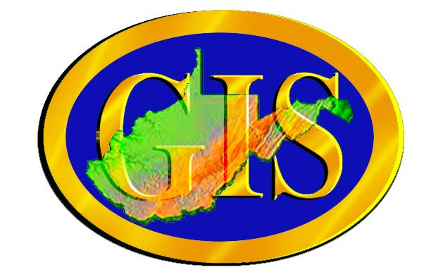
Contact Information:
Craig A. Neidig
WV GIS Coordinator
WV Geological and Economic Survey
1124 Smith St., Suite LM-10
Charleston, WV 25301
Phone: 304.558.4218
Fax: 304.558.4963
Email: cneidig@gis.state.wv.us

State GIS Clearinghouse URL: http://wvgis.wvu.edu
A. Describe your state’s top 3 geospatial accomplishments during the past year:
1. Completion of aerial photography, orthoimagery compilation and planimetric mapping at 1:4800 scale for the statewide addressing project
2. Completion of 1:24000 NHD (National Hydrography Data) conflation for the entire state
3. Completion of 1:24000 DLG coverages for the entire state as part of the Mineral Lands Mapping Program (MLMP) through the WV GIS Technical Center and coop with USGS

B. Describe your state’s top 3 geospatial goals for the coming year:
1. Educate the new incoming Governor, Administration and Legislature on the value of the state GIS program and its accomplishments over the last nine years
2. Renew Executive Order with new Governor, and formalize the state GIS program and GIS Council through legislative and administrative initiatives
3. Seek to stabilize and restore budgets for agency GIS programs cutback over the last three years

C. Describe the 3 most significant geospatial challenges for your state:
1. Sustainable funding for agency GIS programs
2. Strained cooperation and coordination among local and state agencies in a time of diminishing fiscal resources (see above)
3. Political justification and outreach to local and state officials to promote the value and benefits of the state GIS program

D. Describe any significant cooperative efforts with Federal, State or Local partners:
- USGS: WV signed MOU in support of The National Map
- USGS-WRD (Charleston): continued funding support for the development of DOI High Priority mapping in WV
- USDA: Provided $375,000 in coop funding to support digital orthoimagery for the statewide addressing project
- FEMA: WV GIS Technical Center became a Cooperating Technical Partner (CTP) for the FEMA Map Modernization Program.
- WV View (http://www.wvview.org) is a consortium of remote sensing users in the state that acts as an imagery clearinghouse to promote remote sensing research, education and applied remote sensing activities, as well as the open sharing of imagery. WVView was created using a NASA grant and is part of the AmericaView program.
- WV Statewide Addressing and Mapping Board (WVSAMB): Completed statewide mapping contract and contracted addressing contractor to initiate addressing fieldwork and database compilation; received letters of cooperation from all 55 WV counties and many municipalities; each county designated an addressing coordinator; working with WV Association of Counties (WVACo) and other organizations to sponsor workshops and training seminars. For more information go to http://www.addressingwv.org
- Formation of ad hoc Water Resources working group to examine hydrographic database cross-walking and further development of the NHD and conflation with the watershed delineation based on the new NRCS classifications
E. Describe any significant data development activities, innovative applications, cost saving measures, contracts, etc.:
- WV Division of Environmental Protection (WVDEP) contracted with Intermap for acquisition of IFSAR high-resolution elevation data over the southern WV coalfields.
- With funding from DHS, the WVGISTC and State Office of Emergency Services (OES) are developing a restricted-access critical infrastructure dataset to be used by first responders and other emergency management personnel
- The WV Office of Miner’s Health Safety and Training (MHST) and the WV Geological Survey were awarded a grant from the US Mine Safety and Health Administration (MSHA) to continue the state underground mine map compilation process in the aftermath of the Quecreek mine incident
- The Mineral Lands Mapping Program (MLMP) collaboration with WVGES, WV Tax Department, and WVGIS Tech Center continues to develop and refine the GIS-based coal valuation system (http://ims.wvgs.wvnet.edu/coalims.htm)
- Both the WVDEP and Canaan Valley Institute acquired airborne multispectral scanners to rapidly collect environmental data, especially in emergency situations (such as toxic spills, landslides, etc.) and for long-term monitoring of specific sites (surface mines, etc.)

F. Please provide the following Information: (enter N/A if not applicable or unknown; also enter a URL if available on the Internet)
1. GIS mission statement: To implement a statewide Geographic Information System (GIS) program, in partnership with all state, federal, county, and local governments, and in cooperation with private industry, that will develop a comprehensive, standardized,
and public domain digital cartographic database to be shared and used by government agencies, the general public, and business community in order to modernize and improve decision-making processes at all levels of government in order to benefit the citizens of West Virginia.
2. GIS Statutory authority: Executive Order 04-93 (1993) and House Bill 2222 (1995)
3. GIS Coordinator: Craig A. Neidig
4. GIS Coordinating Body: WV GIS Steering Committee
5. GIS Personnel Classifications: WV Division of Personnel:
http://www.state.wv.us/admin/personnel/clascomp/compindx/comp_g.htm
(look for listings under Geographic Information System)
6. GIS Data Distribution Policy: Agency dependent following State Open Records Laws
7. GIS Data Standards: Use FGDC, ASPRS, SDSFIE, USGS, NENA, etc. as applicable.
8. GIS Budget (including grants, etc.): approx. $1.5M for MLMP (FY05, including GIS coordinator’s office); est. $5M among other state agencies; various USGS, DHS-ODP, FEMA, USDA, etc. grants and cost shares, est. $5M statewide
9. Other policies, publications, RFP’s, etc.:
State Information Technology Strategic Plan (2004): http://www.wvgot.org/2004_itstrategicplan/2004_reports/GeologicalandEconomicSurvey-GISCoordinator.pdf

WISCONSIN


Contact Information:
Ted Koch
State Cartographer
University of Wisconsin-Madison
550 North Park Street
Madison, WI 53706
Phone: 608/262-3065
Fax: 608/262-5205
Email: tkoch@wisc.edu

State GIS Clearinghouse URL: http://wisclinc.state.wi.us/index.html
A. Describe your state’s top 3 geospatial accomplishments during the past year:
1. Prototype development of the Internet-based Wisconsin Land Information System (WLIS) core node and distributed node.
2. Reconvening of the WI Land Information Board following appointments to the board by the Governor.
3. Very successful, well attended statewide GIS conference in March, plus a number of well attended specialty workshops.

B. Describe your state’s top 3 geospatial goals for the coming year:
1. Removal of the 9/1/05 legislative “sunset” provision on the WI Land Information Board.
2. Restructuring the state’s Land Information Program such that fewer personnel are required to administer local grants, monitor plans, and identify strategic directions. State government is being downsized so we have to find ways to continue LIS/GIS growth with involvement of fewer people.
3. Achieving better coordination of enterprise GIS goals involving state agencies. Issues of governance, services, standards and data accessibility are all at the forefront.

C. Describe the 3 most significant geospatial challenges for your state:
1. Finding acceptable governance and leadership structure for state agencies.
2. Identifying potential federal agency funding cooperators.
3. Accessing data and resources from state and local government through an open source Web based service.

D. Describe any significant cooperative efforts with Federal, State or Local partners:
USGS appointed a new state liaison that is located in Madison. Several large, multi-county consortia groups have formed to collectively contract for digital orthophotos and terrain model data in 2005.
E. Describe any significant data development activities, innovative applications, cost saving measures, contracts, etc.:
- NRCS is working hard to find partners and organize a statewide NAIP flight in spring 2005.
- The number of county Web mapping sites is growing significantly. Thirty (of 72) counties are now on-line and another 12 are in development.

F. Please provide the following Information: (enter N/A if not applicable or unknown; also enter a URL if available on the Internet)
1. GIS mission statement:
2. GIS Statutory authority: WI Land Information Board -http://www.doa.state.wi.us/pagesubtext_detail.asp?linksubcatid=473&linkcatid=216&linkid=
3. GIS Coordinator: N/A
4. GIS Coordinating Body: WI Land Information Board; WI Land Information Association
5. GIS Personnel Classifications:
6. GIS Data Distribution Policy: Local policies
7. GIS Data Standards: WI land Information Board
8. GIS Budget (including grants, etc.): Approx $13.5 million collected annually through real estate document recording fees to support LIS/GIS at the local level. At a minimum, an equal amount is contributed by county and municipal governments from the local levy to support LIS/GIS.
9. Other policies, publications, RFP’s, etc.:

G. Other comments: (e.g., Has participation in NSGIC benefited your state’s geospatial
efforts?)
Yes, provides a voice/ear to the national scene, and a great way to share and learn what all the states are doing.

WYOMING
Contact Information:

Joseph M. Huss
WGIAC Chair and GIS Coordinator
Wyoming State Geological Survey
Wyoming Geographic Information Advisory Council
and Wyoming State Geological Survey
PO Box 1347
Laramie, Wyoming 82073
Phone: (307) 766-2286 ext. 234
Fax: (307) 766-2605
Email: jhuss@uwyo.edu

State GIS Clearinghouse URL: http://www.wygisc.uwyo.edu/clearinghouse/ and http://wgiac2.state.wy.us/html/wsdc_index.asp
A. Describe your state’s top 3 geospatial accomplishments during the past year:
1. Initial development plan for Wyoming State GIS Coordination
2. Getting executive level interest, help and backing in developing GIS coordination for Wyoming.
3. Getting the GIS community involved in developing a GIS coordination plan for Wyoming

B. Describe your state’s top 3 geospatial goals for the coming year:
1. Implement the new GIS Coordination plan for Wyoming
2. Get the legislature to back developing GIS coordination for Wyoming
3. Initiate the new Wyoming GIS Coordination plan in stages

C. Describe the 3 most significant geospatial challenges for your state:
1. Complete implementation of GIS Coordination for Wyoming
2. Getting the Wyoming legislature to fund GIS Coordination

D. Describe any significant cooperative efforts with Federal, State or Local partners:
The Federal, State, County, Municipalities, Private Industry and University system is all involved in developing the State of Wyoming GIS Coordination Plan. As all know and view the need for a cooperative and coordinated GIS coordinator and plan are needed for the state.
E. Describe any significant data development activities, innovative applications, cost saving measures, contracts, etc.:
A variety of agencies are implementing IMS to streamline State procedures. Additionally many agencies of all levels of government are committing to help reinforce the need for a Wyoming State GIS Coordinator and coordination effort to help save finances, time and confusion of information.
F. Please provide the following Information: (enter N/A if not applicable or unknown; also enter a URL if available on the Internet)
1. GIS mission statement: New one under development
2. GIS Statutory authority: Under development
3. GIS Coordinator: Do not have one other than Chair of WGIAC, Joseph Huss
4. GIS Coordinating Body: Presently WGIAC, but to change in 2004-2005
5. GIS Personnel Classifications: Under State development for State agencies
6. GIS Data Distribution Policy: By individual agencies
7. GIS Data Standards: Utilize Wyoming I-Team (http://gis.dot.state.wy.us/iteam/) and FGDC guidance
8. GIS Budget (including grants, etc.): Under Development
9. Other policies, publications, RFP’s, etc.: Presently utilize WGIAC for some state policy at http://wgiac2.state.wy.us/html/index.asp, but will change in the coming year.
G. Other comments: (e.g., Has participation in NSGIC benefited your state’s geospatial efforts?)
Other than one Agency, Wyoming is limited in sending other individuals due to finances. And without a single GIS Coordinator for Wyoming the benefits do not show to other agencies or local government. But with the implementation of the State of Wyoming GIS Coordination Development Plan, hopefully a Wyoming State GIS Coordinator will represent all levels of the organizations from state to local, including education and private industry will attend to represent Wyoming in 2006.

