White Paper
Digital Conversion of Flood Insurance Rate Maps
WV GIS Technical Center

April 2004

INTRODUCTION

In August 2003, the WV GIS Technical Center (WVGISTC) became a Cooperating Technical Partner with the Federal Emergency Management Agency (FEMA;http://www.fema.gov/fhm/ctp_main.shtm). Our mission, to create digital flood themes from paper West Virginia Flood Insurance Rate Map (FIRM) and Floodway Boundary and Floodway Map (FBFM) panels and to deliver the data in specified formats and with appropriate documentation. FEMA prepares Mapping Activity Statements (MAS) that outline the scope of work and deliverables for each county-based project. Final products are primarily seamless, countywide geospatial data files in the ESRI shapefile format, along with associated metadata.

According to FEMA (Michael Craghan, pers. comm.), the final vector products will have the following qualities:
- A seamless county-wide dataset, with no gaps or overlaps
- The lines and polygons end up in their real-world locations
- There is no scale distortion (i.e. spatial relationships are maintained; if paper map is 1”=500’, digital version should be too).

The FIRM/FBFM features collected by WVGISTC are:
- Base Flood Elevations (BFE-lines)
- Cross Sections (Xsection-lines)
- Flood Hazard Areas (polygons in final format)

The current Mapping Activity Statement for conversion of Jefferson and Berkeley counties specifies these deliverables:
- Written certification that the digital base data meet the minimum standards and specifications.
- DFIRM database and mapping files, prepared in accordance with the requirements in Guidelines and Specifications for Flood Hazard Mapping Partners (see references for citation); (S_ Base_Index, S_Fld_Haz_Ar, S_BFE, S_XS, S_FIRM_Pan).
- Metadata files describing the DFIRM data, including all required information shown in Guidelines and Specifications for Flood Hazard Mapping Partners.
- Printed work maps showing the 1- and 0.2-percent-annual-chance floodplain boundary delineations, regulatory floodway boundary delineations, cross sections, and BFEs at a scale of 1:100,000 or larger.
- A Summary Report that describes and provides the results of all automated or manual QA/QC review steps taken during the preparation of the DFIRM.
- An ESRI shape file showing points where mapping problems are discovered during the digitizing process.

The following sections describe the procedures we follow to (1) prepare the base material for digitizing, (2) digitize features, (3) perform quality control, and (4) prepare final files using ESRI ArcMap 8.x software. This document assumes the user is skilled with ESRI ArcMap 8.x GIS software and has the ability to use reference materials. For help using ESRI ArcMap consult the help files or ESRI on-line support (http://support.esri.com/).

DATA COLLECTION PROCEDURES

Source Material

Source Material Inspection
In the MAS cost estimation phase it is advantageous to become familiar with the FIRM and FBFM panels that cover the geographic extent of the county. In the back of our FEMA binder, there are 3 CDs with scanned panels for 10 high priority counties. The scanned or paper FIRM and FBFM panels should be visually inspected to check for insets and other format issues that may impact the amount of time it takes to digitize and attribute. At the on-line FEMA Flood Map Store (http://store.msc.fema.gov/webapp/wcs/stores/servlet/StoreCatalogDisplay?storeId=10001&catalogId=10001&langId=-1&userType=G) search for FEMA issued flood maps. Follow the prompts for state, county, and community. This is one way to become familiar with the number of panels in a county and also to gather information on the effective date. The effective date on-line may be compared to the effective date on the paper panels to determine if we have the newest source. This is important because FEMA may have done some digital conversion in the counties we are digitizing; in Berkeley County, for instance, 2 of the panels were available in a digital CAD format. We received the CAD files (DLG) and copied the line vectors into our ArcMap project.

Base Layer Compilation
As part of the MAS, a ‘base map’ is obtained for georeferencing the FIRM and FBFM panels in a county. The MAS states: “the base map is to be the USGS digital orthophoto 3.75-minute quarter-quadrangles (DOQQs), or other digital orthophotography that meets FEMA standards.” Currently, we use the DOQQs to georeference the panels; when it becomes available, we will use the Statewide Addressing and Mapping photography. Countywide mosaics of the DOQQs are available either from CDs in our office or from the NRCS geospatial data gateway (http://lighthouse.nrcs.usda.gov/gateway/gatewayhome.html). Before beginning panel georeferencing, gather all the base map photography to cover the geographic extent of the county. Check DOQQ tiles and the ortho mosaic, if used, for agreement with each other. Also check the individual DOQQ tiles against the quarter quadrangle index to make sure that they are NAD83 and not NAD27. Finally, check to make sure that the spatial properties (coordinate system and projection) are defined for each quarter quad.

Georeferencing

FEMA provides scanned (TIFF) images of the paper FIRMs and FBFMs. Not all counties have separate floodway panels (FBFMs). The steps taken to georeference the scanned FIRMs/FBFMs using ArcMap are:
- Start an ArcMap project in the desired coordinate system. When using West Virginia DOQQs that will primarily be UTM 83 zone 17 (although Jefferson County was zone 18).
- Add the DOQQs for the area of interest to the project.
- Add the scanned TIFF to the project. The first panel to be georeferenced is the most difficult, because locating the correct spot on the base map photographs using the landmarks on the panel can be frustrating without a good reference system. One way to do this is to warp the panel index first—hence giving a rough estimate of panel location on the photographs. Alternatively, after warping one panel, work with adjacent panels to make landmark location easier.
- Use “fit to display” on the georeferencing toolbar pull-down menu to move the TIFF to the current extent.
- Use the georeferencing toolbar to create control points on the DOQQs and the scanned TIFF, using roads and other major features appearing on the FIRM.
- It is recommended that “Auto Adjust” be checked on the georeferencing dropdown and that the layer being georeferenced is partially transparent. As control point links are added the scanned TIFF will be shifted over the DOQQs, making finding and adding additional links easier.
- As you are adding control points, check the residual values and total RMS value in the link table. The goal is for a total RMS value of 10 or less (units are mapping units, meters). After adding as many control points as possible it is sometimes useful to remove links that have very high residual values to improve the overall RMS value of the warp. Sometimes it is not possible to get an RMS below 10.
- Concentrate control points around areas with flood features to improve the fit of areas that will be digitized. We recommend adding at least 10 sets of control points, although in some cases we used over 20 sets to improve fit.
- Record the total RMS value of the transformation for each panel in a spreadsheet for the county.

Digitizing and Attributing Flood Features

Digitizing Notes

ArcMap Project and File Specifications

The UTM NAD83 projection, zone 17 is used for all West Virginia countywide flood mapping projects, with the exception of Jefferson County, which is zone 18. All features are initially collected as lines, although special flood hazard areas (e.g., Zone A, AE) are later converted to polygons. All features are drawn in one line shapefile and are later separated into the separate files required to meet MAS deliverables. For the purposes of drawing the flood feature lines we are using a line shapefile with the following attribute fields: Type (text, 10), Letter (text 2), Elev (long integer, precision 5). A description of the values we use in those fields is given below with each different feature type. In the first round of digitizing the shapefile was named All_Lines.shp, although in the future we may switch to using a county name in combination with employee name. Save edits frequently while digitizing, both by using the save edits button in ArcMap and by making backup copies of the file with ArcCatalog.

Snapping

Begin an edit session and set up the snapping environment. Having snapping turned on is important to allow snapping of BFEs to the edges of flood hazard areas and for snapping the flood zone line segments together. We generally usually use a snapping tolerance between 7 and 10 pixels; this is a personal drawing preference and may vary from person to person. Use the appropriate snapping mode for each type of feature, i.e. ‘vertex’ for closing zone boundaries, ‘end’ for snapping arc ends together and ‘edge’ for snapping BFE lines to zone boundaries. Note that having ‘vertex’ snapping on can make it more difficult to accurately place BFE endpoints. The goal is clean intersections and BFEs that are snapped to flood hazard area boundaries.

Feature Collection

We generally draw flood map features in this order: floodway, flood zone, BFE, and cross-sections. Some counties have floodway features on a separate map (FBFM) from the FIRM. When working with two maps, collect floodways and cross sections from the FBFM and collect flood hazard zones, BFEs, and streams and channels from the FIRM maps. When working with a FIRM and a FBFM for a panel, it is recommended that lines are drawn from the FBFM first and the FIRM second. Features are to be seamless across panel boundaries, meaning when the same feature type occurs on both sides of a panel boundary, it should be drawn with no interruption. Adjacent panels digitized by different people should have the endpoints of flood feature lines snapped together in the final line shapefile. Be sure to check panel edges carefully for small flood zone polygons.

Panel Index and Base Index

Collection and attribution of flood features will be discussed in detail below. In addition to the flood features, we also submit 2 polygon index shapefiles to FEMA for each county. One of the shapefiles is called S_FIRM_Pan and is an index of the FIRM panels for a county. It is created by digitizing the lines on the scanned and warped county FIRM index. Only unincorporated areas are included the in the panel index, not the incorporated areas. Secondly, an index of the “base” data for a county is to be provided in a polygon shapefile called S_Base_Index. In our case, the base data is the DOQQs. The S_Base_Index shapefile can be generated by clipping out the appropriate quarter quads from the DOQQ index. As with all other shapefiles we submit, both the S_FIRM_Pan and S_Base_Index shapefiles have a required attribute table format, discussed later in this document.

Flood Feature Symbology and Attributes

Floodways

The floodway is the channel of a river plus any adjacent floodplain areas. Floodways won’t be found on all panels. There are 2 different presentations of floodways on FEMA panels, which vary by county. In some counties, Berkeley for example, floodway symbology is included on the FIRM (Figure1a). Other counties have separate floodway panels (FBFM, Figure 1b) and they must be added as a separate layer for floodway line collection.
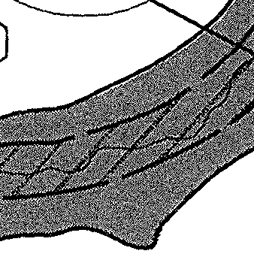
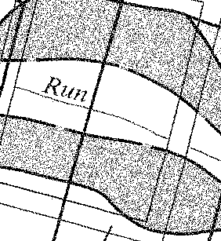
Figure 1a. Floodway symbology on FIRM (circled in red).
Figure 1b. Floodway symbology on FBFM (circled in red).

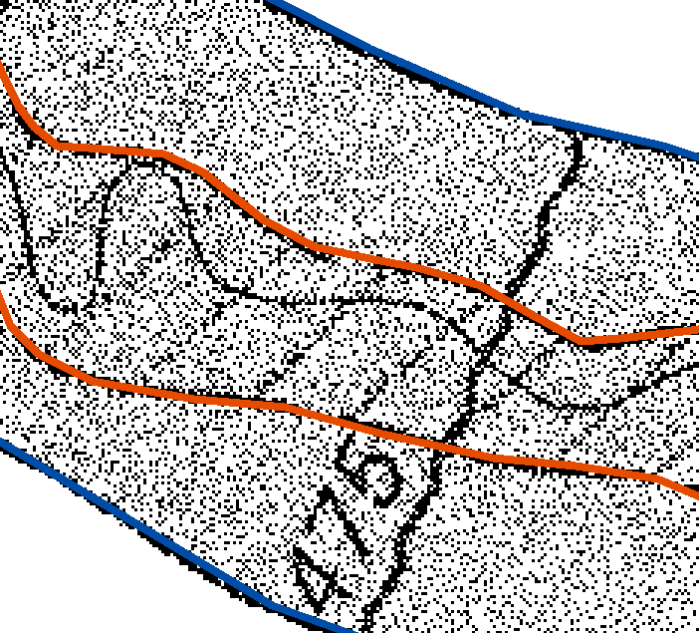
Figure 1c. Example of completed floodway vectors. Floodway lines shown in red, surrounding zone AE lines shown in blue.

In the initial drawing, lines defining the floodway are given the following attributes:

Type: floodway
Letter:
Elev:

Flood Hazard Areas

Flood hazard areas will also be referred to as ‘flood zones’ or ‘zones’ and they identify areas of different levels of flood risk. Flood zones are labeled on the FIRMs with letters; commonly used zone names are A, AE, B, C, X and they are shown on the paper maps with different densities of shading and text labels (Figure 2a). Zones are collected as lines, although later they will be converted to polygons. Digitizing proceeds from the inside out, i.e., collect the innermost zones first (In Figure 2a, the floodway would be collected first, and then AE, then X). Where an outer zone line flows into an interior zone line, they should be snapped (Figure 2c). Each line defining flood zones should be collected only ONCE. In areas where zone boundaries are coincident, only one line is collected (Figure 2c). There are zone division lines (Figure 2c and d, also referred to as gutter lines), which separate “special” flood hazard areas (generally zones A and AE). The zone division lines are thin white strips that are hard to see in the shaded zones. Gutter lines should be considered the border of those particular zones and treated as any zone boundary would be (i.e., collected once, continuous with other zone lines).
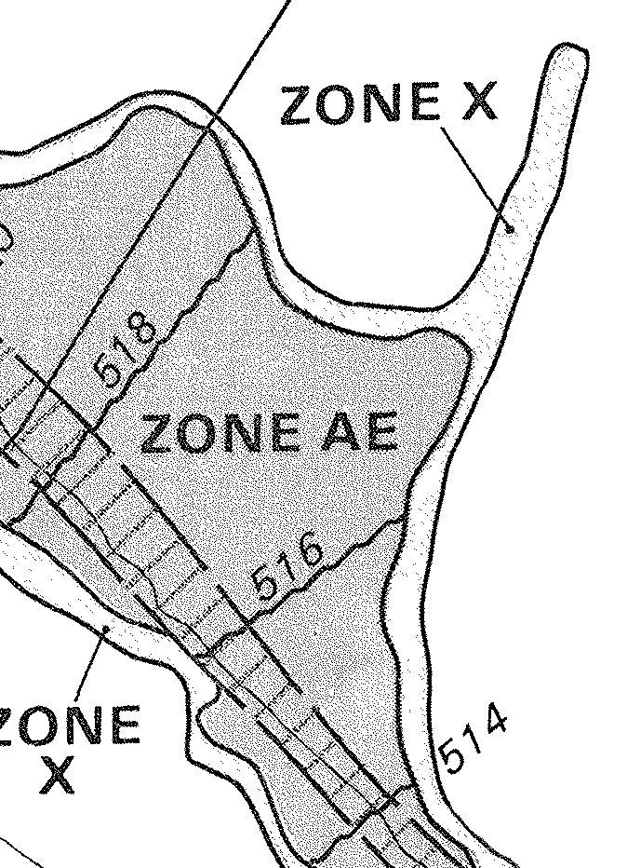
Figure 2a. Clip of scanned FIRM panel showing
flood hazard areas X and AE.
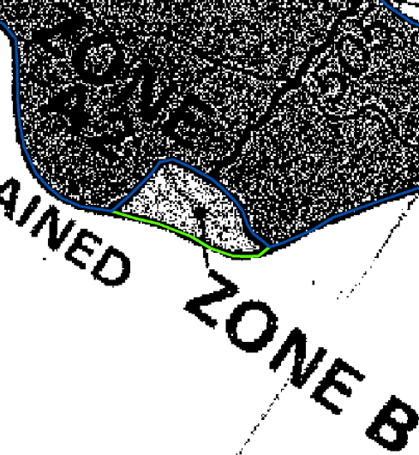
Figure 2b. Example of flood zone vectors.


Figure 2c. Clip of scanned FIRM panel showing zone division (or ‘gutter’) line.

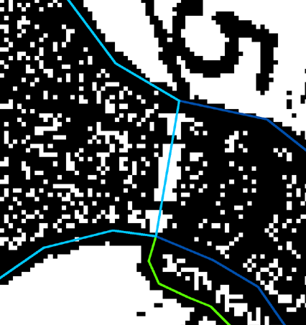
Figure 2d. Correct collection of zone division lines; treat as zone boundary.

Figure 1c. Example of vector floodway data. Red lines outline the floodway; blue lines outline the AE zone around the flooway.

In the initial drawing, lines defining the flood hazard areas are given the following attributes:

Type: zone
Letter:
Elev:

Base Flood Elevations

Base Flood Elevation (BFE) is the height of the base (100-year) flood in relation to a specified datum. BFEs are symbolized on the FIRM panels with a wavy line (Figure 3a) but the feature is usually collected as a straight line (Figure 3b) that is snapped to the edge of the flood hazard area. IF there is a significant bend in the BFE as drawn on the panel, then additional points may be added to follow the curve. Ends should always be snapped to the flood hazard area.
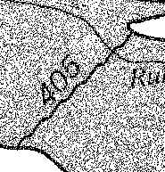
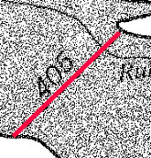
Numeric elevation value
Figure 3a. BFE symbology on FEMA FIRM panels.

Figure 3b. Red line demonstrates correct vector placement for BFE.

In the initial drawing, lines defining the BFEs are given the following attributes:

Type: bfe

Letter:

Elev: numeric elevation value on FIRM (e.g., 405)

Cross Sections

Cross sections (Figure 4a) show the location of floodplain cross sections used for computing base flood elevations. Cross sections are normally collected as a straight line, crossing and exiting the flood hazard area (Figure 4b). It is not necessary to follow bends in the cross section line that occur outside of the flood hazard area, nor is it necessary to extend the line through the hexagons at the end of the line symbol. If there are bends in the cross section within the flood hazard area, place only as many vertices needed to maintain shape. Cross section lines should not be snapped to the flood hazard area lines, and instead should extend beyond them.
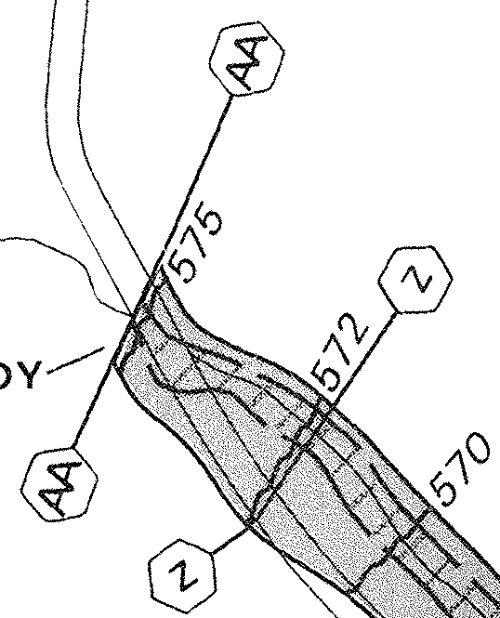
Figure 4a. Cross section symbology
(AA and Z) on FIRM and FBFM panels.

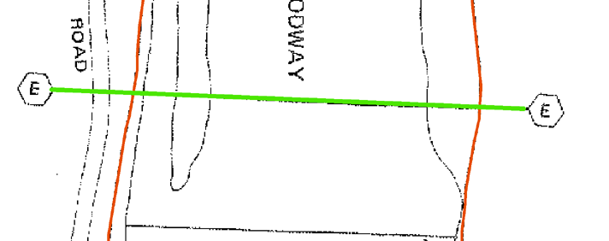
Figure 4b. Example of drawn cross section vector (green); red lines are floodway boundaries.

In the initial drawing, lines defining the cross sections are given the following attributes:

Type: xsection
Letter: letter of cross section, found in hexagon symbol (e.g., z)
Elev:

Channels and Streams

Channels and streams (Figure 5a and 5b) are collected in the flood hazard areas for QC purposes. No snapping is required and the stream or channel line should extend just beyond the flood hazard area when applicable. Streams are collected as single lines and both lines of a channel are collected.
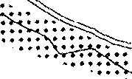
Figure 5b. Stream as shown on FEMA FIRM panels.
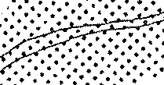
Figure 5a. Channel as shown on FEMA FIRM panels.

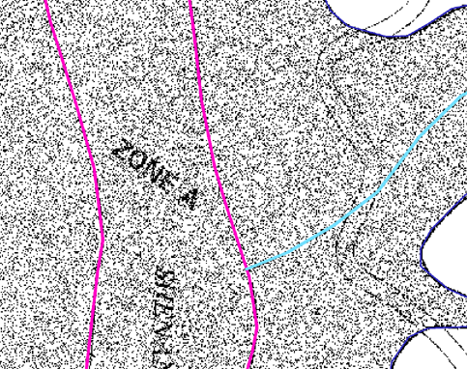
Figure 5c. Example of channel (pink) and stream (blue) digitizing.
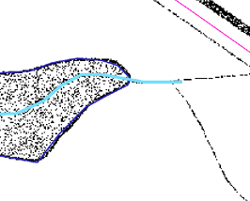
Figure 5d. Example of stream (blue) digitizing, showing stream collection ending just outside flood zone.

In the initial drawing, lines defining the channels and streams are given the following attributes:

Type: channel or stream, as appropriate
Letter:
Elev:

POST-DRAWING QUALITY CONTROL AND ADJUSTMENTS

Visual QC Of Linework

After all lines are digitized and in a countywide, seamless file, a visual check is done to ensure that all features have been collected. The “Type” field in the line shapefile can be used to categorically symbolize the different feature types for the visual QC. Different colors and line styles can be used to represent separate feature types and the legend symbols can be saved as a layer file to preserve the symbol assignments. Turn on the labels for BFEs (elevation) and xsections (letter) and select a font style and color that allows them to be easily seen and checked in the visual QC process. Each person will probably have a different method of doing a systematic visual inspection. Some suggestions: a grid could be used to scan the linework, drainages can be followed, or the check can be done panel by panel. The important thing is to scan at a level such that all of the panel raster features can be identified and vectors examined. The person doing the QC should have a full understanding of what features are supposed to be collected and the symbology variations (e.g., floodways on FIRMs vs FBFMs). Any missed features should be digitized. This is also a good time to make note of any unusual problems or non-conformities in the scanned panels (e.g., zone type changes at panel or corporate boundary). This is the time to check that features are seamless across panel boundaries; BFEs and cross sections in particular should be checked at panel boundaries because there is no further geometric processing with these lines that will reveal continuity errors.

Spatial Adjustments (otherwise known as “Adjusting To The Real World”)

Post-drawing manipulation of lines to improve “fit” is hard-to-quantify and subjective. As stated in the introduction, FEMA requires the digital data to have a reasonably good fit to the “real world”. The “real world” in our case is the DOQQs. The scanned panels do not warp perfectly and in some areas the digitized lines will not overlay real world features very well. Current adjustment procedures involve these steps:
- Compile the following layers in ArcMap:
  - DOQQs
  - Line shapefile with county-wide seamless flood features
  - 1:24,000-scale NHD centerline data layer (route.rch, in catalog unit coverages)
  - Problem point file (discussed in the next section)
- Determine a systematic method for visually scanning the data (similar to that used in the visual QC) and adjust “Type” symbology for easy differentiation.
- Begin a visual check of the linework, this time concentrating on how well the streams and channels drawn from the flood panels line up with the DOQQ and the NHD data. It is strongly recommended that you do not use the FIRM panels at this point, as they will increase confusion.
- NHD data are a fairly good guide to where the flood panel waterways “should” be; however they are not perfect. While visually scanning the linework, check that the streams and channels collected from FEMA panels line up fairly well with the NHD data, while also checking to see that NHD data appears to overlay the hydrologic feature on the DOQQ. There is never going to be a perfect fit; the panels streams will wander back and forth over the NHD vectors. What you are looking for is areas of consistent difference that extend for a noticeable distance (again, hard to quantify). In Figure 6a, the blue dashed panel stream channel lines are not aligned with the DOQQ stream channel edges.
- When areas of consistent difference are found, ALL the linework surrounding the area is shifted at the same time, until the panel stream has a better fit to the real world stream. This is accomplished by first breaking all the continuous flood zone, floodway, and stream lines at about the same point on 2 imaginary lines that run perpendicular to the “flow,” one at each end of the area to be shifted. Then, the cut lines are selected, along with any BFEs or cross sections that are in the area (Figure 6b), and all the selected features are moved until the streams are better aligned (Figure 6c). The adjustment is accomplished mostly with the move tool in ArcMap, although in occasion the rotate tool may be used to improve the fit of the selected lines with the DOQQ.
- Lastly, snap the dangling ends together and smooth out the curves of the reattached lines by moving or adding vertices (Figure 6d). This is the only time lines should be moved or stretched individually, as it distorts proportions.
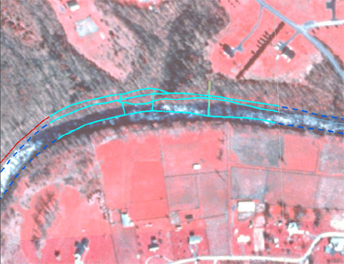
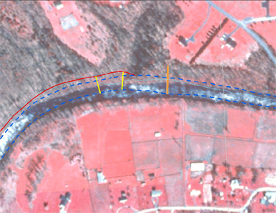
Figure 6a. Before the adjustment. Flood hazard zone (red), floodway (blue dashed), BFE (yellow), and cross section (orange) lines in this area will be moved slightly to better fit the DOQQ base data.
Figure 6b. During adjustment procedures, continuous flood features are split along an imaginary perpendicular line at either end of the area and all lines in the adjustment area are selected.

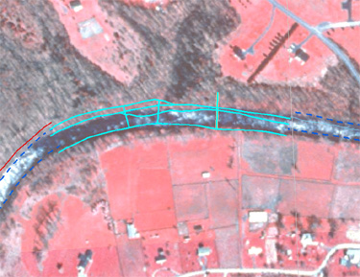
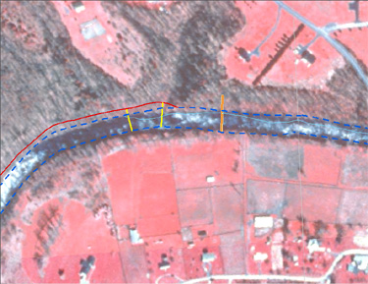
Figure 6c. During adjustment procedures, selected lines are shifted to the desired location, corresponding as closely as possible with the DOQQ base data.
Figure 6d. After the adjustment. All lines have been moved slightly to better fit the DOQQ base data, while maintaining spatial relationships between the flood features. Split lines have been rejoined and smoothed.

Mapping Problem File
One of the required deliverables is a point file indicating areas where certain “problem” situations arise. At the same time as adjustments are being performed, the problem point file can be edited. FEMA defined mapping problems are outlined in the draft Technical Memo, dated October 3, 2003, a copy of which is found in the FEMA project notebook; they have also been listed below for convenience. A point shapefile is created for each county with the following fields: Error_type (text, 10) and Descrip (text, 75).

Error_type Descrip
BFE Base Flood Elevation problem
XSECT Cross-section problem
SFHA-PAN Special Flood Hazard Area changes at map panel edge
SFHA-BDY Special Flood Hazard Area changes at a political boundary
SFHA-STR Special Flood Hazard Area different on each side of a stream
SFHA-OTH Other Special Flood Hazard Area problems
STR-FW Stream outside of floodway
STR-SFHA Stream outside of Special Flood Hazard Area

As of this writing, we have primarily found the STR-SFHA, STR-FW, and SFHA-BDY types of errors. Note: errors should be determined AFTER lines are adjusted in a given area, as the adjustment may correct the problem. Place a point in the shapefile at the location where the problem occurs. In Figure 7 the pink point indicates a location where the stream (orange) is outside of the flood hazard area (blue line).
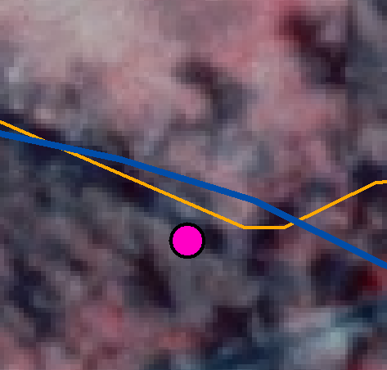
Figure 7. Flood mapping “problem” indicated by pink point.

POLYGON CREATION

The flood hazard zones and floodways must be converted to polygons for final processing. Select all lines with a “Type” of zone or floodway and export to a separate line shapefile. Topological checks will be performed on the line file before polygons are built. Topology work can only be done in ArcMap via the geodatabase model. Import the line shapefile into a geodatabase feature class that is under a feature dataset (must have a feature dataset to create a topology). If you are starting with a geodatabase / feature class, then use Export | Geodatabase to Geodatabase in ArcCatalog to transfer the feature class into the dataset.

Add a new topology under the feature dataset. Set the cluster tolerance relatively high (0.1 was used in the first 2 MAS, which corresponds to 10 centimeters on the ground) to reduce the number of small pieces formed. Only the flood hazard zone lines feature class will participate in the topology. The topology rules used are: must not have pseudos, must not have dangles, and must not self-overlap. After creating the topology for the lines, validate it. Bring the validated topology layer into an ArcMap project to view the errors found. Use the topology tools to analyze and correct all errors before proceeding. See the Topology section in the ArcGIS book “Building a Geodatabase” for help.

After validating the topology and fixing all topological errors, convert the lines feature class to a polygon feature class. To do this, right click on the feature dataset in ArcCatalog and select ‘new’ and then ‘polygon feature class from lines’. A wizard helps with the conversion; accept the default tolerance.

Once the polygon layer is created, create a new topology for it. Use the default cluster tolerance, which is very small. Only the polygon feature class participates in the topology, and the rules are: must not overlap and must not have gaps. Bring the validated polygon topology into ArcMap as with the line topology. Ideally, there will be no errors in this topology. After checking for and fixing topological errors, another check should be done for sliver polygons. This can be done by viewing the polygon attribute table in ArcMap and sorting the table based on the shape_area attribute field in ascending order. Examine the smallest polygons to be sure they are not slivers.

Next, the polygon flood hazard features need to be attributed. This can be done in the geodatabase, setting up a domain so that attributes can be chosen from a drop down list. Overlay the flood hazard polygon layer with the FIRM/FBFM panels and attribute the polygons. It saves time if the shapefile you are using to add attributes has the same column structure as the required final product (see Table 2). In the future we hope to have template files available for use, so that the required structure will already be in place. We have tried merging with a template file in the geodatabase, but that resulted in features shifting. This process is still being developed.

PREPARATION OF DELIVERABLES

For the final deliverables, the flood features collected in the line shapefile must be processed into separate shapefiles with specified fields. Table 1 gives an overview of the shapefile names and contents. Attribute fields have required field types (e.g., text, number) and sizes; details can be found on the pages of Guidelines & Specifications for Flood Hazard Mapping Partners Appendix L referred to in Table 1. These pages from Appendix L have been printed out and are in the guidelines/technical section of the FEMA project binder. Table 2 provides details on the required fields.

Table 1. Deliverable shapefile description
Shapefile Name | Contents | Pages in Appendix L
S_Base_Index | Grid of base data, in our case, DOQQs. Polygons. | L-270 to L-271
S_FIRM_Pan | Grid of FEMA panels; digitized from county panel index. Polygons. | L-286 to L-290
S_Fld_Haz_Ar | Flood hazard zone polygons | L-291 to L-293
S_BFE | Base flood elevation lines collected from FEMA panel | L-272 to L-273
S_XS | Cross section lines collected from FEMA panel | L-350 to L-354

Table 2. Shapefile attribute field requirements
Shapefile | Field Name | What Goes In It
S_Fld_Haz_Ar (polygon) | FLD_AR_ID | A unique feature number. Can be copied from FID field. [Text, 11]
 | FLD_ZONE | Flood zone from FIRM. Use values in FLD_ZONE field of Table D_Zone on pg L-452 of Appendix L. [Text 55]
 | FLOODWAY | “FLOODWAY” if polygon is a floodway. Null if not. [Text, 30]
 | SFHA_TF | “T” if any zone beginning with A. “F” for any other zone. True or false. [Text, 1]
 | SOURCE_CIT | 11-digit FIRM panel number that majority of feature is on. If polygon crosses many panels, use downstream panel. [Text, 11]
S_XS (line) | XS_LN_ID | A unique feature number. Can be copied from FID field. [Text, 11]
 | XS_LTR | Upper case letter(s) of cross-section from FIRM. [Text, 12]
 | XS_LN_TYP | “LETTERED” in all cases. [Text, 20]
 | WTR_NM | Name of water feature (stream) cross section is on. From FIRM or FIS. [Text, 100]
 | SOURCE_CIT | 11-digit FIRM panel number cross section is on. If on two, list panel with majority. [Text, 11]
S_BFE (line) | BFE_LN_ID | A unique feature number. Can be copied from FID field. [Text, 11]
 | ELEV | Numeric elevation of BFE, from FIRM [Double, Prec. 13, Scale 2]
 | LEN_UNIT | “FEET” in all cases. [Text, 20]
 | V_DATUM | Vertical datum of panel. Listed on panel, and values must come from the V_DATUM field of the D_V_Datum table on page L-444 of Appendix L. [Text, 6]
 | SOURCE_CIT | 11-digit FIRM panel number BFE is on. If on two, list panel with majority. [Text, 11]
S_ Base_Index (polygon) | BASE_ID | A unique feature number. Can be copied from FID field. [Text, 11]
 | FILENAME | Name of DOQQ or other image file used as base map. [Text, 50]
 | BASE_DATE | Date image was captured. For DOQQs can be found in header file. [Date]
 | SOURCE_CIT | BASE1 or other abbreviation that corresponds to metadata [Text, 11]
S_FIRM_Pan (polygon) | FIRM_ID | A unique feature number. Can be copied from FID field. [Text, 11]
 | FIRM_PAN | FIRM panel number. [Text, 11]
 | EFF_DATE | Effective date on FIRM panel. [Date]
 | SCALE | Scale of FIRM panel. If map scale on FIRM is 1” = 500’, then scale is 6000. Multiply feet by 12 to get true scale. [Text, 5]
 | SOURCE_CIT | 11-digit FIRM panel number. [Text, 11]

BFE Shapefile Creation

From the line shapefile that was used for digitizing, use the Type field to select and export BFEs to a separate shapefile. Either modify the resulting shapefile to match the required format, or, merge the digitized lines with a pre-formatted template. The output merge file can be a geodatabase feature class, which allows for the use of an attribute domain drop-down for the SOURCE_CIT field. Use ArcMap editing tools to assign attributes to the fields shown in the preceding table. BFE lines are submitted in the S_BFE shapefile.

Cross-section Shapefile Creation

From the line shapefile that was used for digitizing, use the Type field to select and export cross-sections to a separate shapefile. Either modify the resulting shapefile to match the required format, or, merge the digitized lines with a pre-formatted template. The output, as with BFE, can be a geodatabase feature class. Attribute domains can be created for the XS_LTR, XS_ LN_TYP, WTR_NM (a list of stream names is available in the county FIS book) and SOURCE_CIT fields. Cross-section lines are submitted in the X_Xs shapefile.

Certification

One of the required deliverables relating to the base map (DOQQs in our case) is a “written certification that the digital data meet the minimum standards and specifications.” A text file with the following statement was created:

“This text file serves as written certification that the base map digital data meet the minimum standards and specifications in Guidelines and Specifications for Flood Hazard Mapping Partners Appendix K. On page K-42 (Section K.4.1.1) of that document it is written "The most common form of raster image map is the digital orthophoto, especially the standard Digital Orthophoto Quadrangle (DOQ) produced by the U.S. Geological Survey." DOQQ's were used as the base map for georeferencing scanned paper FIRMs and for visually locating features of interest.

DOQQ Metadata Link: http://www.wvgis.wvu.edu/fullmetadata/wvdoqq.html

Digital Orthophoto Standards: http://rockyweb.cr.usgs.gov/nmpstds/doqstds.html”

Metadata File

One of the deliverables for each county is a metadata file to represent the vector countywide flood data. There are sample metadata records in Appendix L of the Guidelines & Specifications for Flood Hazard Mapping Partners. FEMA representative Michael Craghan has indicated that metadata format should follow Section L.6. of those guidelines (page L-261; Metadata Example for Draft Digital Data ) and “put WVU where it calls for a study contractor.” There should be a Source_Information section in the metadata for each panel that flood features are collected from and the panel number is used as the Source_Citation_Abbreviation. DOQQs get a Source_Information section (one section for all DOQQs, do not list each DOQQ separately) in the metadata and the suggested Source_Citation_Abbreviation is BASE1. The Source_Citation_Abbreviation from the metadata is then listed in the SOURCE_CIT field in each of the shapefiles where appropriate. In other words, each shapefile feature must have an associated data source. NHD data was listed in a Source_Information section because it was used as a reference, although it is never cited in a shapefile, since we don’t actually draw any features from it. The metadata record should be processed through MP (USGS metadata parsing software) with no errors and a text, html, and sgml version generated. Metadata is discussed in general terms in Appendix L (section L.2.8) of the Guidelines & Specifications for Flood Hazard Mapping Partners, beginning on page L-44. Metadata files are named metadata_countyname.txt, etc. For example, the metadata file for Jefferson County was named metadata_jefferson.txt. A sample metadata record is included in Appendix B.

Summary QA/QC Report

Another deliverable is a report describing QA/QC steps taken. Roughly the same QA/QC steps will be used each time, and the existing report can be modified each time. Appendix C has an example of the QA/QC report.

Printed Work Maps
The final deliverable is a countywide plotted image of the digitized flood features at a scale of 1:100,000 or larger. In the first MAS flood features were plotted on a DOQQ background—the DOQQ had been turned black and white. Features to be shown are flood hazard areas, floodways, BFEs, and cross sections.
APPENDIX A. REFERENCES
Guidelines & Specifications for Flood Hazard Mapping Partners
http://www.fema.gov/fhm/dl_cgs.shtm
Appendix L is the primary document of interest

NHD website
http://nhd.usgs.gov/data.html
Retrieve the 1:24:000 NHD coverages to use as reference

FEMA flood documents in the black FEMA 3 ring binder

ArcMap editing and geodatabase manuals.

Mapping Activity Statement documents – be sure to understand all deliverables.
APPENDIX B. SAMPLE METADATA FILE

Identification_Information:
Citation:
Citation_Information:
Originator: FEMA Mapping Partner West Virginia GIS Technical Center
Publication_Date: 20031231
Title: Digital Flood Insurance Rate Map Database, Jefferson County, West Virginia, USA
Geospatial_Data_Presentation_Form: Vector Digital Data
Publication_Information:
Publication_Place: Washington, DC
Publisher: Federal Emergency Management Agency
Other_Citation_Details: Metadata file name is 540065_20020806_metadata.txt
Online_Linkage: http://www.fema.gov/msc
Description:
Abstract: The Digital Flood Insurance Rate Map (DFIRM) Database depicts flood risk information and supporting data used to develop the risk data. The primary risk classifications used are the 1-percent-annual-chance flood event, the 0.2-percent-annual-chance flood event, and areas of minimal flood risk. The DFIRM Database is derived from Flood Insurance Studies (FISs), previously published Flood Insurance Rate Maps (FIRMs), flood hazard analyses performed in support of the FISs and FIRMs, and new mapping data where available. The FISs and FIRMs are published by the Federal Emergency Management Agency (FEMA). The file is georeferenced to earth's surface using the UTM projection and coordinate system. The specifications for the horizontal control of DFIRM data files are consistent with those required for mapping at a scale of 1:12,000.
Purpose:
The FIRM is the basis for floodplain management, mitigation, and insurance activities for the National Flood Insurance Program (NFIP). Insurance applications include enforcement of the mandatory purchase requirement of the Flood Disaster Protection Act, which "... requires the purchase of flood insurance by property owners who are being assisted by Federal programs or by Federally supervised, regulated or insured agencies or institutions in the acquisition or improvement of land facilities located or to be located in identified areas having special flood hazards" (Section 2 (b) (4) of the Flood Disaster Protection Act of 1973). In addition to the identification of Special Flood Hazard Areas (SFHAs), the risk zones shown on the FIRMs are the basis for the establishment of premium rates for flood coverage offered through the NFIP.
The DFIRM Database presents the flood risk information depicted on the FIRM in a digital format suitable for use in electronic mapping applications. The DFIRM Database is a subset of the Digital FIS database that serves to archive the information collected during the FIS.
Time_Period_of_Content:
Time_Period_Information:
Range_of_Dates/Times:
Beginning_Date: 1980
Ending_Date: 1993
Currentness_Reference: FIRM and FIS Effective date
Status:
Progress: Complete
Maintenance_and_Update_Frequency: Irregular
Spatial_Domain:
Bounding_Coordinates:
West_Bounding_Coordinate: -78.04
East_Bounding_Coordinate: -77.71
North_Bounding_Coordinate: 39.50
South_Bounding_Coordinate: 39.13
Keywords:
Theme:
Theme_Keyword_Thesaurus: None
Theme_Keyword: FEMA Flood Hazard Zone
Theme_Keyword: DFIRM Database
Theme_Keyword: DFIRM
Theme_Keyword: Special Flood Hazard Area
Theme_Keyword: Digital Flood Insurance Rate Map
Theme_Keyword: Riverine Flooding
Theme_Keyword: NFIP
Theme_Keyword: Base Flood Elevation
Theme_Keyword: SFHA
Theme_Keyword: Flood Insurance Rate Map
Theme_Keyword: FIRM
Theme_Keyword: Floodway
Place:
Place_Keyword_Thesaurus: None
Place_Keyword: Jefferson County
Place_Keyword: West Virginia
Place_Keyword: USA
Access_Constraints: None
Use_Constraints:
The hardcopy FIRM and DFIRM maps and the accompanying FISs are the official designation of SFHAs and Base Flood Elevations (BFEs) for the NFIP. For the purposes of the NFIP, changes to the flood risk information published by FEMA may only be performed by FEMA and through the mechanisms established in the NFIP regulations (44 CFR Parts 59-78).
These digital data are produced in conjunction with the hardcopy FIRMs and generally match the hardcopy map exactly. However the hardcopy flood maps and flood profiles are the authoritative documents for the NFIP.
Acknowledgement of FEMA would be appreciated in products derived from these data.
Point_of_Contact:
Contact_Information:
Contact_Organization_Primary:
Contact_Organization: WV GIS Technical Center
Contact_Position: FEMA Digital Conversion Project Manager
Contact_Address:
Address_Type: mailing address
Address: 425 White Hall, PO Box 6300
City: Morgantown
State_or_Province: West Virginia
Postal_Code: 26506
Country: USA
Contact_Voice_Telephone: 1-304-293-5603
Contact_Electronic_Mail_Address: www.wvgistc.wvu.edu

Native_Data_Set_Environment: Vector shapefiles were developed using ESRI ArcGIS software on Windows 2000 PC platform
Cross_Reference:
Citation_Information:
Originator: Federal Emergency Management Agency
Publication_Date: 19990106
Title: Flood Insurance Study, Jefferson County, West Virginia
Geospatial_Data_Presentation_Form: Document
Publication_Information:
Publication_Place: Washington, DC
Publisher: Federal Emergency Management Agency
Cross_Reference:
Citation_Information:
Originator: Federal Emergency Management Agency
Publication_Date: 19990106
Title: Flood Insurance Rate Map, Jefferson County, West Virginia
Geospatial_Data_Presentation_Form: Map
Publication_Information:
Publication_Place: Washington, DC
Publisher: Federal Emergency Management Agency
Data_Quality_Information:
Attribute_Accuracy:
Attribute_Accuracy_Report:
The DFIRM Database consists of vector files for a portion of the county and associated attributes produced in conjunction with the hardcopy FEMA FIRMs. The published effective FIRM and DFIRM are issued as the official designation of the SFHAs. As such, they are adopted by local communities and form the basis for administration of the NFIP. For these purposes they are authoritative. Provisions exist in the regulations for public review, appeals and corrections of the flood risk information shown to better match real world conditions. As with any engineering analysis of this type, variation from the estimated flood heights and floodplain boundaries is possible. Details of FEMA's requirements for the FISs and flood mapping process that produces these data are available in the Guidelines and Specifications for Flood Hazard Mapping Partners. Attribute accuracy was tested by manual comparison of source graphics with hardcopy plots and a symbolized display on an interactive computer graphic system.
Independent quality control testing of FEMA's DFIRM database was also performed.
To obtain more detailed information in areas where Base Flood Elevations (BFEs) and/or floodways have been determined, users are encouraged to consult the Flood Profiles and Floodway Data and/or Summary of Stillwater Elevations tables contained within the FIS report that accompanies this DFIRM database. Users should be aware that BFEs shown in the S_BFE table represent rounded whole-foot elevations. These BFEs are intended for flood insurance rating purposes only and should not be used as the sole source of flood elevation information. Accordingly, flood elevation data presented in the FIS report should be used in conjunction with the FIRM for purposes of construction and/or floodplain management. The 1-percent-annual-chance water-surface elevations shown in the S_XS table match the regulatory elevations shown in the FIS report.
Logical_Consistency_Report: When FEMA revises an FIS, adjacent studies are checked to ensure agreement between flood elevations at the boundaries of the studies. Like wise, flood elevations at the confluence of streams studied independently are checked to ensure agreement at the confluence. The FIRM and the FIS are developed together and care is taken to ensure that the elevations and other features shown on the flood profiles in the FIS agree with the information shown on the FIRM. However, the elevations as shown on the FIRM are rounded whole-foot elevations. They must be shown so that a profile recreated from the elevations on the FIRM will match the FIS profiles within one half of one foot.
Completeness_Report:
The data contained in the DFIRM Database files reflect the content of the source materials. Features may have been eliminated or generalized on the source graphic, due to scale and legibility constraints. With new mapping, FEMA plans to maintain full detail in the spatial data it produces. However, older information is often transferred from existing maps where some generalization has taken place.
Flood risk data are developed for communities participating in the NFIP for use in insurance rating and for floodplain management. Flood hazard areas are determined using statistical analyses of records of river flow, storm tides, and rainfall, information obtained through consultation with the communities, floodplain topographic surveys, and hydrological and hydraulic analysis. Both detailed and approximate analyses are employed. Generally, detailed analyses are used to generate flood risk data only for developed or developing areas of communities. For areas where little or no development is expected to occur, FEMA uses approximate analyses to generate flood risk data. Typically, only drainage areas that are greater than one square mile are studied.
Positional_Accuracy:
Horizontal_Positional_Accuracy:
Horizontal_Positional_Accuracy_Report:
The DFIRM Database consists of countywide vector files and associated attributes produced in conjunction with the hard copy FEMA FIRMs. The published effective FIRM and DFIRM maps are issued as the official designation of the SFHAs. As such they are adopted by local communities and form the basis for administration of the NFIP. For these purposes they are authoritative. Provisions exist in the regulations for public review, appeals and corrections of the flood risk information shown to better match real world conditions. As with any engineering analysis of this type, variation from the estimated flood heights and floodplain boundaries is possible. Details of FEMA's requirements for the FISs and flood mapping process that produces these data are available in the Guidelines and Specifications for Flood Hazard Mapping Partners. Horizontal accuracy was tested by manual comparison of source graphics with hardcopy plots and a symbolized display on an interactive computer graphic system.
Independent quality control testing of FEMA's DFIRM database was also performed.
Vertical_Positional_Accuracy:
Vertical_Positional_Accuracy_Report:
The DFIRM Database consists of countywide vector files and associated attributes produced in conjunction with the hard copy FEMA FIRMs. The published effective FIRM and DFIRM maps are issued as the official designation of the SFHAs. As such they are adopted by local communities and form the basis for administration of the NFIP. For these purposes they are authoritative. Provisions exist in the regulations for public review, appeals and corrections of the flood risk information shown to better match real world conditions. As with any engineering analysis of this type, variation from the estimated flood heights and floodplain boundaries is possible. Details of FEMA's requirements for the FISs and flood mapping process that produces these data are available in the Guidelines and Specifications for Flood Hazard Mapping Partners. Vertical accuracy was tested by manual comparison of source graphics with hardcopy plots and a symbolized display on an interactive computer graphic system.
Independent quality control testing of FEMA's DFIRM database was also performed.

Lineage:
Source_Information:
Source_Citation:
Citation_Information:
Originator: U.S. Geological Survey
Publication_Date: 1997
Title: Digital Orthophoto Quadrangle
Geospatial_Data_Presentation_Form: Remote sensing image
Publication_Information:
Publication_Place: Reston, VA
Publisher: U.S. Geological Survey
Other_Citation_Details: The digital orthophoto quadrangle (DOQ) is a 1-meter ground resolution, quarter-quadrangle (3.75-minutes of latitude by 3.75-minutes of longitude) image cast on the Universal Transverse Mercator Projection (UTM) on the North American Datum of 1983 (NAD83). The imagery is based on panchromatic black and white (or color infra-red) NAPP or NAPP-like photography.
Source_Scale_Denominator: 12,000
Type_of_Source_Media: online
Source_Time_Period_of_Content:
Time_Period_Information:
Single_Date/Time:
Calendar_Date: 19970401
Source_Currentness_Reference: Ground conditions
Source_Citation_Abbreviation: BASE1
Source_Contribution: Location of roads, railroads, bridges, streams, and other physical features.
Source_Information:
Source_Citation:
Citation_Information:
Originator: Federal Emergency Management Agency
Publication_Date: 19801015
Title: Flood Insurance Rate Map 5400650005B, Jefferson County, West Virginia (unincorporated areas)
Geospatial_Data_Presentation_Form: Map
Publication_Information:
Publication_Place: Washington, D.C.
Publisher: Federal Emergency Management Agency
Source_Scale_Denominator: 12,000
Type_of_Source_Media: Paper
Source_Time_Period_of_Content:
Time_Period_Information:
Single_Date/Time:
Calendar_Date: 19801015
Source_Currentness_Reference: FIRM effective dates
Source_Citation_Abbreviation: 5400650005B
Source_Contribution: Spatial and attribute information for political entities, cross sections, floodplain information, BFEs.

Source_Information:
Source_Citation:
Citation_Information:
Originator: Federal Emergency Management Agency
Publication_Date: 19801015
Title: Flood Insurance Rate Map 5400650010B, Jefferson County, West Virginia (unincorporated areas)
Geospatial_Data_Presentation_Form: Map
Publication_Information:
Publication_Place: Washington, D.C.
Publisher: Federal Emergency Management Agency
Source_Scale_Denominator: 12,000
Type_of_Source_Media: Paper
Source_Time_Period_of_Content:
Time_Period_Information:
Single_Date/Time:
Calendar_Date: 19801015
Source_Currentness_Reference: FIRM effective dates
Source_Citation_Abbreviation: 5400650010B
Source_Contribution: Spatial and attribute information for political entities, cross sections, floodplain information, BFEs.

Source_Information:
Source_Citation:
Citation_Information:
Originator: Federal Emergency Management Agency
Publication_Date: 19990106
Title: Flood Insurance Rate Map 5400650015C, Jefferson County, West Virginia (unincorporated areas)
Geospatial_Data_Presentation_Form: Map
Publication_Information:
Publication_Place: Washington, D.C.
Publisher: Federal Emergency Management Agency
Source_Scale_Denominator: 12,000
Type_of_Source_Media: Paper
Source_Time_Period_of_Content:
Time_Period_Information:
Single_Date/Time:
Calendar_Date: 19990106
Source_Currentness_Reference: FIRM effective dates
Source_Citation_Abbreviation: 5400650015C
Source_Contribution: Spatial and attribute information for political entities, cross sections, floodplain information, BFEs.

Source_Information:
Source_Citation:
Citation_Information:
Originator: Federal Emergency Management Agency
Publication_Date: 19801015
Title: Flood Insurance Rate Map 5400650020B, Jefferson County, West Virginia (unincorporated areas)
Geospatial_Data_Presentation_Form: Map
Publication_Information:
Publication_Place: Washington, D.C.
Publisher: Federal Emergency Management Agency
Source_Scale_Denominator: 12,000
Type_of_Source_Media: Paper
Source_Time_Period_of_Content:
Time_Period_Information:
Single_Date/Time:
Calendar_Date: 19801015
Source_Currentness_Reference: FIRM effective dates
Source_Citation_Abbreviation: 5400650020B
Source_Contribution: Spatial and attribute information for political entities, cross sections, floodplain information, BFEs.

Source_Information:
Source_Citation:
Citation_Information:
Originator: Federal Emergency Management Agency
Publication_Date: 19801015
Title: Flood Insurance Rate Map 5400650025B, Jefferson County, West Virginia (unincorporated areas)
Geospatial_Data_Presentation_Form: Map
Publication_Information:
Publication_Place: Washington, D.C.
Publisher: Federal Emergency Management Agency
Source_Scale_Denominator: 12,000
Type_of_Source_Media: Paper
Source_Time_Period_of_Content:
Time_Period_Information:
Single_Date/Time:
Calendar_Date: 19801015
Source_Currentness_Reference: FIRM effective dates
Source_Citation_Abbreviation: 5400650025B
Source_Contribution: Spatial and attribute information for political entities, cross sections, floodplain information, BFEs.

Source_Information:
Source_Citation:
Citation_Information:
Originator: Federal Emergency Management Agency
Publication_Date: 19801015
Title: Flood Insurance Rate Map 5400650027B, Jefferson County, West Virginia (unincorporated areas)
Geospatial_Data_Presentation_Form: Map
Publication_Information:
Publication_Place: Washington, D.C.
Publisher: Federal Emergency Management Agency
Source_Scale_Denominator: 6,000
Type_of_Source_Media: Paper
Source_Time_Period_of_Content:
Time_Period_Information:
Single_Date/Time:
Calendar_Date: 19801015
Source_Currentness_Reference: FIRM effective dates
Source_Citation_Abbreviation: 5400650027B
Source_Contribution: Spatial and attribute information for political entities, cross sections, floodplain information, BFEs.

Source_Information:
Source_Citation:
Citation_Information:
Originator: Federal Emergency Management Agency
Publication_Date: 19801015
Title: Flood Insurance Rate Map 5400650029B, Jefferson County, West Virginia (unincorporated areas)
Geospatial_Data_Presentation_Form: Map
Publication_Information:
Publication_Place: Washington, D.C.
Publisher: Federal Emergency Management Agency
Source_Scale_Denominator: 6,000
Type_of_Source_Media: Paper
Source_Time_Period_of_Content:
Time_Period_Information:
Single_Date/Time:
Calendar_Date: 19801015
Source_Currentness_Reference: FIRM effective dates
Source_Citation_Abbreviation: 5400650029B
Source_Contribution: Spatial and attribute information for political entities, cross sections, floodplain information, BFEs.

Source_Information:
Source_Citation:
Citation_Information:
Originator: Federal Emergency Management Agency
Publication_Date: 19930802
Title: Flood Insurance Rate Map 5400650035C, Jefferson County, West Virginia (unincorporated areas)
Geospatial_Data_Presentation_Form: Map
Publication_Information:
Publication_Place: Washington, D.C.
Publisher: Federal Emergency Management Agency
Source_Scale_Denominator: 12,000
Type_of_Source_Media: Paper
Source_Time_Period_of_Content:
Time_Period_Information:
Single_Date/Time:
Calendar_Date: 19930802
Source_Currentness_Reference: FIRM effective dates
Source_Citation_Abbreviation: 5400650035C
Source_Contribution: Spatial and attribute information for political entities, cross sections, floodplain information, BFEs.

Source_Information:
Source_Citation:
Citation_Information:
Originator: Federal Emergency Management Agency
Publication_Date: 19930802
Title: Flood Insurance Rate Map 5400650036C, Jefferson County, West Virginia (unincorporated areas)
Geospatial_Data_Presentation_Form: Map
Publication_Information:
Publication_Place: Washington, D.C.
Publisher: Federal Emergency Management Agency
Source_Scale_Denominator: 6,000
Type_of_Source_Media: Paper
Source_Time_Period_of_Content:
Time_Period_Information:
Single_Date/Time:
Calendar_Date: 19930802
Source_Currentness_Reference: FIRM effective dates
Source_Citation_Abbreviation: 5400650036C
Source_Contribution: Spatial and attribute information for political entities, cross sections, floodplain information, BFEs.

Source_Information:
Source_Citation:
Citation_Information:
Originator: Federal Emergency Management Agency
Publication_Date: 19930802
Title: Flood Insurance Rate Map 5400650038C, Jefferson County, West Virginia (unincorporated areas)
Geospatial_Data_Presentation_Form: Map
Publication_Information:
Publication_Place: Washington, D.C.
Publisher: Federal Emergency Management Agency
Source_Scale_Denominator: 6,000
Type_of_Source_Media: Paper
Source_Time_Period_of_Content:
Time_Period_Information:
Single_Date/Time:
Calendar_Date: 19930802
Source_Currentness_Reference: FIRM effective dates
Source_Citation_Abbreviation: 5400650038C
Source_Contribution: Spatial and attribute information for political entities, cross sections, floodplain information, BFEs.

Source_Information:
Source_Citation:
Citation_Information:
Originator: Federal Emergency Management Agency
Publication_Date: 19801015
Title: Flood Insurance Rate Map 5400650042B, Jefferson County, West Virginia (unincorporated areas)
Geospatial_Data_Presentation_Form: Map
Publication_Information:
Publication_Place: Washington, D.C.
Publisher: Federal Emergency Management Agency
Source_Scale_Denominator: 6,000
Type_of_Source_Media: Paper
Source_Time_Period_of_Content:
Time_Period_Information:
Single_Date/Time:
Calendar_Date: 19801015
Source_Currentness_Reference: FIRM effective dates
Source_Citation_Abbreviation: 5400650042B
Source_Contribution: Spatial and attribute information for political entities, cross sections, floodplain information, BFEs.

Source_Information:
Source_Citation:
Citation_Information:
Originator: Federal Emergency Management Agency
Publication_Date: 19801015
Title: Flood Insurance Rate Map 5400650044B, Jefferson County, West Virginia (unincorporated areas)
Geospatial_Data_Presentation_Form: Map
Publication_Information:
Publication_Place: Washington, D.C.
Publisher: Federal Emergency Management Agency
Source_Scale_Denominator: 6,000
Type_of_Source_Media: Paper
Source_Time_Period_of_Content:
Time_Period_Information:
Single_Date/Time:
Calendar_Date: 19801015
Source_Currentness_Reference: FIRM effective dates
Source_Citation_Abbreviation: 5400650044B
Source_Contribution: Spatial and attribute information for political entities, cross sections, floodplain information, BFEs.

Source_Information:
Source_Citation:
Citation_Information:
Originator: Federal Emergency Management Agency
Publication_Date: 19930802
Title: Flood Insurance Rate Map 5400650050C, Jefferson County, West Virginia (unincorporated areas)
Geospatial_Data_Presentation_Form: Map
Publication_Information:
Publication_Place: Washington, D.C.
Publisher: Federal Emergency Management Agency
Source_Scale_Denominator: 12,000
Type_of_Source_Media: Paper
Source_Time_Period_of_Content:
Time_Period_Information:
Single_Date/Time:
Calendar_Date: 19930802
Source_Currentness_Reference: FIRM effective dates
Source_Citation_Abbreviation: 5400650050C
Source_Contribution: Spatial and attribute information for political entities, cross sections, floodplain information, BFEs.

Source_Information:
Source_Citation:
Citation_Information:
Originator: Federal Emergency Management Agency
Publication_Date: 19801015
Title: Flood Insurance Rate Map 5400650051B, Jefferson County, West Virginia (unincorporated areas)
Geospatial_Data_Presentation_Form: Map
Publication_Information:
Publication_Place: Washington, D.C.
Publisher: Federal Emergency Management Agency
Source_Scale_Denominator: 6,000
Type_of_Source_Media: Paper
Source_Time_Period_of_Content:
Time_Period_Information:
Single_Date/Time:
Calendar_Date: 19801015
Source_Currentness_Reference: FIRM effective dates
Source_Citation_Abbreviation: 5400650051B
Source_Contribution: Spatial and attribute information for political entities, cross sections, floodplain information, BFEs.

Source_Information:
Source_Citation:
Citation_Information:
Originator: Federal Emergency Management Agency
Publication_Date: 19801015
Title: Flood Insurance Rate Map 5400650052B, Jefferson County, West Virginia (unincorporated areas)
Geospatial_Data_Presentation_Form: Map
Publication_Information:
Publication_Place: Washington, D.C.
Publisher: Federal Emergency Management Agency
Source_Scale_Denominator: 6,000
Type_of_Source_Media: Paper
Source_Time_Period_of_Content:
Time_Period_Information:
Single_Date/Time:
Calendar_Date: 19801015
Source_Currentness_Reference: FIRM effective dates
Source_Citation_Abbreviation: 5400650052B
Source_Contribution: Spatial and attribute information for political entities, cross sections, floodplain information, BFEs.

Source_Information:
Source_Citation:
Citation_Information:
Originator: Federal Emergency Management Agency
Publication_Date: 19930802
Title: Flood Insurance Rate Map 5400650053C, Jefferson County, West Virginia (unincorporated areas)
Geospatial_Data_Presentation_Form: Map
Publication_Information:
Publication_Place: Washington, D.C.
Publisher: Federal Emergency Management Agency
Source_Scale_Denominator: 6,000
Type_of_Source_Media: Paper
Source_Time_Period_of_Content:
Time_Period_Information:
Single_Date/Time:
Calendar_Date: 19930802
Source_Currentness_Reference: FIRM effective dates
Source_Citation_Abbreviation: 5400650053C
Source_Contribution: Spatial and attribute information for political entities, cross sections, floodplain information, BFEs.

Source_Information:
Source_Citation:
Citation_Information:
Originator: Federal Emergency Management Agency
Publication_Date: 19801015
Title: Flood Insurance Rate Map 5400650054B, Jefferson County, West Virginia (unincorporated areas)
Geospatial_Data_Presentation_Form: Map
Publication_Information:
Publication_Place: Washington, D.C.
Publisher: Federal Emergency Management Agency
Source_Scale_Denominator: 6,000
Type_of_Source_Media: Paper
Source_Time_Period_of_Content:
Time_Period_Information:
Single_Date/Time:
Calendar_Date: 19801015
Source_Currentness_Reference: FIRM effective dates
Source_Citation_Abbreviation: 5400650054B
Source_Contribution: Spatial and attribute information for political entities, cross sections, floodplain information, BFEs.

Source_Information:
Source_Citation:
Citation_Information:
Originator: Federal Emergency Management Agency
Publication_Date: 19801015
Title: Flood Insurance Rate Map 5400650057B, Jefferson County, West Virginia (unincorporated areas)
Geospatial_Data_Presentation_Form: Map
Publication_Information:
Publication_Place: Washington, D.C.
Publisher: Federal Emergency Management Agency
Source_Scale_Denominator: 6,000
Type_of_Source_Media: Paper
Source_Time_Period_of_Content:
Time_Period_Information:
Single_Date/Time:
Calendar_Date: 19801015
Source_Currentness_Reference: FIRM effective dates
Source_Citation_Abbreviation: 5400650057B
Source_Contribution: Spatial and attribute information for political entities, cross sections, floodplain information, BFEs.

Source_Information:
Source_Citation:
Citation_Information:
Originator: Federal Emergency Management Agency
Publication_Date: 19801015
Title: Flood Insurance Rate Map 5400650059B, Jefferson County, West Virginia (unincorporated areas)
Geospatial_Data_Presentation_Form: Map
Publication_Information:
Publication_Place: Washington, D.C.
Publisher: Federal Emergency Management Agency
Source_Scale_Denominator: 6,000
Type_of_Source_Media: Paper
Source_Time_Period_of_Content:
Time_Period_Information:
Single_Date/Time:
Calendar_Date: 19801015
Source_Currentness_Reference: FIRM effective dates
Source_Citation_Abbreviation: 5400650059B
Source_Contribution:
Spatial and attribute information for political entities, cross sections, floodplain information, BFEs.

Source_Information:
Source_Citation:
Citation_Information:
Originator: Federal Emergency Management Agency
Publication_Date: 19801015
Title: Flood Insurance Rate Map 5400650065B, Jefferson County, West Virginia (unincorporated areas)
Geospatial_Data_Presentation_Form: Map
Publication_Information:
Publication_Place: Washington, D.C.
Publisher: Federal Emergency Management Agency
Source_Scale_Denominator: 12,000
Type_of_Source_Media: Paper
Source_Time_Period_of_Content:
Time_Period_Information:
Single_Date/Time:
Calendar_Date: 19801015
Source_Currentness_Reference: FIRM effective dates
Source_Citation_Abbreviation: 5400650065B
Source_Contribution: Spatial and attribute information for political entities, cross sections, floodplain information, BFEs.

Source_Information:
Source_Citation:
Citation_Information:
Originator: Federal Emergency Management Agency
Publication_Date: 19801015
Title: Flood Insurance Rate Map 5400650066B, Jefferson County, West Virginia (unincorporated areas)
Geospatial_Data_Presentation_Form: Map
Publication_Information:
Publication_Place: Washington, D.C.
Publisher: Federal Emergency Management Agency
Source_Scale_Denominator: 6,000
Type_of_Source_Media: Paper
Source_Time_Period_of_Content:
Time_Period_Information:
Single_Date/Time:
Calendar_Date: 19801015
Source_Currentness_Reference: FIRM effective dates
Source_Citation_Abbreviation: 5400650066B
Source_Contribution: Spatial and attribute information for political entities, cross sections, floodplain information, BFEs.

Source_Information:
Source_Citation:
Citation_Information:
Originator: Federal Emergency Management Agency
Publication_Date: 19801015
Title: Flood Insurance Rate Map 5400650067B, Jefferson County, West Virginia (unincorporated areas)
Geospatial_Data_Presentation_Form: Map
Publication_Information:
Publication_Place: Washington, D.C.
Publisher: Federal Emergency Management Agency
Source_Scale_Denominator: 6,000
Type_of_Source_Media: Paper
Source_Time_Period_of_Content:
Time_Period_Information:
Single_Date/Time:
Calendar_Date: 19801015
Source_Currentness_Reference: FIRM effective dates
Source_Citation_Abbreviation: 5400650067B
Source_Contribution: Spatial and attribute information for political entities, cross sections, floodplain information, BFEs.

Source_Information:
Source_Citation:
Citation_Information:
Originator: Federal Emergency Management Agency
Publication_Date: 19801015
Title: Flood Insurance Rate Map 5400650068B, Jefferson County, West Virginia (unincorporated areas)
Geospatial_Data_Presentation_Form: Map
Publication_Information:
Publication_Place: Washington, D.C.
Publisher: Federal Emergency Management Agency
Source_Scale_Denominator: 6,000
Type_of_Source_Media: Paper
Source_Time_Period_of_Content:
Time_Period_Information:
Single_Date/Time:
Calendar_Date: 19801015
Source_Currentness_Reference: FIRM effective dates
Source_Citation_Abbreviation: 5400650068B
Source_Contribution: Spatial and attribute information for political entities, cross sections, floodplain information, BFEs.

Source_Information:
Source_Citation:
Citation_Information:
Originator: Federal Emergency Management Agency
Publication_Date: 19801015
Title: Flood Insurance Rate Map 5400650069B, Jefferson County, West Virginia (unincorporated areas)
Geospatial_Data_Presentation_Form: Map
Publication_Information:
Publication_Place: Washington, D.C.
Publisher: Federal Emergency Management Agency
Source_Scale_Denominator: 6,000
Type_of_Source_Media: Paper
Source_Time_Period_of_Content:
Time_Period_Information:
Single_Date/Time:
Calendar_Date: 19801015
Source_Currentness_Reference: FIRM effective dates
Source_Citation_Abbreviation: 5400650069B
Source_Contribution: Spatial and attribute information for political entities, cross sections, floodplain information, BFEs.

Source_Information:
Source_Citation:
Citation_Information:
Originator: Federal Emergency Management Agency
Publication_Date: 1980318
Title: Flood Insurance Rate Map 5400690001C, Town of Shepherdstown, Jefferson County, West Virginia
Geospatial_Data_Presentation_Form: Map
Publication_Information:
Publication_Place: Washington, D.C.
Publisher: Federal Emergency Management Agency
Source_Scale_Denominator: 2,400
Type_of_Source_Media: Paper
Source_Time_Period_of_Content:
Time_Period_Information:
Single_Date/Time:
Calendar_Date: 1980318
Source_Currentness_Reference: FIRM effective dates
Source_Citation_Abbreviation: 5400690001C
Source_Contribution: Spatial and attribute information for political entities, cross sections, floodplain information, BFEs.

Source_Information:
Source_Citation:
Citation_Information:
Originator: Federal Emergency Management Agency
Publication_Date: 19840824
Title: Flood Insurance Rate Map 5400670001A, Town of Harpers Ferry, Jefferson County, West Virginia
Geospatial_Data_Presentation_Form: Map
Publication_Information:
Publication_Place: Washington, D.C.
Publisher: Federal Emergency Management Agency
Source_Scale_Denominator: 4,800
Type_of_Source_Media: Paper
Source_Time_Period_of_Content:
Time_Period_Information:
Single_Date/Time:
Calendar_Date: 19840824
Source_Currentness_Reference: FIRM effective dates
Source_Citation_Abbreviation: 5400670001A
Source_Contribution: Spatial and attribute information for political entities, cross sections, floodplain information, BFEs.

Source_Information:
Source_Citation:
Citation_Information:
Originator: Federal Emergency Management Agency
Publication_Date: 19930120
Title: Flood Insurance Rate Map 5400680001D, Town of Ranson, Jefferson County, West Virginia
Geospatial_Data_Presentation_Form: Map
Publication_Information:
Publication_Place: Washington, D.C.
Publisher: Federal Emergency Management Agency
Source_Scale_Denominator: 4,800
Type_of_Source_Media: Paper
Source_Time_Period_of_Content:
Time_Period_Information:
Single_Date/Time:
Calendar_Date: 19930120
Source_Currentness_Reference: FIRM effective dates
Source_Citation_Abbreviation: 5400680001D
Source_Contribution: Spatial and attribute information for political entities, cross sections, floodplain information, BFEs.

Source_Information:
Source_Citation:
Citation_Information:
Originator: Federal Emergency Management Agency
Publication_Date: 19920930
Title: Flood Insurance Rate Map 5400660001C, Town of Ranson, Jefferson County, West Virginia
Geospatial_Data_Presentation_Form: Map
Publication_Information:
Publication_Place: Washington, D.C.
Publisher: Federal Emergency Management Agency
Source_Scale_Denominator: 4,800
Type_of_Source_Media: Paper
Source_Time_Period_of_Content:
Time_Period_Information:
Single_Date/Time:
Calendar_Date: 19920930
Source_Currentness_Reference: FIRM effective dates
Source_Citation_Abbreviation: 5400660001C
Source_Contribution: Spatial and attribute information for political entities, cross sections, floodplain information, BFEs.
Source_Information:
Source_Citation:
Citation_Information:
Originator: U.S. Geological Survey
Publication_Date: 2001
Title: National Hydrography Dataset
Geospatial_Data_Presentation_Form: Vector digital data
Publication_Information:
Publication_Place: Rolla, MO
Publisher: U.S. Geological Survey
Other_Citation_Details: The National Hydrography Dataset is a comprehensive set of digital spatial data that encodes information about naturally occurring and constructed bodies of water, paths through which water flows, and related entities
Source_Scale_Denominator: 24,000
Type_of_Source_Media: online
Source_Time_Period_of_Content:
Time_Period_Information:
Single_Date/Time:
Calendar_Date: 20010905
Source_Currentness_Reference: Publication date
Source_Citation_Abbreviation: NHD1
Source_Contribution: 1:24,000 scale vector reference for location of water features.
Process_Step:
Process_Description: The DFIRM Database is compiled in conjunction with the hard copy FIRM and the Final printed FIS report. The specifics of the hydrologic and hydraulic analyses performed are detailed in the FIS report. The results of these studies are submitted in digital format to FEMA. These data and unrevised data from effective FIRMs are compiled onto the base map used for DFIRM publication and checked for accuracy and compliance with FEMA standards.
Source_Used_Citation_Abbreviation: FIRM1-FIRM5, BASE1
Process_Date: 2003

Spatial_Data_Organization_Information:
Direct_Spatial_Reference_Method: Vector
Point_and_Vector_Object_Information:
SDTS_Terms_Description:
SDTS_Point_and_Vector_Object_Type: Point
SDTS_Terms_Description:
SDTS_Point_and_Vector_Object_Type: String
SDTS_Terms_Description:
SDTS_Point_and_Vector_Object_Type: GT-polygon composed of chains

Spatial_Reference_Information:
Horizontal_Coordinate_System_Definition:
Planar:
Grid_Coordinate_System:
Grid_Coordinate_System_Name: Universal Transverse Mercator
Universal_Transverse_Mercator:
UTM_Zone_Number: 18
Transverse_Mercator:
Scale_Factor_at_Central_Meridian: 0.9996
Longitude_of_Central_Meridian: -75.0
Latitude_of_Projection_Origin: 0.0
False_Easting: 500000
False_Northing: 0.0
Planar_Coordinate_Information:
Planar_Coordinate_Encoding_Method: Coordinate Pair
Coordinate_Representation:
Abscissa_Resolution: 0.061
Ordinate_Resolution: 0.061
Planar_Distance_Units: meters
Geodetic_Model:
Horizontal_Datum_Name: North American Datum 1983
Ellipsoid_Name: Geodetic Reference System 80
Semi-major_Axis: 6378206.4
Denominator_of_Flattening_Ratio: 294.98
Vertical_Coordinate_System_Definition:
Altitude_System_Definition:
Altitude_Datum_Name: National Geodetic Vertical Datum of 1929
Altitude_Resolution: 0.03
Altitude_Distance_Units: feet
Altitude_Encoding_Method: Attribute Values

Entity_and_Attribute_Information:
Overview_Description:
Entity_and_Attribute_Overview: The DFIRM Database is made up of several data themes containing both spatial and attribute information. These data together represent the current flood risk for the subject area as identified by FEMA. The attribute tables include SFHA locations, flood zone designations, BFEs, political entities, cross-section locations, FIRM panel information, and other data related to the NFIP.
Entity_and_Attribute_Detail_Citation:
Appendix L of FEMA's Guidelines and Specifications for FEMA Flood Hazard Mapping Partners contains a detailed description of each attribute code and a reference to other relevant information.
The following tables are included in this data set:
S_BFE
S_Fld_Haz_Ar
S_XS
S_Base_Index
S_FIRM_Pan
Distribution_Information:
Distributor:
Contact_Information:
Contact_Organization_Primary:
Contact_Organization: FEMA, Map Service Center
Contact_Address:
Address_Type: mailing address
Address: P.O. Box 1038
City: Jessup
State_or_Province: Maryland
Postal_Code: 20794-1038
Country: USA
Contact_Voice_Telephone: 1-800-358-9616
Contact_Electronic_Mail_Address: www.fema.gov/msc
Contact_Instructions: Data requests must include the full name of the community or county and the FIRM panel number(s) or the 7.5- minute series quadrangle sheet area(s) covered by the request.

Distribution_Liability: No warranty expressed or implied is made by FEMA regarding the utility of the data on any other system nor shall the act of distribution constitute any such warranty. FEMA will warrant the delivery of this product in a computer-readable format, and will offer appropriate adjustment of credit when the product is determined unreadable by correctly adjusted computer input peripherals, or when the physical medium is delivered in damaged condition. Requests for adjustment of credit must be made within 90 days from the date of this shipment from the ordering site.

Standard_Order_Process:
Digital_Form:
Digital_Transfer_Information:
Format_Name: ESRI Shapefile
Digital_Transfer_Option:
Offline_Option:
Offline_Media: CD-ROM
Recording_Format: ISO 9660
Fees: Contact Distributor
Metadata_Reference_Information:
Metadata_Date: 20031215
Metadata_Contact:
Contact_Information:
Contact_Organization_Primary:
Contact_Organization: West Virginia GIS Technical Center, West Virginia University
Contact_Position: Senior Project Coordinator
Contact_Address:
Address_Type: mailing address
Address: 425 White Hall, PO Box 6300
City: Morgantown
State_or_Province: WV
Postal_Code: 26505
Country: USA
Contact_Voice_Telephone: 304-293-5603
Contact_Electronic_Mail_Address: wvgis@wvu.edu
Metadata_Standard_Name: FGDC Content Standards for Digital Geospatial Metadata
Metadata_Standard_Version: FGDC-STD-001-1998

APPENDIX C. SAMPLE QA/QC REPORT

Summary Report

QA/QC Review Steps During Digital Conversion of Flood Insurance Rate Maps
Mapping Activity Statement 2003-02, West Virginia GIS Technical Center

Prepared 4/15/04

The following QA/QC checks were performed during the digital conversion of Flood Insurance Rate Maps by the West Virginia GIS Technical Center (WVGISTC):

- Source Material Inspection
  - Visually reviewed scanned panels received in .tif format; compared with printed paper maps to check for completeness

- Base Layer Compilation/Verification
  - Used a vector quarter quad index certified by WVGISTC to confirm that the USGS Digital Ortho Quarter Quads (DOQQs) were in the UTM NAD83 projection; DOQQS were used for the georegistration base map
  - Checked the spatial integrity of a county-wide ortho mosaic (used as a reference; obtained from the NRCS Geospatial Data Gateway http://lighthouse.nrcs.usda.gov/gateway/gatewayhome.html)

- Georegistration of Scanned Panel Source Material
  - Ensured data were correctly referenced to the UTM coordinate system
    - Set ArcMap software data frame projection to UTM NAD83, Zone 17 or 18, as appropriate
    - Georeferenced scanned panels to real-world coordinates using DOQQs to establish reference links
      - The mean RMS value for warped panels was 5.63 meters (mapping units). This was the best attainable georeferencing that could be accomplished without stretching features and impacting length relationships
    - Re-warped portions of scanned panels in areas of poor fit to attain a better visual real-world correlation
  - Checked that the scale of warped raster (.tif) and original paper maps were compatible
    - Plotted georeferenced FIRMS at the same scale as paper maps; conducted manual ruler measurements on paper map in comparison to plotted data to confirm accuracy of feature location and length relationships
- Digitizing of Flood Features
  - Digitized SFHA, BFE, and cross section features from the georeferenced panels as line feature types
    - SFHAs and Floodways were digitized first; BFEs and Xsections were digitized next and BFEs were snapped to AE zone boundaries (ArcMap snapping tolerance set to 10 pixels)
    - Streams and channel banks were partially digitized as additional reference features
  - Systematically visually scanned collected vectors and compared them with underlying georeferenced paper flood maps
    - Checked that character of features was maintained
    - Checked that required features were collected
  - Edgematched features on adjacent panels
    - Checked that features were snapped seamlessly at panel boundaries
- Spatial Adjustments
  - National Hydrography Dataset (NHD) vector stream centerlines were used to assist in identifying real-world (DOQQ) stream position
  - Proportional piecewise adjustments
    - Adjusted all features (SFHAs, BFEs, cross sections) in small sections of the floodplain when:
      - the DOQQ stream was not located within the SFHA or
      - there was a visibly constant difference between location of the DOQQ stream and location of the digitized stream
    - Attempted to bring the digitized FIRM stream in line with the NHD stream or the stream on the ground, if it was visible on the DOQQ
    - Used ArcMap editing functions such as line moving and rotating
  - Created a point shapefile to mark location of “mapping problems” as defined in the FEMA technical memo dated October 3, 2003. Examples of problems found:
    - Stream outside of SFHA
    - Stream outside of floodway
    - SFHA changes at political boundary

- Topology
  - Used the ArcGIS geodatabase model and topology rules on SFHA and floodway line features
    - Corrected pseudo-nodes, dangles, and self-overlapping lines
  - Generated polygons from SFHA and floodway line features and used the ArcGIS geodatabase model and topology rules for polygons
    - Confirmed there were no polygon overlaps or gaps
    - Removed sliver polygons

- Feature Attribution
  - Reviewed technical memo and MAS to format the 5 required shapefiles (S_Base_Index, S_FIRM_Pan, S_Fld_Haz_ar, S_BFE, S_Xs)
    - Checked that file names, attribute names, types and sizes meet specs
  - Checked that correct attributes were assigned to digitized flood features
    - Completed a systematic visual scan of vector flood features overlaid with georeferenced panels; used symbology variation and labeling to confirm proper attributes had been applied
    - Checked that valid domain values were used in attribute table columns
- Map plot for final visual inspection and scale check
APPENDIX D. FILE BACKUP AND NAMING CONVENTIONS

File Backup
Everything pertaining to the current flood mapping project should be backed up to Vesta. This includes warped panels, line shapefiles, and other reference documents.

A FEMA backup folder is set up at this location:

\\Vesta\FEMA_BkUp

It is visible from the TechCenter network under Vesta and is shared openly. This is where all the files for a MAS in progress should be stored. Use sensible file and folder names to help everyone identify the pieces of the project.

A final backup of everything was kept in this location:

\\Ra\TechCenter\Projects\FEMA

This backup location became unavailable when Ra’s storage array (RAID) controller failed recently. It can be restored when the server is again operational or an alternative location should be selected. The final deliverables should also be backed up to a CD-R and kept in the Tech Center post-delivery.

It is recommended that drawing shapefiles be backed up every time they are changed; a file versioning system may be preferable to overwriting the same file each time.

Naming Conventions/Path Structure

FEMA has requested that we name the metadata files in this format:

metadata_countyname.txt

So, for example, the metadata files submitted for Jefferson County were named:

metadata_jefferson.txt
metadata_jefferson.html
metadata_jefferson.sgml

On the CD containing the final deliverable files, this is the requested structure:

\jefferson\ArcShape\
\jefferson\Ortho_photos\
\jefferson\Document\
\jefferson\RFIRM\

The county name behind the first backslash will change for each countywide project completed and submitted. The ArcShape folder contains the S_Base_Index, S_FIRM_Pan, S_Xs, S_BFE, and S_FLD_Haz_Ar shapefiles, plus the problem shapefile. The Ortho_photos subdirectory contains the DOQQs or other imagery used for the base map. The document subfolder contains the metadata, QA/QC report, and base map certification. I made subfolders for each of those items under the document folder. The RFIRM folder contains all the georeferenced panels.
DIGITAL CONVERSION OF FLOOD FEATURES FROM FEMA FLOOD INSURANCE RATE MAPS
FLOWCHART

Base layer compilation/ verification

Geo-registration

Digitizing + initial line attribution

Edge-matching/ Spatial adjustments
Source material inspection
Final QC Checks
Visual QC lines

Polygon creation and topology

Final feature attribution

Preparation of metadata

Mapping problem file

Preparation of deliverables

