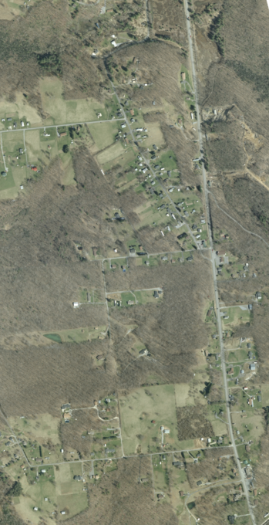
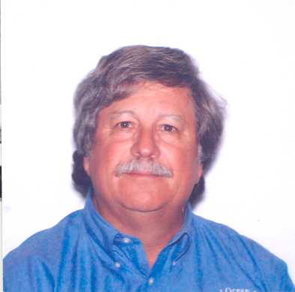

DAVID DOYLE
Chief Geodetic Surveyor
National Geodetic Survey
1315 East-West Highway, #8826
Silver Spring, MD 20910
Tel: (301) 713-3178

Fax: (301) 713-3242
E-Mail: dave.doyle@noaa.gov

Dave Doyle is the Chief Geodetic Surveyor of the National Geodetic Survey (NGS), where he is responsible for the development, technical design and management of high accuracy reference networks. He provides technical assistance in Geodesy to International, Federal, State and local surveying, mapping and GIS agencies. Since 1967 his experiences have included all phases of geodetic triangulation, astronomic positioning, leveling, GPS data collection, data analysis, network adjustments, and publication.
Mr. Doyle is a Past President of the American Association for Geodetic Surveying, a Fellow member of the American Congress on Surveying and Mapping, a Charter member of the Geographic and Land Information Society, and the District of Columbia Association of Land Surveyors, and is active in the Maryland Society of Surveyors and the International Association of Geodesy.
The National Geodetic Survey Workshop Program DEVELOPING AN ACCURATE GIS/LIS is a 1-day seminar on creating a Geographic Information System/ Land Information System. Topics include essential geodetic concepts, coordinate systems, accuracy standards, and surveying methods. These fundamentals are vital for individuals who perform geodetic control or data collection surveys for a GIS, those using or assessing the accuracy of a GIS and those converting data from one GIS to another including surveyors, engineers, corporate and governmental managers and planners, real estate and GIS professionals.

Seminar Schedule

Thursday September 9, 2004

8:00 am Check-in/registration
8:30 Begin Seminar
10:00-10:10 Break
10:10- 12:00 Continue Seminar
12:00 – 1:00 Lunch (provided)
1:00 – 2:30 Continue Seminar
2:30 – 2:40 Break
2:40 – 4:30 Finish Seminar

Continuing Education Credits
This seminar qualifies for 8 PDH’s in surveying.

Seminar handout materials and a certificate of attendance will be provided.

Lodging

Rooms are available at Ramada for $68.00 per night. This includes indoor pool, Jacuzzi and free full breakfast. A block of rooms has been reserved. Call Ramada at 304-414-0449 for details and confirmation. Mention group code WVSU.

Directions

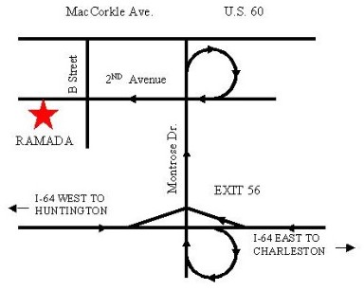

WVSPS
Continuing Education Seminar

Developing an accurate

GIS/LIS

West Virginia Society
of

Professional Surveyors
Greater Kanawha Valley Chapter
In cooperation with the

National Geodetic Survey

Thursday September 9, 2004

Ramada Inn
400 2nd Avenue
South Charleston, WV 25303

