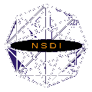
Certificate of Attendance
Don’t Duck Metadata
Introducing Geospatial Metadata
This document certifies that

successfully completed the two-day workshop, Introducing Geospatial Metadata, held at____________________________ on ____________________.
Instructor:
________________________
________________________

