STEPS FOR DIGITIZING TAX MAPS

TO START A NEW DISTRICT/CORP.

- Start AutoCAD Map 5
- From start-up dialog box,
  - Pick “Create Project” on the tab
  - Select “Start from Scratch” to begin
  - Click on “Metric” for units. See Fig. 1
This will take you to a brand new drawing w/ a blank screen.

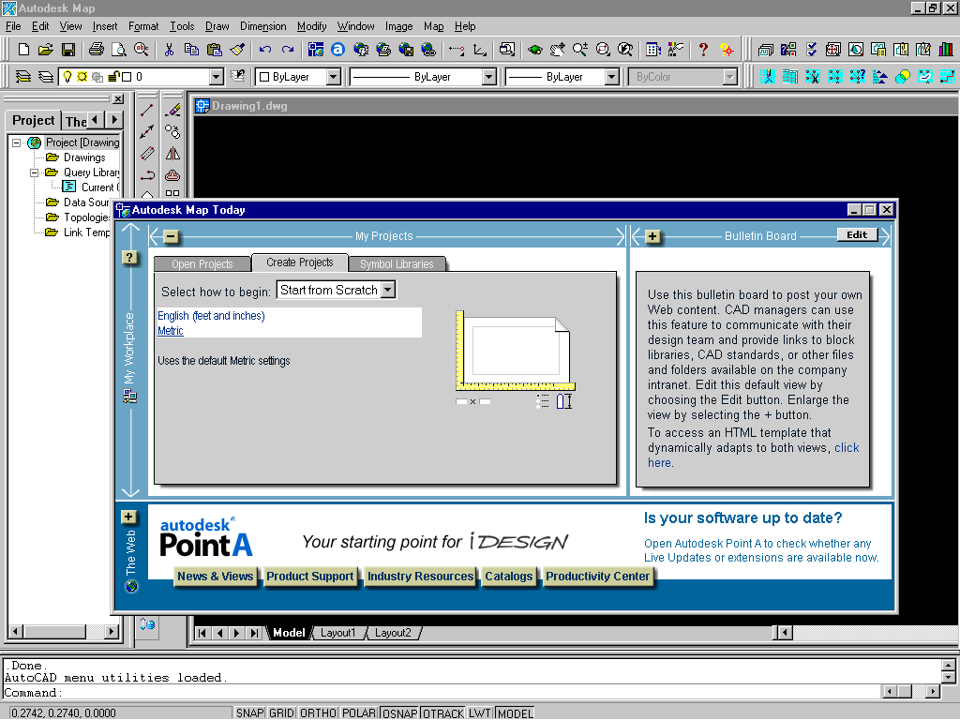
Fig. 1 To start a new drawing

TO INSERT A DOQQ - using Summersville Corp as an example

- From pull-down menu “Map”, pick “Image” ➔ “Insert”. See Fig. 2

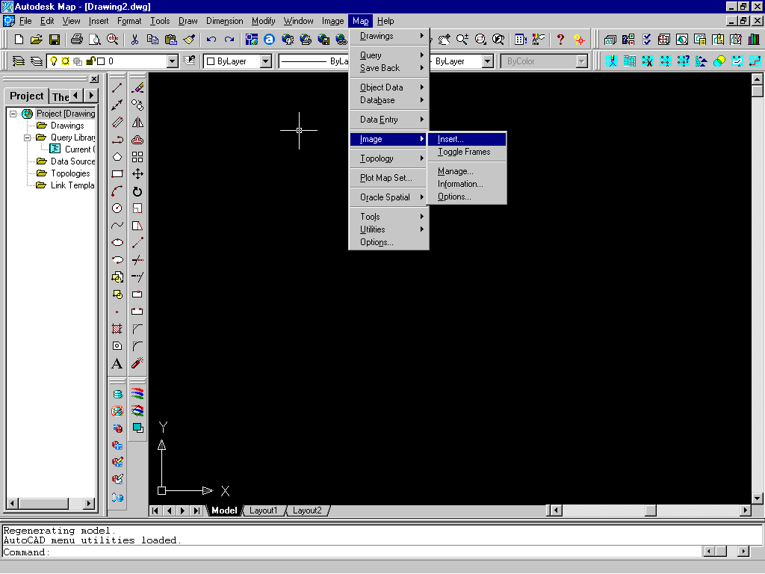
Fig. 2 To insert a DOQQ (1)

- Locate the DOQQ file “summersville_sw.sid”, and click OK. See Fig. 3

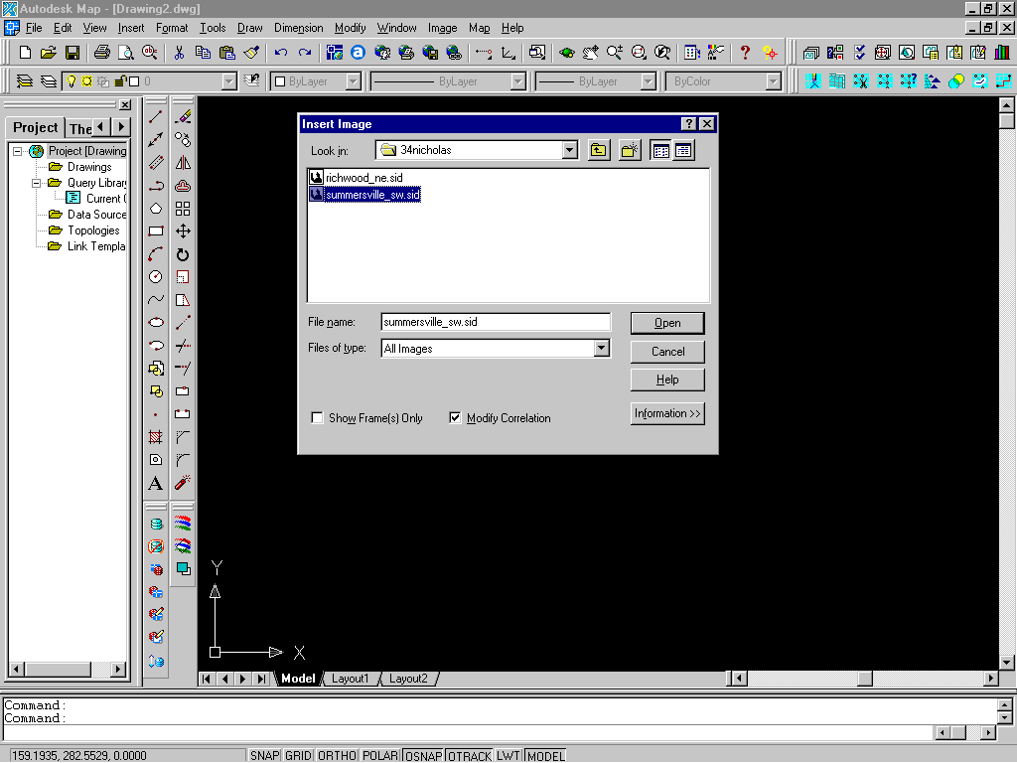
Fig. 3 To insert a DOQQ (2)

- Zoom extents to view the whole DOQQ inserted. See Fig. 4

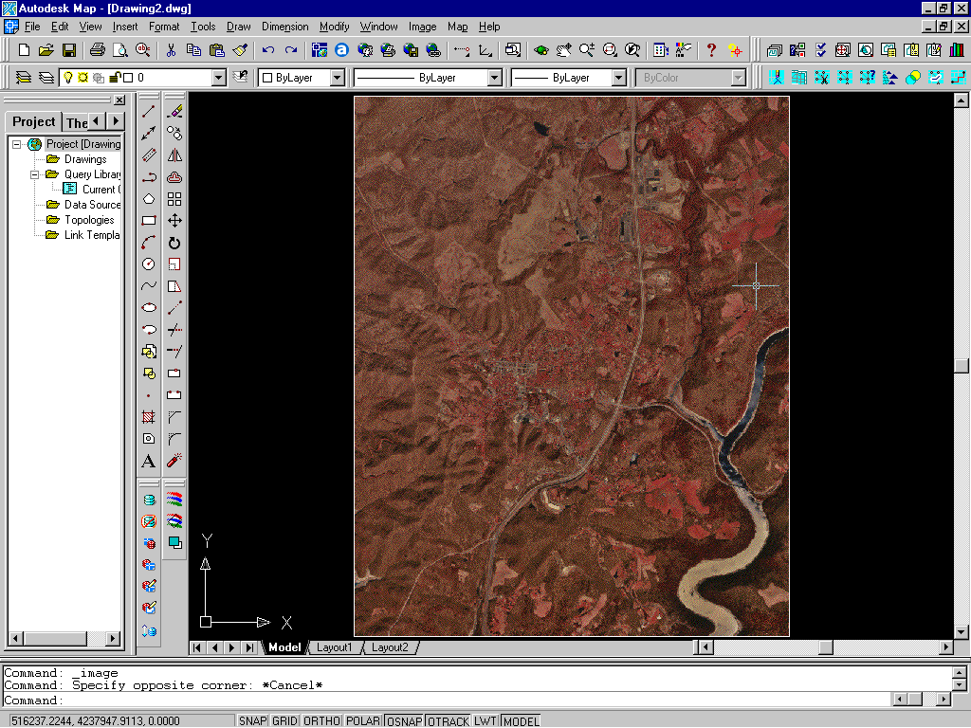
Fig 4 Zoom out to extents of DOQQ inserted

TO INSERT A TAX MAP, SUPERIMPOSING ON DOQQ- using Summersville Corp as an example

- Create a new layer named “TIFF” for tax map image files, using “Layers”
- Set current layer to “TIFF”
- Zoom in approximate area to be worked on, using “Zoom Window”
- Click on to insert a tax map – a raster image file. See Fig. 5.
The map after inserted is defaulted as “untransparent”. See Fig. 6
- To make the map transparent, click on , select the image and switch transparency from “OFF” to “ON”. The map image should become transparent. See Fig. 7

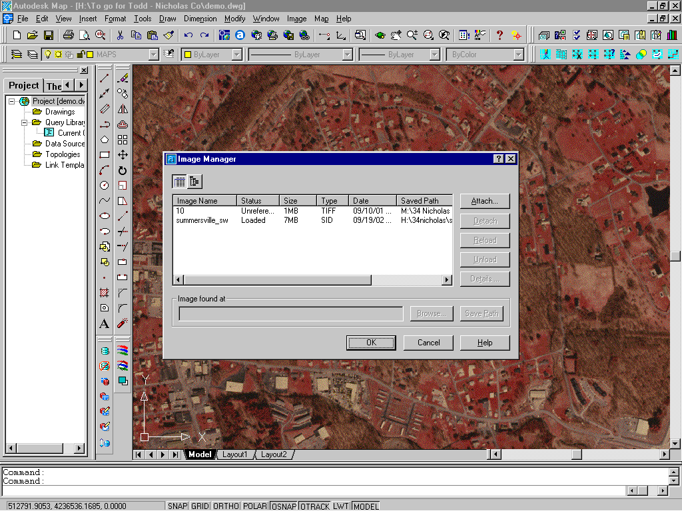
Fig. 5 To insert a raster image (tax map)

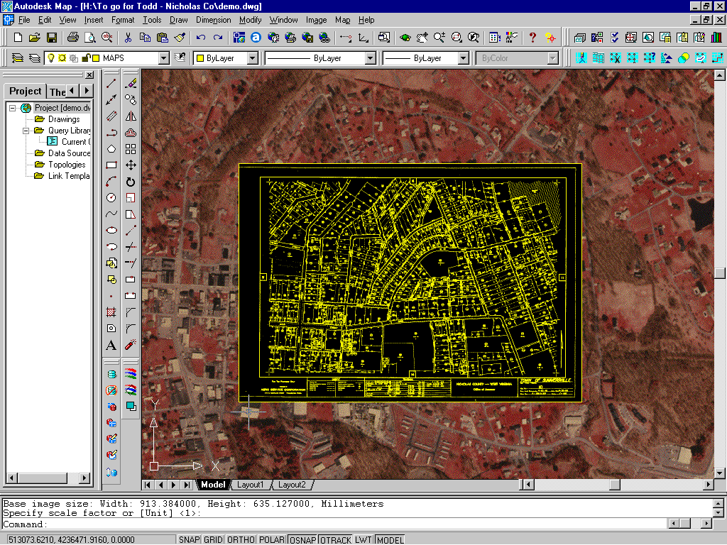
Fig. 6 Map is not transparent after inserted

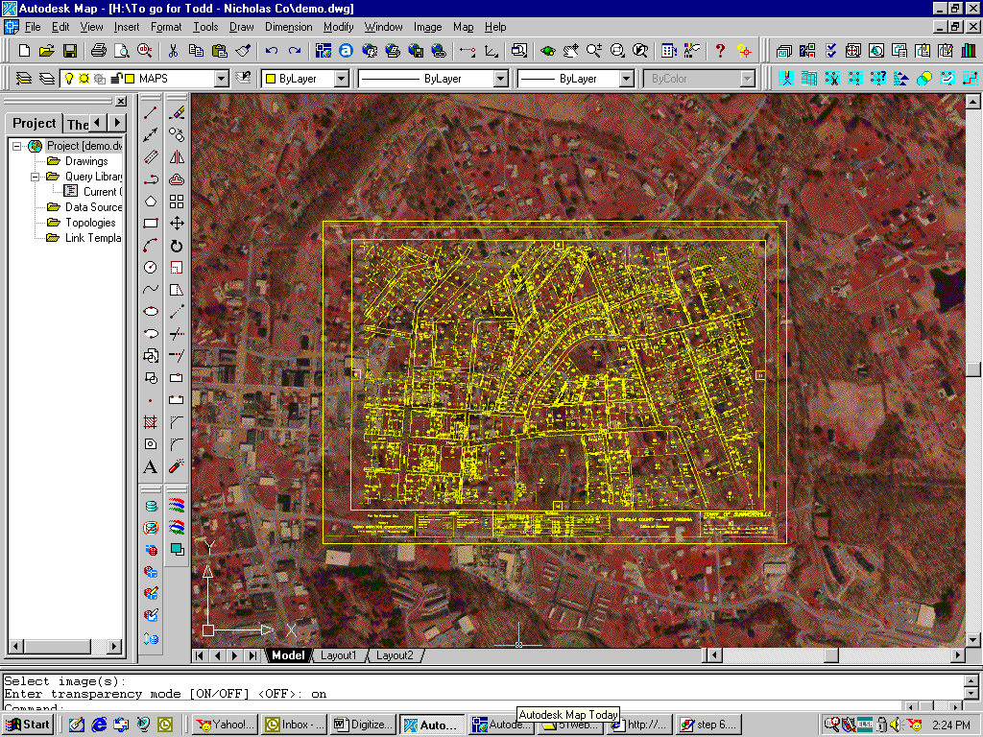
Fig. 7 Set image to transparency

- “Move” map to an approximate position overlaying DOQQ, using “one reference point” method.
- From pull-down menu “Map”, pick “Tools” ➔ “Transform”. See Fig. 8
  - Follow prompt line. Type in “S” for “Select”
  - Select the map image. Hit “Enter” to accept selection.
  - Zoom in a “street intersection” that you would like to use for the 1st “reference point”.
Click on the intersection point on the map as the “first source point”.
Click on the intersection point on the DOQQ as the “first destination point”.
  - Zoom out to previous view . Repeat Step 7c for the 2nd “reference point”.

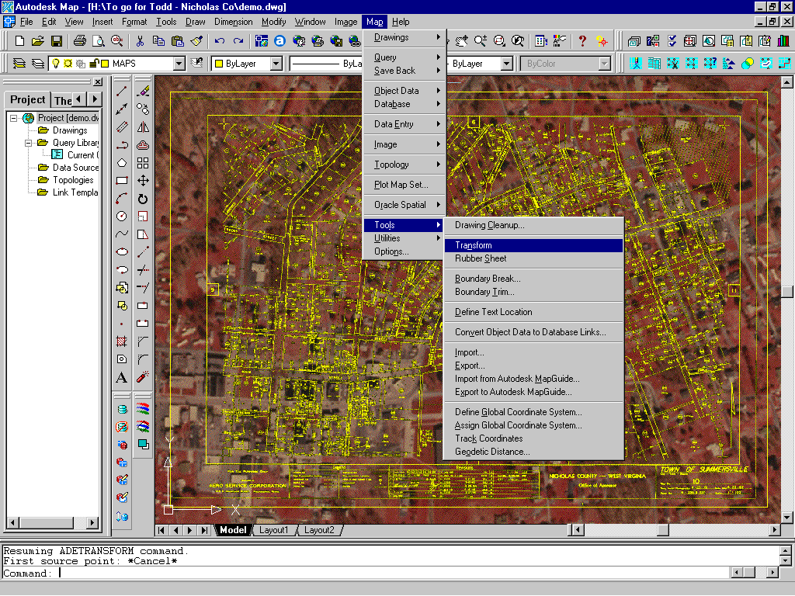
Fig. 8 Scale and rotate map to match DOQQ

- Now the map should be scaled and rotated accordingly to match with DOQQ.
- Repeat Step 7 as necessary if the map does not appear to match well with DOQQ.
- Create a new layer named “LINES” for parcel boundaries, using “Layers”
- Set current layer to “LINES”
- Start drawing parcel lines accordingly.

TO LABEL PARCEL Ids - using Summersville Corp, Map 10 as an example

It is recommended that parcel IDs be labeled before one continues on the next map. Labeling procedures are as follows:

- Create a new layer named “MAP” for “Map IDs”, using “Layers”
- Create a new layer named “PID” for “Parcel IDs”, using “Layers” . See Note below.

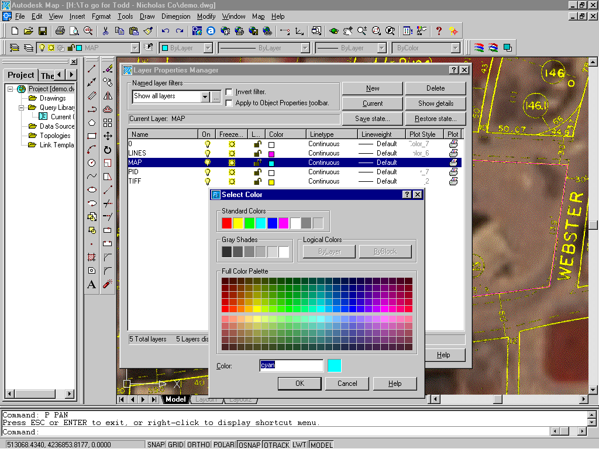
Figure 9 Changing objects’ color by layers

- On Layer “MAP”, insert map number, which is “10” in this case, inside one parcel, using “Single line text”
- On Layer “PID”, insert parcel number as “0” inside the same parcel, using “Single line text” . For text size, see Note below. For text insert location, see Note below.
- Copy both map ID (value 10) and parcel ID (value 0) to the rest of the empty parcels for the entire map. Type in “m” under the copy command for “multiple copy”.
- Edit parcel IDs for the entire map. Change their value from “0” to their true parcel numbers, using “Edit Text” .
- Filtering Text Values: After finishing editing parcel IDs, check if there are still any IDs left out without being changed from value “0”. To do so, type in “FILTER” under command line. An “Object Selection Filter” dialog box would pop out as shown on Figure 10.
  - Under “Select Filter” box, click on the down cursor and highlight “Text Value”
  - Set “X” value to “0”
  - Click on “Add to List” button
  - Under “Named Filter” box, type in “PID_check” (or any other name preferred) in the empty box, and click on “Save As” button to create a new filter list for this particular purpose.
  - Set “PID_check” as the current filter list.
  - Click on “Apply” button.
  - Select the area inside the entire map, then hit “ENTER”. AutoCAD will filter out any text(s) values of “0”.
  - Look under the command lines and check the outcome of this filtering. For instance, if it prompts “106 found, 103 were filtered out”, that means there are 3 IDs on the map which values are still unchanged as “0”.
  - Look through the map to find and edit the unchanged “0” text(s). Use “Filter” command to repeat Step f and Step g until all texts are filtered out.

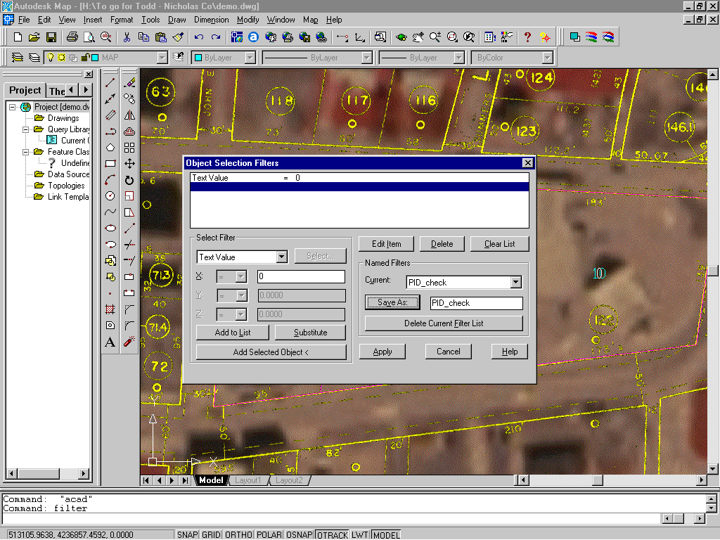
Figure 10 Using “Filter” command to check unchanged parcel ID value

Change colors of layers any time in the process as desired by clicking the “color box” under “Layers” to make them visually preferable. See Figure 9.
Set text height to 10 for maps of rural areas (scale 1”=400’); set text height to 2.5 for maps of corporations (scale 1”=100’).
Map ID and Parcel ID may be placed on top of each other as long as their insert points are INSIDE the parcel polygon.

