Strategic Plan

January 2004

Executive Summary

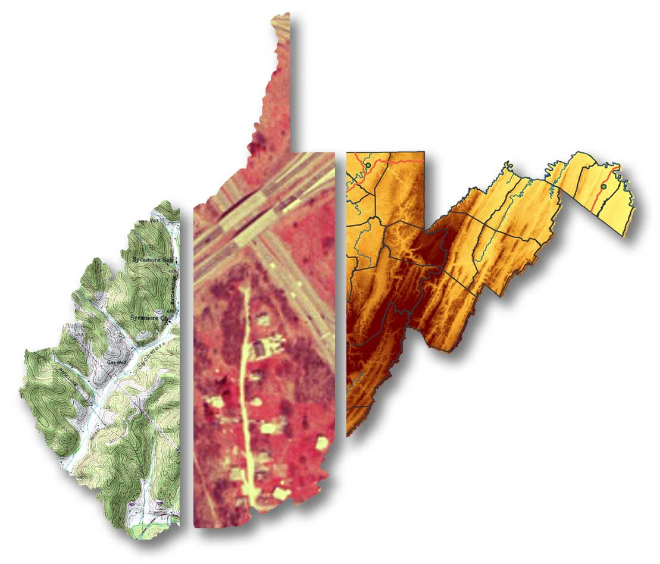

Prepared by the WV State GIS Technical Center
West Virginia GIS Technical Center
425 White Hall
Department of Geology and Geography
PO Box 6300
West Virginia University
Morgantown
West Virginia 26506-6300

Tel. (304) 293-5603 ext. 4336
Fax (304) 293-6522
Email wvgis@wvu.edu
Web http://wvgis.wvu.edu

Executive Summary

Vision and Mission of the West Virginia State GIS Technical Center

The West Virginia Geographic Information Systems Technical Center (WVGISTC) provides a focal point for the State for the coordination of developments in Geographic Information Systems, distributes geospatial data, conducts research in the latest GIS technologies, and makes training and education available in GIS topics for state and local agencies. Geographic information is vital for the 21st century. About 80% of all computerized data contain some form of locational information; consequently geographical data are incorporated increasingly in private and public sector decision-making. Geographic information systems (GIS) are used extensively by business and government organizations in West Virginia at statewide, regional and local scales of analysis for mapping, modeling, investigating and forecasting. GIS technologies are evolving rapidly and are central to the new information technologies and infrastructure that support geographic data acquisition, analysis and dissemination. In November 1993 Executive Order No. 4-93 directed the Technical Center to provide services to support the development and operation of GIS in West Virginia. Currently the Center is funded through provisions of House Bill 2222 (1995), the Mineral Lands Mapping Program, and other state and federal sources. As the state of West Virginia’s primary GIS resource, the Center provides state-of-the-art technology and professional expertise to support the development of GIS statewide.

The principal objectives of the State GIS Technical Center are to:

- Advance the State’s Spatial Data Infrastructure through digital data conversion, data development, and coordination with federal geospatial data initiatives and local data producers.
- Develop, maintain, coordinate, and provide the infrastructure to support Web-based access to geospatial data and information through the WV Geographic Information Network and FGDC State Data Clearinghouse node.
- Coordinate with state, federal, local government, and private sector entities to define, refine, and implement the State Strategic Plan for GIS initiatives and standards-based geospatial data development.
- Provide outreach, educational and training support, and advisory services to the citizens, government agencies, non-profit organizations, and businesses of West Virginia in the area of GIS and related spatial data handling technologies
- Undertake and support research and projects in GIS that improve the safety, quality of life, and economic well being of all West Virginia citizens.

Since its inauguration, the Technical Center has continued to meet each of these objectives in a number of ways that are detailed in this plan.

GIS is a major component of the information economy. Geospatial data in the form of remotely sensed images, on-line maps and global positioning coordinates are essential for economic growth, emergency preparedness and response, E-911, location-based services and environmental management and conservation. WVGISTC seeks to expand and maintain a complete range of digital geographic data for West Virginia, improve the geographic representation of its diverse physical and cultural entities, and investigate the dynamic earth, economic and social processes that shape planning and decisions. The WVGISTC benefits all state and local agencies that incorporate geographic information, interpret spatial data, and employ spatial decision-making to advance their missions. Simultaneously, the WVGISTC serves West Virginia's society at large by improving access to geographic information, encouraging more and better use of geographic technology, and providing new insights.

Current priorities include five major goals seen to be continuing and critical elements of WVGISTC’s mission. These goals are:

- Digital Mapping, Data Development and Coordination Services: WVGISTC advances the Spatial Data Infrastructure in West Virginia through data generation, data sharing agreements, enabling data conflation and interoperability, database development and digital mapping services. Continuing projects include:
  - Digital Line Graph (DLG) Conversion Project: Convert USGS 1:24,000-scale map sheets for the entire State into a standards-based digital format for use in GIS. Geospatial data layers include hydrology, contours (elevation), transportation (road, rail), and boundaries.
  - Flood Hazard Mapping: Prepare digital flood map layers for West Virginia.
  - Critical Infrastructure Mapping: Coordinate with the WV Office of Emergency Services and other agencies in the development of statewide critical infrastructure data sets.
  - County Mapping Projects: Provide assistance to counties for tax map conversion, transportation and land use mapping.
  - Municipal Boundaries: Coordinate with Census and the WV Legislature to create standards and procedures for the electronic submission of incorporated boundaries.
  - WV Gazetteer: Partner with the U.S. Geological Survey to keep current the Geographic Names Information System (GNIS), a names database of 38,000 physical and cultural geographic features.

- Geographic Information Network Services: WVGISTC provides a variety of geographic information services to disseminate data and geospatial news over the Internet.
  - Data Access and Distribution Services: These services allow users access to certified, documented geospatial data through distribution services such as Data Clearinghouses and metadata catalogs.
  - Geospatial News and Directory Services: WVGISTC disseminates geospatial information about relevant Internet map services, statewide mapping activities, and GIS standards and publications. Other geographic information services include promulgating GIS news and a statewide directory of GIS professionals.

- Strategic Planning and Mapping Standards: WVGISTC develops strategic business plans for the production and stewardship of standards-based geospatial data to make state and local governments more efficient.
  - Digital Tax Mapping Procedures: WVGISTC is spearheading an effort to create digital tax mapping guidelines for the State.
  - Local Government GIS Business Plan: WVGISTC is creating a business plan template to assist counties and municipalities with GIS implementation.
  - State GIS Plan: WVGISTC is developing geographic information technology reports and business plans that will contribute to the State GIS Plan.

- Advisory and Training Services:
  - Technical Advisory Services: WVGISTC provides consulting services to develop high quality geospatial data.
  - Technical Support Services: WVGISTC averages over four hundred service requests per year via e-mail or telephone from West Virginia GIS users.
  - Outreach Services: WVGISTC provides outreach services to select organizations throughout West Virginia. Recent outreach services include the statewide critical infrastructure and economic development maps for the WV Office of Emergency Services and WV Development Office, respectively.
  - Training and Educational Services: WVGISTC trains and certifies GIS specialists of today and the future. The Center continues to conduct a variety of GIS workshops, educational seminars, and conference poster displays.

- Research and Applications:
  - Research: The Technical Center interfaces with and builds upon the resources and experience of the Department of Geology and Geography at West Virginia University. Co-directors of the Technical Center also serve as Professors of Geography in the Eberly College of Arts and Sciences. GIS research focuses on basic and emerging topics across multiple disciplines.
  - Applications: Current application-focused areas include homeland security, flood hazard mitigation, transportation, cadastral, health, community planning, economic development and geology

Preparing for the Future

A sound business model for any organization such as WVGISTC requires an analysis of the best estimate of return on an investment. Since the Technical Center is not revenue-generating in the sense of selling a product, returns are best measured in terms of savings due to reduced redundancy of data conversion, data sharing, and the provision of innovative information products unavailable through any other state agency. In state government agencies specializing in mapping applications, GIS have been found to provide a 2-to-1 benefit to cost ratio and for state agencies that analyze spatial data a 4-to-1 benefit to cost ratio has been demonstrated. These returns are compounded when GIS is deployed in interagency and inter-institutional environments on the enterprise model. Additionally the WV GIS Technical Center needs to prepare for circumstances outside its control. External events necessitate an orderly response and a contingency plan is essential for effective management. The most likely eventualities will be budgetary in nature, but planning for other events, such as personnel changes, disaster response and recovery strategies is appropriate.

The Technical Center is a principal component in West Virginia’s information infrastructure for future growth and development. It will continue in its mission to provide focus, direction and leadership to users of geographic information systems (GIS), digital mapping and remote sensing within the state of West Virginia.

