The National Map State Business Plan

D-R-A-F-T
Prepared by the West Virginia GIS Technical Center (February 2004)

Vision

The National Map is envisioned by the USGS as a seamless, continuously maintained, and consistent set of online, public domain, core geographic data. The National Map will serve as a foundation for integrating, sharing, and using other government and private sector data easily and consistently. Eight primary data layers constitute The National Map: digital orthorectified imagery, elevation, hydrography (water), transportation, boundaries, cultural features, geographic names, and land cover.
The state of West Virginia wants to implement The National Map (TNM) by means of a coordinated, multiphase business plan that leads to the dissemination of national map layers through Web services and printed cartographic products.

Communications Network

Primary communication will be through the State GIS Coordinator, WV GIS Technical Center, and coordinating bodies such as the WV Framework Implementation Team, the WV Steering Committee, and other organized groups. These entities will enact policies and resolve issues regarding TNM implementation in West Virginia. The communications network will involve:

Principals: The State GIS Coordinator and the West Virginia GIS Technical Center at West Virginia University are focal points for implementing TNM in the State. The West Virginia Office of State GIS Coordinator (WVGISSC), which is responsible for the promotion and implementation of state GIS activities, has signed a Memorandum of Understanding with the U.S. Geological Survey (USGS) for coordination and cooperation pertaining to TNM. The West Virginia GIS Technical Center (WVGISTC) is the designated clearinghouse for statewide GIS data, developer of core Framework layers, and author of this State Business Plan.
Cooperators: Effective communication and coordination is essential to the successful implementation of TNM. The creation and implementation of the State Business Plan will involve multiple entities, including the WVGISSC, WVGISTC, State GIS Steering Committee, federal liaisons, state and county geospatial leaders, and private sector vendors associated with statewide mapping projects. Neighboring states also will be consulted. To facilitate communications among cooperators, WVGISTC will post on its website the minutes and other documents related to TNM program. The website will also provide a forum for the geospatial community to comment on the State Business Plan.

WV Framework Implementation Team: The WV Framework Implementation Team (I-Team) is an important coordinating body comprised of public and private sector geospatial leaders. The focus of the I-Team is to cooperatively produce and share the “best” available geographic data. The I-Team met initially in February 2003 to coordinate funding and technical services to integrate new, standards-based, statewide addressing and mapping base layers at a minimum scale of 1:4800 (1”: 400’) into the National Spatial Data Infrastructure. The next scheduled meeting is winter 2004.

Strategic Planning: With guidance from the State GIS Coordinator, The National Map State Business Plan will integrate with other West Virginia GIS plans, including the WVGISTC Strategic Plan (2004), Flood Map Modernization State Business Plan (in progress), State All-Hazards Mitigation Plan (2004), Long Term Addressing and Management Maintenance Plan (in progress), and State GIS Strategic Plan (in progress). Many of these plans are interrelated and converge upon TNM. Eventually, all these plans will be integrated with state information technology (IT) plans.

Organizational Roles

Newly defined organizational roles must be instituted to carry out this ambitious national program at the state level (Figure 1). Key roles for administering, coordinating, and implementing a TNM program in West Virginia may include:

State TNM Administrator: Facilitates development of all TNM layers and associated metadata within West Virginia; coordinates with neighboring state and national TNM administrators; collaborates with TNM Layer Coordinators and Oversight Authorities; inventories geospatial assets; standardizes “master datasets” into TNM; transfers suitable TNM layers to Web Services Managers and Map Publishers.
State TNM Layer Oversight Authority: Committees consisting of members from multiple agencies having managerial, supervisory, investigatory, or advisory powers for a specific TNM layer. Proposed oversight authorities include a State Geographic Names Board, State GIS Hydrography Board, and State GIS Transportation Board.

State TNM Layer Coordinator(s): Oversees the development and maintenance of a specific TNM layer at the state level (Table 1). In certain cases, multiple TNM Layer Coordinators affiliated with various federal or state governments, universities, or private agencies, will partner together to collect, maintain, and distribute a TNM data layer. TNM Layer Coordinators carry out technical tasks such as implementing standards and quality assurance procedures, coordinating data creation and maintenance activities among organizations that produce data for the geographic area, and incorporating updates into the centrally held maintenance system architecture. Where applicable, maintenance of a TNM layer will be validated through Web services.

State Web Services Manager: Supervises state access and distribution services of TNM layers via the Internet. Provides Web service support to the TNM Administrator and TNM Layer Coordinators. Coordinates with other state and national Web service managers.

Map Publishers: Publish standard TNM products with consistent symbology.

Mapping Partnership Offices (MPO) / Implementation Teams: USGS Liaisons, other federal assistance teams, or their sub-contractors who provide hardware and software technical support services to implement TNM at the state level.

Web
Services Manager

MPO

I -Teams
TNM
Layer
Oversight
Authority

National TNM Admin.

State TNM Admin.

Local Data
Producers
TNM
Layer
Coordinator
Map
Publisher

Figure 1: Possible organizational roles to implement TNM at the state level.

Products

Proposed products include integrated base map themes that will replace paper topographic maps and be available and accessible on the Internet for downloading and printing through Web portals. On-demand maps will be produced interactively and to specifications defined by the users. Initially, the State Business Plan will focus on two end products:

- An interactive, print-on-demand Web product through a portal. Although West Virginia spatial data accessed through public data clearinghouses is worth an estimated 50 million dollars, it is not easily accessible to the general public. User-friendly Web portals and other Internet services will make print-on-demand maps and file downloading more easily accessible to citizens (Appendix B).
- Programmed applications that generate high quality cartographic maps in a timely and efficient manner. Programmed applications will generate cost-effective, visually appealing map books for the entire State. These print-ready, digital map books may contain both core and application data layers, and allow for customization such that individual map sheets may vary in scale and orientation. The cartographic maps will meet higher standards than the Web-based print-on-demand maps. (As part of the National Map Denver Pilot, Appendix C is a sample graphic product of the “new” topographic map for the LaFayette, Colorado 7.5-minute quadrangle.)

Project Management

A series of tables in the State Business Plan will serve as project management tools to monitor progress and issues related to TNM implementation. These tables include organizational and coordination issues, action items, performance measures, funding and technical support, and status of the WV Spatial Data Infrastructure. This information will be updated periodically and posted on the WVGISTC website.

Table 1: Proposed State TNM Layer Coordinator positions
Table 2: Description of multiphase implementation of TNM in West Virginia
Table 3: Statewide mapping programs
Table 4: Targeted features that constitute the TNM in West Virginia
Table 5: Action items to develop Framework layers for TNM
Table 6: Funding and technical support requests to the federal government
Table 7: Present and future direction of the West Virginia Spatial Data Infrastructure

Multiphase Approach

With assistance from the State GIS Coordinator, the State Business Plan will be implemented in multiple phases: planning, design, implementation, and production. Table 2 outlines the tasks, performance measures, and time period associated with each phase.

West Virginia Framework Base Layers

The successful implementation of TNM in West Virginia will depend on the development and long-term maintenance of integrated Framework base map themes. In turn, the advancement of WV Framework base layers will depend on the State’s ability to overcome administrative, institutional, and data interoperability issues. First, the State must resolve administrative and commercial issues concerning data ownership, maintenance, cost, availability, and security. Secondly, because the scope of this national program reaches far beyond any single agency, institutional mechanisms must be employed that connect federal, state, local, and private entities. Thirdly, there must be technical solutions that overcome the barriers to data interoperability and address issues of scale, format, projection, schema, and accuracy. Lastly, data conflation is necessary to create new ‘master’ datasets from the best spatial and attribute qualities of two or more source datasets.
Framework base layers will be derived from local data producers and from map modernization programs. Base layers derived from statewide mapping programs will form the nucleus of WV Framework layer development to enhance the spatial compatibility of the primary eight TNM layers. Two major statewide mapping programs are the digital line graph conversion project and the West Virginia Statewide Addressing and Mapping Board (WVSAMB) project. These multi-agency mapping programs promise to have a profound impact on the WV Spatial Data Infrastructure and the eight primary data layers of The National Map. For the last decade the focus has been on creating base layers from both USGS and USFS 1:24,000-scale topographic maps, but now the State’s new direction is the acquisition of higher spatial and temporal resolution address-based layers (1:4800 scale or better) as part of statewide addressing and mapping project (Table 3).

WVGISTC-USGS Digital Line Graph (DLG) Conversion Project: In cooperation with U.S. Geological Survey, WVGISTC has nearly completed a statewide digital base map for West Virginia based on U.S. Geological Survey 1:24,000 topographic maps. All 1:24,000-scale planimetric layers for the State are finished and DLG hypsography (elevation) is 77% completed. These elevation, transportation, hydrology, and administrative map layers have a variety of uses for state and local governments and are available in the public domain. Funding is primarily from the State’s Mineral Lands Mapping Program, which supports the development of a court mandated electronic mineral lands taxation system to provide an equitable electronic taxation system for the State.
West Virginia State Addressing and Mapping Project: This is an effort to create city-style addresses for the large rural areas of West Virginia. This project will generate new geospatial base layers at a minimum statewide scale of 1:4800 (1”: 400’). In spring 2003, the WVSAMB Mapping Vendor captured statewide natural color aerial photography. These 1:4800-scale, 2-foot resolution orthophotos should be available by December 2004. The orthophotos will provide the base for the addressing layers that should be completed by 2007. Because long-term maintenance issues have not been resolved, the WVSAMB has not decided which orthoimagery and map layers will reside in the public domain. In 2004 the WVSAMB will unveil its Long Term Addressing and Management Maintenance Plan. WVGISTC has submitted a proposal to WVSAMB to disseminate public domain layers, to develop value-added products (Appendix A), to assist in integrating data into the National Spatial Data Infrastructure, and to provide area integrator and maintenance services.

Table 1: State TNM Layer Coordinators. State TNM Layer Coordinators work closely with the State TNM Administrator TNM Layer Authority, Web Services Manager, and Mapping Partnership Office.
Base Layer | TNM Layer Coordinator
Orthoimagery | Orthophoto Coordinator: Conducts orthophoto inventories and distributes statewide and locally-produced orthophotos.
Transportation | Addressing Coordinator: Serves as an “area integrator” to aggregate new road centerline and structure data from the counties or other local data producers. Liaisons with other transportation data producers.  Trail Coordinator: Steward of state trail spatial databases.  Utility Coordinator: Coordinates with the utility companies, government agencies, Miss Utility and other entities to compile and integrate utility spatial data.
Hydrography | Hydrography Coordinator: Updates and maintains hydrographic spatial databases at the state level. Coordinates delineation of watershed boundaries.
Boundaries | Public Lands Boundary Coordinator: Integrates public land boundaries into a single coverage. Resolves shared public land boundaries issues.  Political Boundary Coordinator: Facilitates refinement of political boundaries with the best available data.
Elevation | Elevation Coordinator: Maintains elevation TNM layer and its inclusion into the National Elevation Datasets (NED).
Structures | Structures Coordinator: Works with the Addressing Coordinator to prepare the structures TNM layer.
Land Cover | Land Cover Coordinator: Compiles and collects forested and mined land cover areas for TNM.
Geographic Names | Geographic Names Coordinator: Steward for Geographic Names Information System (GNIS) layer.

Table 2: Multiphase implementation of TNM in West Virginia. Included are the TNM phase, time period, and associated tasks and performance measures.
PHASE | TIME | TASKS | PERFORMANCE MEASURES
Planning | 2004 | Coordination Meetings  Review quality and stewardship issues of WV Framework layers needed for TNM  Review activities listed in the scope of USGS-WV Memorandum of Understanding (MOU)  Mission statements compiled of spatial data producers for WV geographic area  Geospatial inventories and surveys | USGS-WV Memorandum of Understanding  State Business Plan presented to WV GIS Community and USGS  Framework Status Report: Present status, future Directions, challenges  Sample cartographic product of best available data layers
Design | 2005-2006 | Activate TNM “SWAT Teams” to assist the State with its system design for Web services and cartographic products  Identify coordinate systems required for TNM products  Develop statewide WV Framework themes identified as TNM layers  Review stewardship issues of WV Framework spatial databases  Implement prototypes for a state portal and cartographic product | State Business Plan endorsed by GIS community  Data license and security issues resolved  Data sharing and maintenance agreements formalized  Reliable, functional state portal prototype  TNM cartographic product prototype with standardized symbols and text
Implementation | 2007-2008 | Continued development of WV Framework themes identified as TNM layers  Integrate TNM layers “horizontally” and “vertically,” including neighboring states  Initiate map production of cartographic product  Enhance Web services | Modified State Business Plan  Map production and robust Web services  Stewardship issues and organizational roles clearly defined  Networked distributed collection of spatial databases
Production | 2009- | Continued maintenance of WV Framework themes identified as TNM layers | Integration between state and national portals  Cartographic maps published on a regular basis

Table 3: Two statewide mapping programs: topographic- and address-based mapping projects. The West Virginia Statewide Addressing and Mapping Board (WVSAMB) project will constitute the “next generation” base layers. This new direction will modernize the present-day 1:24,000 base layers with higher resolution 1:4800 scale or better data.

Base Layer | Topographic Map-Based Driven  1:24,000 Scale (Present) | Address-Based Driven  WVSAMB 1:4800 Scale or Better (Future)
Orthoimagery | USGS DOQQs (1996-97) | WVSAMB (2003)
Transportation | USGS Digital Line Graphs  USFS Cartographic Feature Files | WVSAMB
Hydrography | USGS Digital Line Graphs  USFS Cartographic Feature Files | WVSAMB
Boundaries | County, Municipal, Tax Districts, Public Lands (mostly derived from topographic maps) | WVSAMB ridgelines,  GPS / Surveyed boundaries,  Tax parcel-derived boundaries
Elevation | USGS Digital Line Graphs (77% completed)  USGS 10-meter DEMs (36% completed) | WVSAMB
Structures | None | WVSAMB

Table 4: Targeted features that constitute TNM for West Virginia. Most features only require an attribute name. Roads should include road name, surface type, and underpass / overpass information.
Base Layer | TNM Target Features
Orthoimagery | Natural color or color-infrared
Transportation | Roads (Interstates, U.S. and State Highways, Local Roads), trails, railroads, Pipeline, Transmission Line, Airport Runways
Hydrography | Rivers, Streams, Lakes
Boundaries | State, county, tax districts, municipal, small parks, public lands
Elevation | Contours (index or intermediate)
Structures | Bridges, tunnels, dams and spillways, schools, churches
Land Cover | Forested and mined areas
Geographic Names | Gazetteer (cultural features periodically updated with addressing layers)

Table 5: Proposed action items to develop Framework layers for TNM. Framework base layers will be derived from local data producers and from map modernization programs.
Base Layer | Proposed Action Items
Orthoimagery | Reproject and re-index WVSAMB orthophotos to a single UTM zone coordinate system, referenced to the popular USGS 3.75-minute quarter quad index.
Transportation | Identify roads (Interstates, U.S. and State Highways, Local Roads), trails, railroads, navigable waterways, and other transportation features to be included as TNM layers. Conflate WVSAMB layers with attributes from other transportation data sets. Determine symbols and other cartographic representations needed. Investigate whether restrictions apply to pipelines and transmission lines being displayed as a TNM layer.
Hydrography | Add name attributes to WVSAMB hydrography data. Form closed polygons for rivers and lakes. Prepare WVSAMB data for inclusion into National Hydrography Dataset (NHD).
Boundaries | Integrate public land datasets and resolve shared boundary conflicts (i.e., Wildlife Management Areas and National Forests). Develop mechanisms for creating more accurate political boundaries with better quality data.
Elevation | Identify and integrate spatial data sources and format for TNM elevation layer.
Structures | Derive TNM structures from statewide addressing and mapping layers.
Land Cover | Identify spatial database sources for TNM land cover layer (i.e., forested areas and mining areas).
Geographic Names | Local data producers coordinate names among the multiple layers and  map services to update the USGS Geographic Names Information System (GNIS).

Table 6: Funding and technical support requests to the federal government. The State appeals to federal liaisons and Mapping Partnership Offices for feedback on the following support requests.

Base Layer | Support (funding and technical)
Orthoimagery | Request support from U.S. Department of Agriculture, U.S. Department of Interior, and other federal agencies to reproject and re-index WVSAMB orthophotos to a single UTM zone coordinate system, referenced to the popular USGS 3.75-minute quarter quad index
Transportation | Request support from Census for the maintenance of the WVSAMB addressing layers which are within the Census’ MAF/TIGER Accuracy Improvement Project (MTAIP) horizontal spatial accuracy standard of 7.6 meters; the State hopes the government avoids maintaining two independent mapping and addressing systems.  Request support from USDOT and other agencies to conflate WVSAMB miscellaneous transportation datasets with fully functional attributes.  Request input from USDOT and other agencies as to how pipelines, transmission lines, or others sensitive transportation data should be included in TNM.
Hydrography | Request support from USGS, EPA, and other federal agencies to create a “master” 1:4800-scale NHD dataset from both sources; the State hopes the government avoids maintaining two independent hydrographic datasets: (1) USGS 1:24,000-scale NHD and the (2) WVSAMB 1:4800 hydro layer.  Request support to develop a single, standardized Watershed Boundary Dataset (WBD) for the State.
Boundaries | Request support from Census and other agencies for boundary refinements with WVSAMB data and for digital submissions of boundary and annexation survey geospatial data.  Request support from USFS to align National Forest and Wildlife Management Boundaries.
Elevation | Request support from NRCS and the USFS to develop the statewide WVSAMB elevation dataset of 10-foot contours.  Request support from FEMA to incorporate 2-foot contour elevation data into the State’s TNM elevation layer.
Structures | Request support from Census and USGS for statewide structure GIS files comprised of either point centroids or polygon footprints.
Land Cover | Request input from USGS, EPA, and other federal agencies on the best approach to synthesize consistent, high resolution land cover datasets (1:24,000-scale or better).
Geographic Names | Request support from USGS to update the Geographic Names Information System (GNIS) database.
133 Cities Project | Request support from USGS to redelineate the Charleston Urbanized Area to follow the linear Teays Valley (ancient glacial valley) between Charleston and Huntington, WV. This will provide a more useful coverage of critical infrastructure than the proposed boundary.  Request support from USGS, NIMA, or DHS to integrate 133 Cities spatial data into TNM layers and for information on data security policies.
Metadata | Request support from FGDC and others for metadata training and publishing.
Web Services | Request support from USGS and others to make online TNM layers accessible to the public via a state Web portal.
Table 7: Present and future direction of the West Virginia Spatial Data Infrastructure. Includes core and application themes, along with challenges and proposed solutions.

Theme | Present Status | Future Directions
Orthoimagery | One-meter color-infrared orthophotos were produced by the USGS in the late 1990’s.  In spring 2003 the National Park Service captured aerial photography for its three parks in southern WV.  In 2003 the WV View Remote Sensing consortium was established to catalog and share remote sensing inventories. It complements the WV Data Clearinghouse and other geospatial data repositories. | In spring 2003 the WVSAMB mapping vendor captured statewide natural color aerial photography. These 1:4800-scale, 2-foot resolution orthophotos should be available by December 2004 and constitute the new photographic base for WV.  In 2003 the WGISTC proposed offering its Data Clearinghouse services to the WVSAMB to distribute the new statewide orthophotos in the public domain.  The Natural Resources Conservation Service (NRCS) has pledged funding to resample, reproject, and re-index the orthophotos to one-meter, a single UTM zone coordinate system, and referenced to the popular USGS 3.75-minute quarter quad index. Other Federal agencies may fund this endeavor.
Hydrography | In 2002 WVGISTC completed statewide coverage of 1:24,000-scale USGS Hydrography DLGs.  In 2003 the Natural Resource Analysis Center (NRAC) at WVU completed NHD mapping by conflating 1:24,000-scale hydrography USGS DLGs/USFS CFFs for all 33 sub-basins (8-digit HUC) in the State. | WVSAMB hydrography will have limited attribution. Funding sources are needed to integrate WVSAMB 1:4800-scale streams into NHD or to minimally conflate name attributes.  Create an interagency team to standardize the delineating of 1:24,000-scale or better hydrologic unit boundaries for WV as part of the national Watershed Boundary Dataset (WBD).
Transportation | In 2002 WVGISTC partnered with Marshall University to develop a GIS implementation plan for the State DOT.  In 2002 a State Trail Map of existing and proposed trails was produced.  In 2003 WVGISTC completed statewide coverage of 1:24,000-scale topo-based transportation vector files.  WVDOT has contracted a vendor to convert its cartographic highway maps into a digital format. | By 2007, the WVSAMB Addressing Vendor will attribute transportation files based on NENA-2-010 format for road centerlines, major driveways, railroad centerlines, navigable waterways, overpasses, bridges and tunnels, building points, major structure polygons, and dams and spillways.  Formalize licensing and distribution and maintenance networks for WVSAMB data.
Table 7 (continued): Present and future direction of the West Virginia Spatial Data Infrastructure.

Theme | Present Status | Future Directions
Boundaries | In 2003 WVGISTC created a 1:24,000-scale digital version of the official tax district boundary lines adopted by the WV Legislature in 1973.  USGS 1:24,000-scale boundaries are available for a large part of the State. | Refine administrative and political boundaries based on WVSAMB breaklines and other sources.  Resolve shared public boundary issues (i.e., WMA’s and NF boundaries)  WVGISTC has initiated a business relationship with the WV Legislative Office and Census with the digital submissions of boundary and annexation surveys.
Elevation | USGS 1:24,000-scale hypsography is available for 77% of the State, 10-meter elevation data for 36%, and LIDAR for 2%.  WVGISTC will continue to create DLG hypsography until a better statewide TNM elevation layer is identified. | WVDOT has committed funds to enhance the WVSAMB elevation data.  The WV Department of Environment Protection may procure IFSAR Radar in the southern WV coalfields although license restrictions may apply.
Land Cover | Rahall Transportation Institute (RTI) is creating master land cover plans for 8 southern counties from USGS 1-meter orthophotos.  Penn State University's Land Analysis Laboratory has been funded by a grant from the EPA to generate land use data within the Chesapeake Bay Watershed.  In 2004 the Natural Resource Analysis Center at WVU will release a more current WV-GAP Land Cover dataset. | Standardize the collection efforts of high-resolution (1:24,000-scale or better) land cover data sets.
Structures | WVGISTC coordinates with the WV Office of Emergency Services (WVOES) and other agencies in the development of statewide critical infrastructure data sets. | The WVSAMB Addressing Vendor will create building points, major structure polygons, and spatial Emergency Service Zone (ESN) useful for TNM and critical infrastructure mapping.
Geographic Names | No active maintenance program exists for geographic names at the State level. Many geographic names are obsolete. | WVGISTC has initiated a business relationship with USGS to update out-of-date named features maintained in the Geographic Names Information System (GNIS).  USGS, Names Project, will provide map and feature services for accessing names data from GNIS for use by State applications.  (http://geonames.usgs.gov/)
Table 7 (continued): Present and future direction of the West Virginia Spatial Data Infrastructure.

Theme | Present Status | Future Directions
Geodetic | In 2000 the WV High Accuracy Reference Network (HARN) for Federal Base Network (FBN) and Cooperative Base Network (CBN) Stations was completed. | Two survey grade GPS base stations exist in the State, with the potential for a third in central Pocahontas County.  Develop training and coordination services for exchanging geographic data between land surveyors and GIS professionals.
Flood Hazards | Q3 data is available for 34 counties; DFIRMs are in progress or completed for 10 counties.  All-Hazard Mitigation and Flood Map Modernization Business Plans are being developed for the State.  State Cooperative Technical Partner’s are preparing Digital Flood Insurance Rate (DFIRM) maps. | FEMA wants to modernize the State’s digital flood mapping program.  Create an interagency team to compile repetitive flood loss information into a centralized spatial database.  Integrate FEMA’s business plans with other state GIS plans.
Cadastral | Approximately 60% of WV Counties are in transition or have made the conversion to digital tax maps. | WVGISTC is spearheading an effort to create digital tax mapping guidelines for the State.
Geology | 1:250,000 Scale: Only complete statewide geological coverage.  1:62,500 Scale: Early 1900’s County Reports. All maps scanned, some georeferenced.  1:24,000 Scale: STATEMAP project is creating 1:24,000-scale geological maps. | Update the statewide 1:250,000 GIS coverage with 24k digital data.  The WVGES Coal-Bed Mapping Project and WVDEP’s mining permits are data sources for the mined areas of TNM.
Topographic Maps | Topographic maps are a popular reference data set. USGS / USFS Digital Raster Graphics (DRG) vary according to color model, resolution, and datum. | Replace paper maps with Internet print-on-demand maps and computer-generated map books.  Organize efforts to create uniform, collarless Digital Raster Graphics (DRG) of USGS topographic maps in both GeoTIFF and ArcSDE formats.

Appendix A: WVSAMB Project Spatial Databases

Table A1: WVSAMB Deliverables and Potential Government Value-Added Products. The 1:4800-scale data will meet the NSSDA horizontal spatial accuracy standard of 5.7 meters.

DATA LAYER | WVSAMB DELIVERABLES (boldfaced text)  GOVERNMENT VALUE- ADDED PRODUCTS (numbered text)  (All WVSAMB data projected to WV State Plane Coordinate System) | CATALOG UNITS  (Seamless)
OrthoImagery | 400’ design scale orthophotos, 2-foot GSD, true color, GeoTIFF/ MrSID, 8,400 image files, ~ 620 GB uncompressed  (1) Reprojected to UTM Zone 17, Reindexed to USGS quarter quad index | 10,000’ x 10,000’ Tiles  3.75-Minute Quarter Quad
Elevation | Enhanced DTM: Mass points and breaklines (pre-TIN format); DGN files; NSSDA absolute vertical accuracy of 10 feet at 95% confidence level (?)  (1) DEM ASCII File Format (mass points and breaklines)  (2) ESRI TIN format  (3) Digital Elevation Models (hydro enforced); 20-30’ post spacing  (4) Hillshaded Terrain  (5) Derived iso-lines and contours at 10’ and 20-25’ intervals, respectively  (6) Ridgeline breaklines for refinement of boundary datasets | 10,000’ x 10,000’ Tiles  10,000’ x 10,000’ Tiles  10,000’ x 10,000’ Tiles  1/2 deg. X 1/2 deg. Blocks  1/2 deg. X 1/2 deg. Blocks  7.5-Minute Quad  County or State
Transportation | Addressable road centerlines, major driveways, RRs, navigable waterways, overpasses, bridges and tunnels, dams and spillways. ESN Zones (Fire, EMS, Police)  (1) Statewide Road Centerline Database  (2) Locator-based datasets (businesses, churches, etc.)  (3) 1:4800-scale Census TIGER/Line Transportation files  (4) Trails with names (conflate names from State Trail Map) | 50,000’ x 50,000’ Tiles  County and State  State  Census Admin. Boundaries  State
Hydrography | Visible water bodies such as rivers, stream, lakes, etc.  (1) Streams with names (conflate names from 1:24k NHD)  (2) 1:4800-scale National Hydrography Dataset (NHD) | 50,000’ x 50,000’ Tiles  County, State, Watershed  Watersheds
Structures | Centroids and polygons (> 100ft on any side) for large structures. Addressing component.  (1) Incorporated into cadastral or Census databases  (2) Updated USGS Geographic Names Information System  (3) Flood At-Risk (repetitive loss) Structures  (4) Pictures of select structures for assessment databases | 50,000’ x 50,000’ Tiles  County or State  State  State  State
Boundaries | (1) Updated political and administrative boundaries (voting precincts, zip codes, municipalities and other political boundaries) | State

Table A2: Accuracy of WVSAMB enhanced Digital Terrain Model (DTM) in relation to other existing elevation products

Elevation Product | Vertical RMSE | Contour  Interval | Horizontal  Post Spacing
USGS 7.5-Minute DEM  - Level 1 (created by auto correlation or manual profiling from aerial photographs.)  - Level 2 (created from DLG or tagged vector contours) | 23 to 50 ft.  10 to 20 ft. | 20 or 40 ft.  20 or 40 ft. | 30 meters  10 or 30 meters
WVSAMB Digital Terrain Model | (?) | 10 ft.(?) | (?)
IFSAR Radar (potential acquisition by WVDEP) | 3 ft. (1st surface) | 10 ft. | 5 meters
LIDAR (Wyoming and Jackson Counties) | 0.5 ft. | < 2 ft. | 0.5 meters

Appendix B: Proposed State Web-Based Portal

The WVGISTC is committed to designing a state Web-based portal for WV Framework spatial data founded on the geodata.gov portal and National Map Layer concepts. This portal will make it easier, faster, and less expensive for the public to access WV Framework spatial databases. The portal will model the Delaware DataMIL, an interactive, on-line National Map pilot project of which commonly used base map layers, or Framework layers, are the primary focus.

- Proposed Framework Layers
  - Hydrography: (Source: National Hydrography Dataset: 1:24,000 or 1:4800 scale)
  - Transportation: (Source: Conflate WVSAMB 1:4800 scale with other transportation datasets)
    - Roads
    - Railroads
  - Elevation (Source: WVSAMB; National Elevation Dataset; 1:24,000 USGS DLG hypsography)
  - Governmental Units (Source: Topographic-based, Census, WVSAMB, state and local data producers)
  - Land Cover: (Source: USGS National Land Cover Dataset; regional land cover datasets)
  - Orthoimagery: (Source: 2003 WVSAMB natural color orthophotos; 1:4800 scale)
  - Geographic Names: (Source: Updated USGS GNIS)
  - Structures: (Source: WVSAMB or local data producers)
  - Cadastral: (Not available)
- Other Datasets
  - Reference Datasets: (Source: Collarless 1:24,000-scale DRGs; Hillshaded Dataset)
  - Flood Hazards: (Source: Statewide Flood Hazard Map Layer)

Functional requirements may include search mechanisms, map display, data and metadata access, transformation and processing. Specific functions may include print-on-demand maps, downloadable georeferenced map images, and coordinate identification for features of interest.
- Search and Map Display Functions
  - Search – search by
    - Place name
    - Street address
    - Geographic location

Map Display
    - Zoom, Pan, Move, Identify and Measure Tools
    - Draw Select and Erase Tool
    - Quick Zoom functions (city and preset scale)
    - Collapsible, scale-dependent layers
    - Descriptive legends
    - Locator map
    - Display coordinate locations (lat./long. & UTM)

Data and Metadata Access

View metadata for map layers and services

Download data with user-defined geographic extent

Transform data or maps to other coordinate systems
- Publication
  - Create print-on-demand maps with legend

Export maps to other image formats

WVGISTC plans to have a prototype Web-based portal completed by 2005. The prototype portal could integrate will other portals or serve as a foundation for Internet system applications (Figure B1). In the future an enterprise GIS implementation may be implemented that allows multiple users to edit spatial data concurrently and continuously over the Internet.

Figure B1: Web services integration. The proposed state portal focuses on core framework layers that synthesize with the National Map portal and other statewide Internet applications. Core framework layers in a Web exchange format will be accessible to other Internet applications
to minimize redundancy, ensure interoperability, and maximize benefits.

Environmental
Protection
(WVDEP)

Health
(WVBPH)

TEAMS
Geology
(WVGES)

National Map Portal

State Portal
(WVGISTC)

Natural
Resources
(NRAC
CVI,
Forestry)

Critical
Infrastructure
(WVOES)

Core Base Layers

Transportation & Economic
Development
(WVDO, RTI)

Appendix C: Comparison of standard USGS Topographic Digital Raster Graphic to The National Map Denver Pilot Graphic
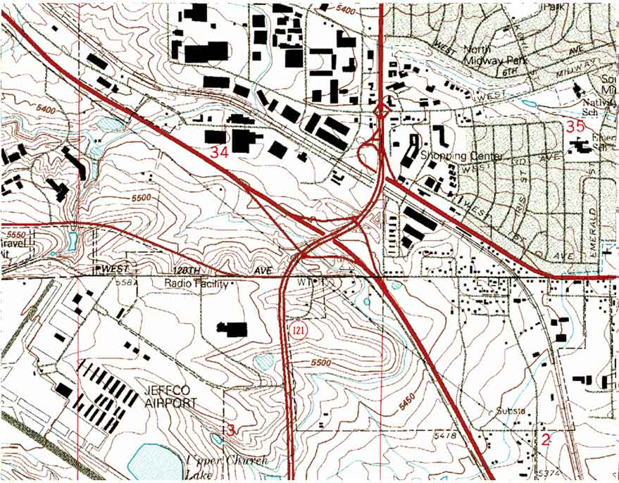

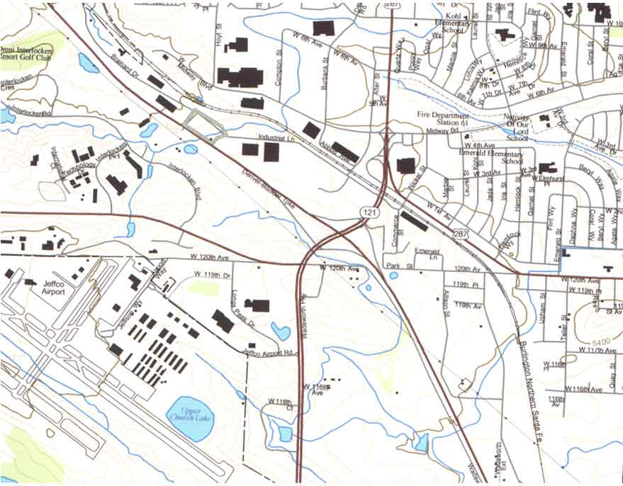
Standard Topo Map
Denver Pilot Data Graphic
Appendix D: The National Map Web Links

USGS Website
http://nationalmap.usgs.gov/

National Map Fact Sheet
http://mac.usgs.gov/mac/isb/pubs/factsheets/fs01802.html

National Academies of National Map
http://www.nsgic.org/hot_topics/national_map/NRC_National_Map_Summary.pdf

